Name _____________ Date _____________

Mr. Schlansky Geometry

***Proofs Regents Review***

**Euclidean Proofs (Basic)**

**If it is not specified, prove triangles are congruent**

**To prove triangles are congruent, prove 3 pairs of sides/angles are congruent**

**To prove segments or angles, use CPCTC**

**\*If you get stuck, make something up and keep on going!**

1. **Do a mini proof with your givens**

Altitude creates congruent right angles

Median creates congruent segments

Line bisector creates congruent segments

Midpoint creates congruent segments

Angle bisector creates congruent angles

Perpendicular lines create congruent right angles

**When given parallel lines:**

**Corresponding angles are congruent OR Alternate interior angles are congruent OR**

**Alternate exterior angles are congruent**

1. **Use additional tools:**

**Vertical Angles** are congruent (Look for an X)

**Reflexive Property** (A side/angle is congruent to itself)

1. Given:  bisects ADC



Prove: 



2. Given: bisects KLM

LKM LMK

Prove: 



3. Given: , 

Prove: 



4. Given:  and  bisect each other

Prove: 



.

5. Given: is the perpendicular bisector of 

 Prove: 

6. Given: , , , 

Prove: 

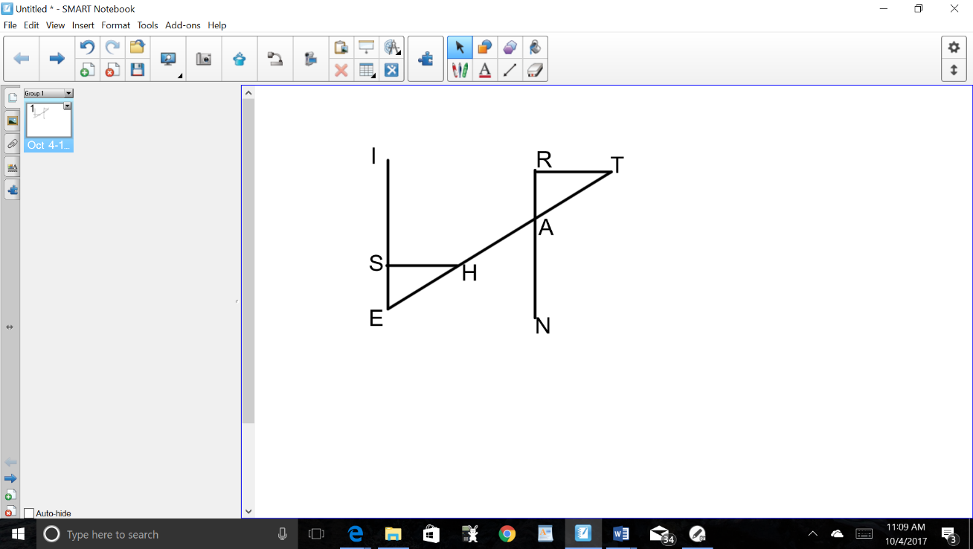

**Euclidean Similar Triangle Proofs**

**To prove triangles are SIMILAR, prove AA  AA**

**If asked to prove a proportion/multiplication:**

1. **Prove triangles are similar**
2. **Corresponding Sides of Similar Triangle are In Proportion (CSSTIP)**
3. **Cross Products are Equal**

**Work Backwards!**

1. Given 

Prove: 

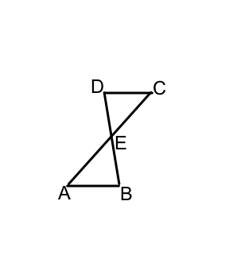

2. Given: 



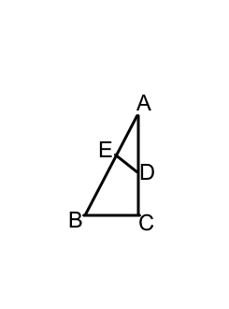 Prove: 

3. Given: 

 Prove: 

4. Given: , 

 Prove: 

1. Given: bisects , 

Prove: 

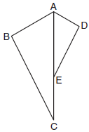

1. Given: ,, 

Prove: 

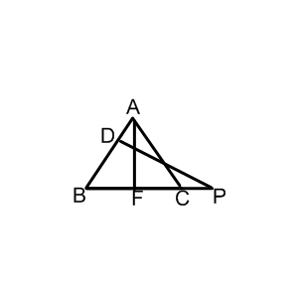

1. In  shown below, points *T* and *O* are

on  and , respectively. Segment *OT* is drawn

so that .

Prove: 

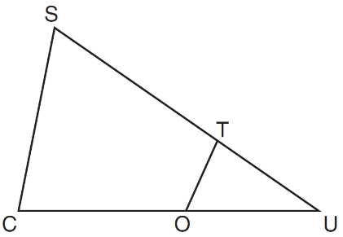

**Euclidean Proofs with Parallelogram and Circle Theorems**

|  |  |
| --- | --- |
| **Parallelogram Theorems** | **Circle Theorems** |
| **A parallelogram/rectangle/rhombus/square has:**  Two pairs of opposite sides congruent  Two pairs of opposite sides parallel  Diagonals that bisect each other  Opposite angles congruent | **All radii/diameters of a circle are congruent**  **Angles inscribed to the same arc are congruent**  **An angle inscribed to a semicircle is a right angle**  **A tangent and a radius/diameter form a right angles**  Congruent arcs have congruent chords have congruent central angles  Parallel Lines intercept congruent arcs  Tangents drawn from the same point are congruent |
| **A rectangle/square has:**  A right angle  Congruent diagonals |
| **A rhombus/square has:**  All sides congruent  Perpendicular diagonals  Diagonals that bisect the angles |

1. Given: ABCD is a parallelogram

Prove: 



2. Given: ABCD is a rectangle, M is the midpoint of 

Prove: 



3. Given: ABCD is a rhombus, 

Prove: 

4. Given: SPIN is a square

Prove: 



5. Given: ABCD is a square, 

Prove: 

6. Given: Parallelogram *ABCD*, , and diagonal 

Prove: 

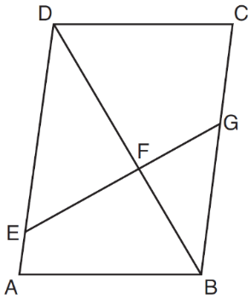

7. In parallelogram *ABCD*, and  are perpendicular

to diagonal  at points *F* and *E*.

Prove: 

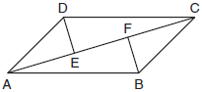

8. Given: Chords and  of circle O intersect at E, 

Prove: 



9. Given: Circle O with diameters  and .

Prove: 



10. In circle Y, tangent is drawn to diameter 

and . Prove that .

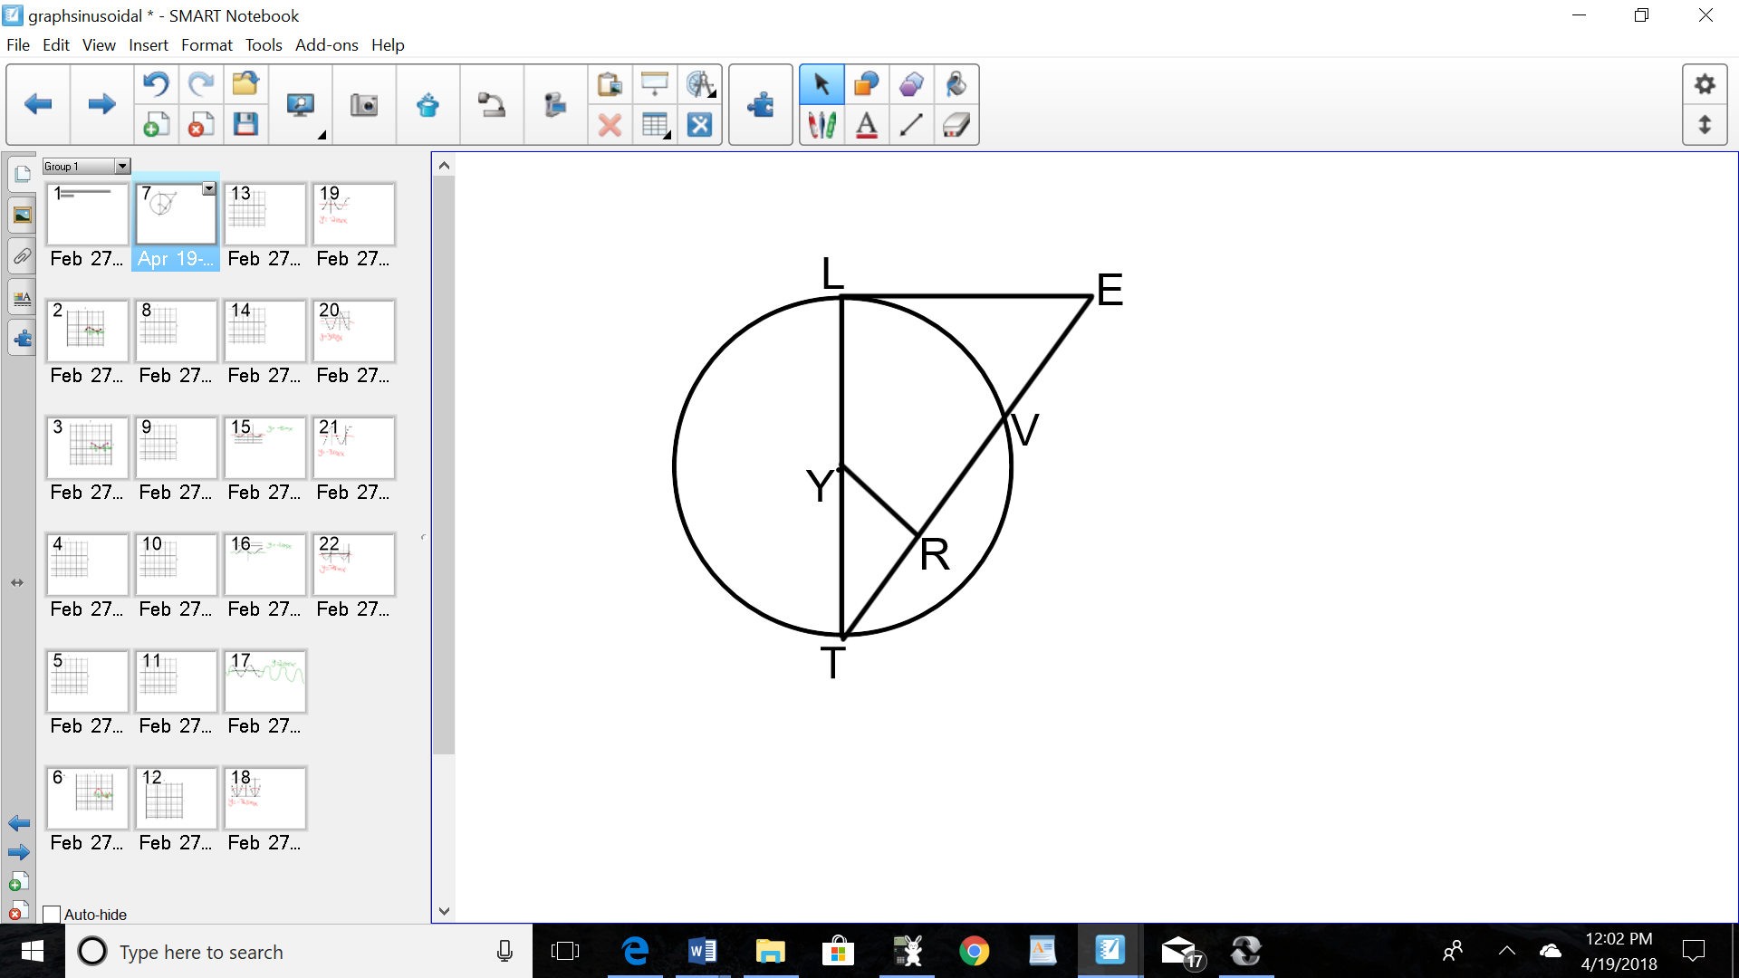

11. In the diagram below, secant  and tangent  are drawn from external point *A* to circle *O*.

Prove the theorem: If a secant and a tangent are drawn to a circle from an external point, the product of the lengths of the secant segment and its external segment equals the length of the tangent segment squared. 

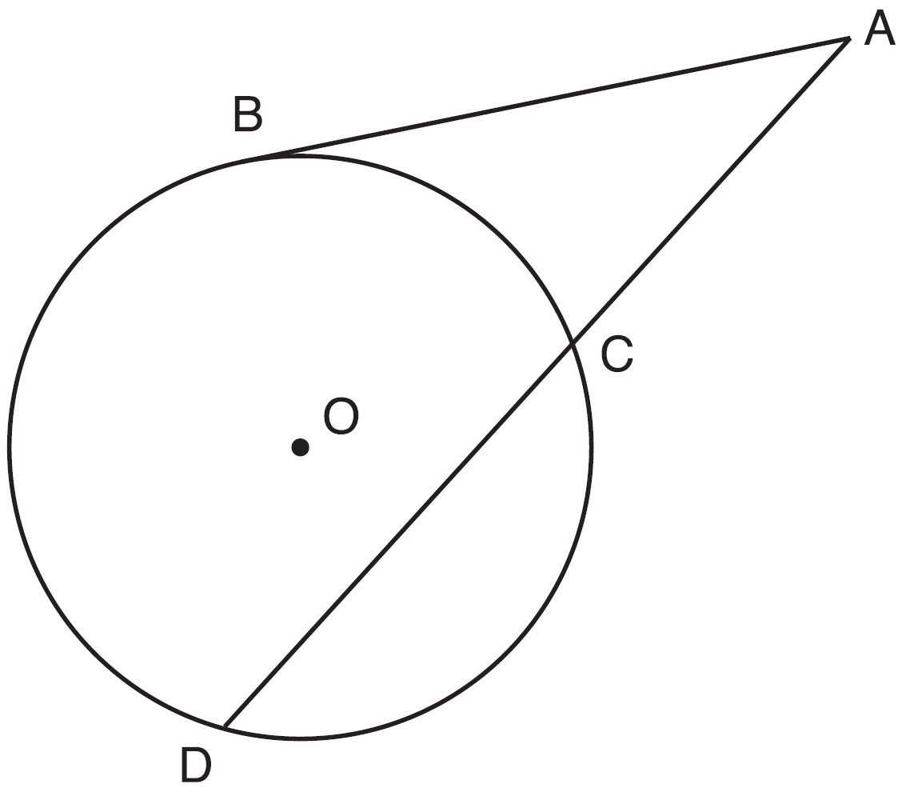

12. Given: Circle *O*, chords  and  intersect at *E*

Theorem: If two chords intersect in a circle, the product of the lengths of the segments of one chord is equal to the product of the lengths of the segments of the other chord. Prove this theorem by proving .

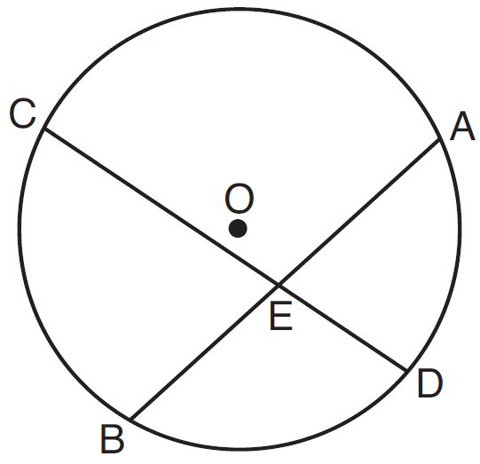

**Euclidean Triangle Proofs with Additional Tools**

**Vertical Angles** are congruent (Look for an X)

**Reflexive Property** (A side/angle is congruent to itself)

**Isosceles Triangles** (In a triangle, congruent angles are opposite congruent sides)

**Addition and Subtraction Property** (If you need more or less of a shared side)

*You must use three congruent statements to get one congruent statement for the triangles. The two that you are adding/subtracting and the one that you want to prove in the triangle.

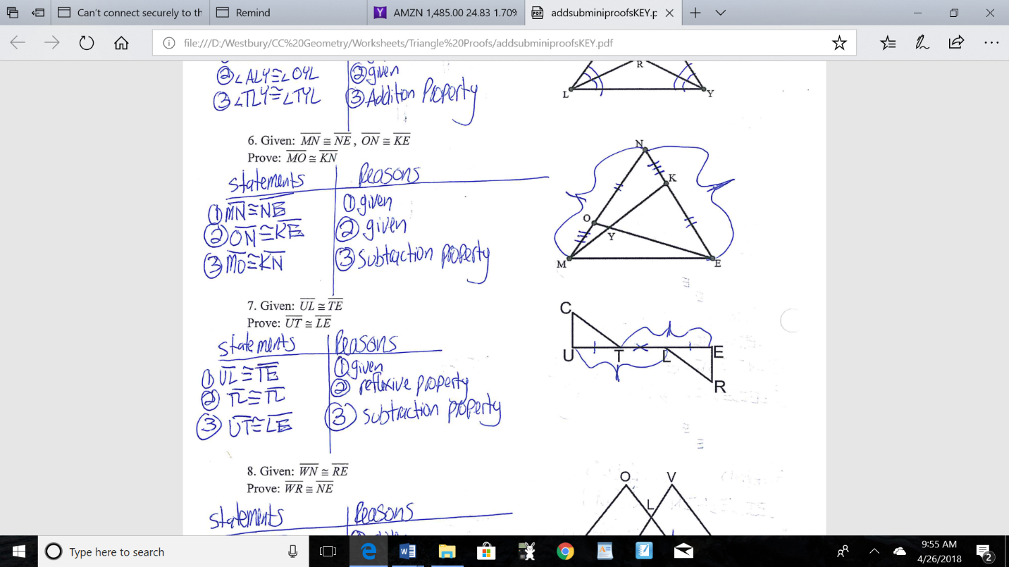

1. Given: 





Prove: QU



2. Given: 

Prove: 

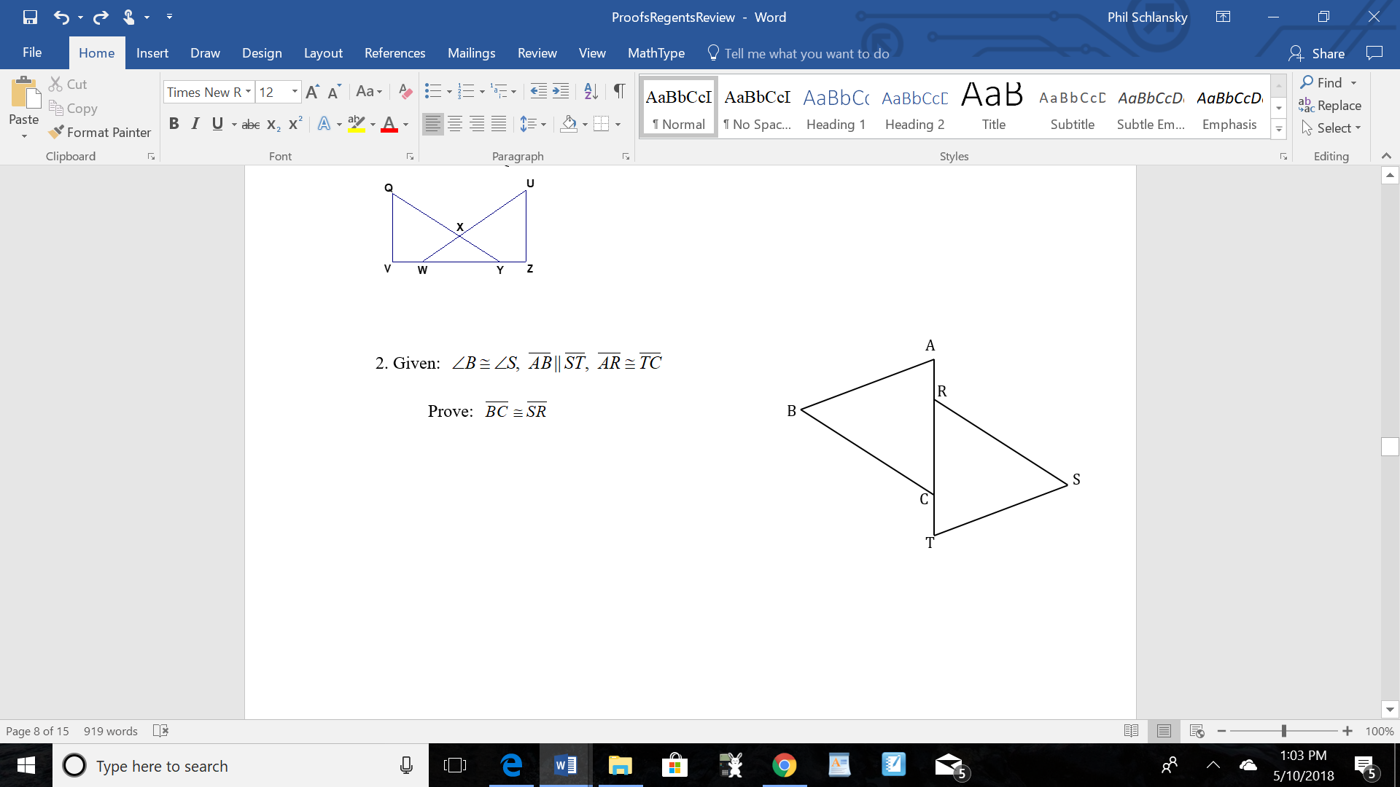

3.Given: is the perpendicular bisector of 

Prove:  is isosceles

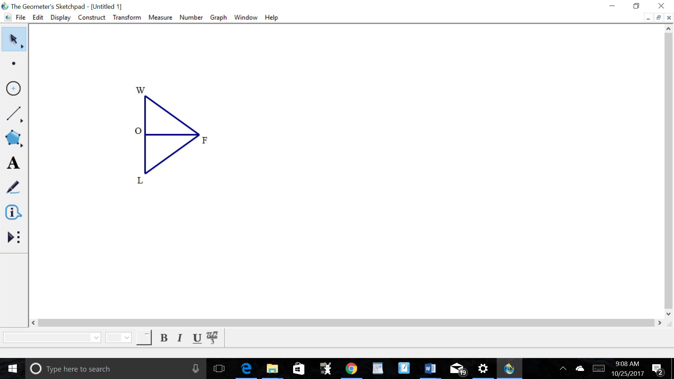

4. Given: In , , , ,

and 

Prove: 

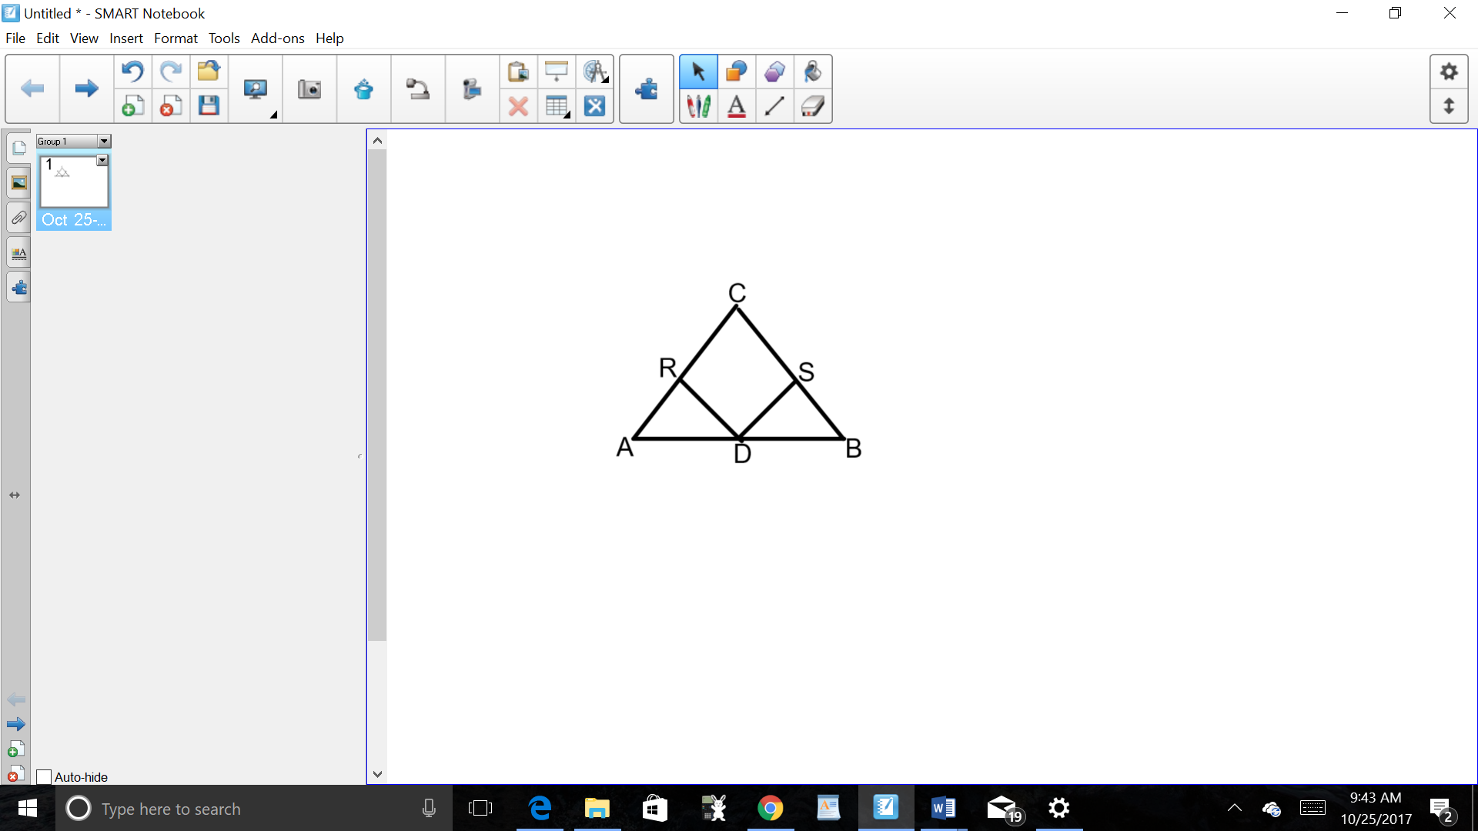

5. Given: , , ,

Prove: 

6. Isosceles trapezoid *ABCD* has bases ** and  with nonparallel legs  and . Segments *AE*, *BE*, *CE*, and *DE* are drawn in trapezoid *ABCD* such that , , and .

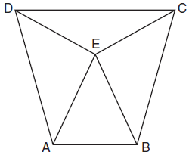Prove  and prove  is an isosceles triangle.

**Euclidean Parallelogram Proofs/Parallelogram Properties**

**To prove parallelograms: Always prove parallelogram first. You will probably have to use congruent triangles with CPCTC to get at least one of the properties.**

**A parallelogram has:**

Two pairs of opposite sides congruent OR Two pairs of opposite sides parallel OR One pair of opposite sides congruent and parallel OR Diagonals that bisect each other OR Opposite angles congruent

**A rectangle is a parallelogram with:**

A right angle OR Congruent diagonals

**A rhombus is a parallelogram with:**

Consecutive sides congruent

**A square is a parallelogram with:**

Consecutive sides congruent AND

A right angle OR Congruent diagonals

**A trapezoid has one pair of opposite sides parallel and one pair of opposite sides not parallel**

**An isosceles trapezoid is a trapezoid with congruent legs**

**For properties questions, draw the shape!**

1. Which of the following is not true of all rectangles?
   1. Consecutive sides are perpendicular
   2. Opposite sides are parallel
   3. Diagonals are perpendicular to each other
   4. Diagonals bisect each other
2. Which of the following is true about rhombuses?
   1. Consecutive sides are perpendicular
   2. Opposite sides are congruent
   3. Consecutive angles are congruent
   4. Diagonals are congruent
3. Which of the following is *not* true about all parallelograms?
4. Diagonals bisect each other
5. Diagonals are perpendicular to each other
6. Opposite angles are congruent
7. Consecutive angles are supplementary

4. A quadrilateral whose diagonals bisect each other and are perpendicular is a

|  |  |  |  |
| --- | --- | --- | --- |
| 1) | rhombus | 3) | trapezoid |
| 2) | rectangle | 4) | parallelogram |

5. If the diagonals of a quadrilateral do *not* bisect each other, then the quadrilateral could be a

|  |  |
| --- | --- |
| 1) | rectangle |
| 2) | rhombus |
| 3) | square |
| 4) | trapezoid |

6. Which statement is true about every parallelogram?

|  |  |
| --- | --- |
| 1) | All four sides are congruent. |
| 2) | The interior angles are all congruent. |
| 3) | Two pairs of opposite sides are congruent. |
| 4) | The diagonals are perpendicular to each other. |

7. Which quadrilateral has diagonals that always bisect its angles and also bisect each other?

|  |  |
| --- | --- |
| 1) | rhombus |
| 2) | rectangle |
| 3) | parallelogram |
| 4) | isosceles trapezoid |

8. The diagonals of a quadrilateral are congruent but do not bisect each other. This quadrilateral is

|  |  |
| --- | --- |
| 1) | an isosceles trapezoid |
| 2) | a parallelogram |
| 3) | a rectangle |
| 4) | a rhombus |

9. Given three distinct quadrilaterals, a square, a rectangle, and a rhombus, which quadrilaterals must have perpendicular diagonals?

|  |  |
| --- | --- |
| 1) | the rhombus, only |
| 2) | the rectangle and the square |
| 3) | the rhombus and the square |
| 4) | the rectangle, the rhombus, and the square |

10. A parallelogram must be a rhombus when its

|  |  |
| --- | --- |
| 1) | Diagonals are congruent. |
| 2) | Opposite sides are parallel. |
| 3) | Diagonals are perpendicular. |
| 4) | Opposite angles are congruent. |

11. A parallelogram must be a rectangle when its

|  |  |
| --- | --- |
| 1) | diagonals are perpendicular |
| 2) | diagonals are congruent |
| 3) | opposite sides are parallel |
| 4) | opposite sides are congruent |

12. A rectangle must be a square when its

1. consecutive sides are perpendicular
2. diagonals are congruent
3. diagonals are perpendicular to each other
4. opposite sides are parallel

13. A rhombus must be a square when its

1. consecutive sides are congruent
2. diagonals are congruent
3. opposite angles are congruent
4. diagonals are perpendicular to each other

14. A parallelogram must be a rectangle when its

1. consecutive sides are congruent
2. opposite angles are congruent
3. consecutive sides are perpendicular
4. opposite sides are parallel

15. Which of the following properties does not make a parallelogram a rhombus?

1. diagonals bisect the angles
2. diagonals are perpendicular to each other
3. opposite angles are congruent
4. consecutive sides are congruent

16. Which of the following properties does not make a rhombus a square?

1. Diagonals are congruent
2. Diagonals are perpendicular to each other
3. Consecutive sides are perpendicular
4. Consecutive angles are congruent

17. Which property is true of all rhombuses but not of all rectangles?

1) opposite sides are parallel

2) diagonals are perpendicular to each other

3) diagonals bisect each other

4) opposite angles are congruent

18. Which set of statements would describe a parallelogram that can always be classified as a rhombus?

I. Diagonals are perpendicular bisectors of each other.

II. Diagonals bisect the angles from which they are drawn.

III. Diagonals form four congruent isosceles right triangles.

|  |  |  |  |
| --- | --- | --- | --- |
| 1) | I and II | 3) | II and III |
| 2) | I and III | 4) | I, II, and III |

19. If *ABCD* is a parallelogram, which statement would prove that *ABCD* is a rhombus?

|  |  |  |  |
| --- | --- | --- | --- |
| 1) |  | 3) |  |
| 2) |  | 4) |  |

20. In parallelogram *ABCD*, diagonals  and  intersect at *E*. Which statement does *not* prove parallelogram *ABCD* is a rhombus?

|  |  |
| --- | --- |
| 1) |  |
| 2) |  |
| 3) |  |
| 4) | bisects |

21. In the diagram below, parallelogram *ABCD* has diagonals  and  that intersect at point *E*.

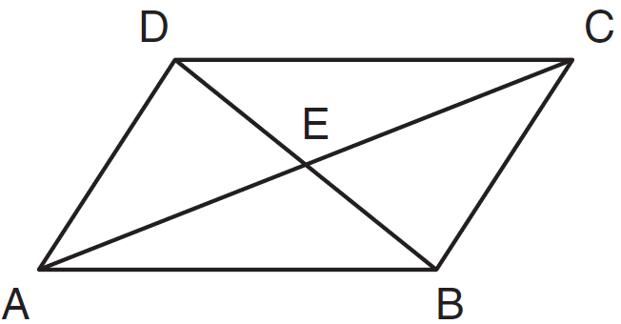

Which expression is *not* always true?

|  |  |
| --- | --- |
| 1) |  |
| 2) |  |
| 3) |  |
| 4) |  |

22.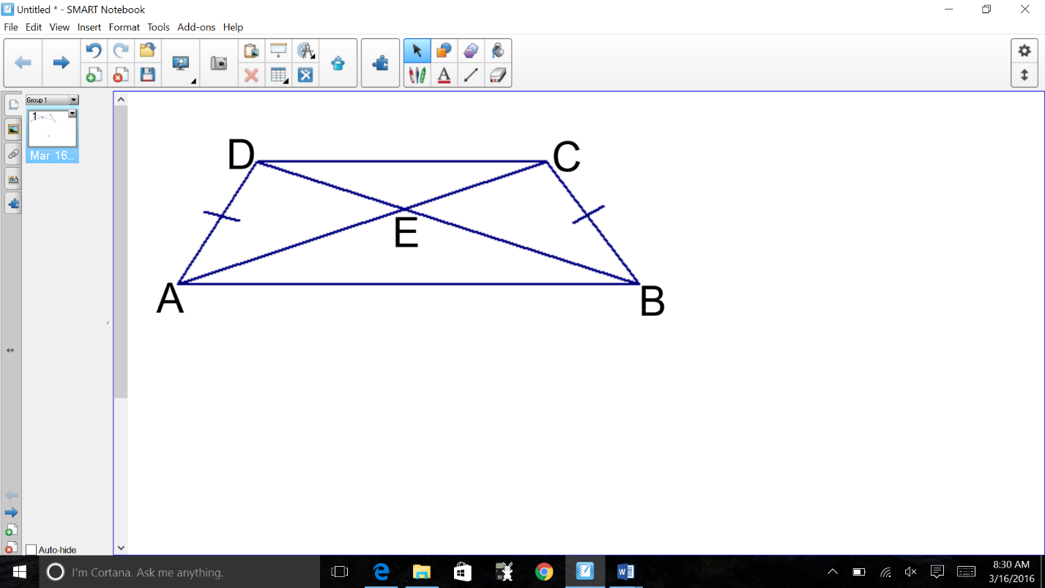 In the diagram below, isosceles trapezoid ABCD has diagonals  and  that intersect at point *E*.

Which expression is *not* always true?

1. 
2. 
3. 
4. 
5. Quadrilateral *ABCD* with diagonals  and  is shown in the diagram below.

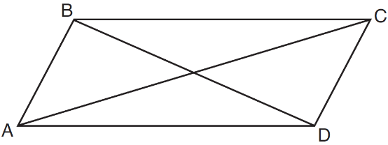Which information is *not* enough to prove *ABCD* is a parallelogram?

|  |  |
| --- | --- |
| 1) | and |
| 2) | and |
| 3) | and |
| 4) | and |

25. Quadrilateral *ABCD* has diagonals  and . Which information is *not* sufficient to prove *ABCD* is a parallelogram?

|  |  |
| --- | --- |
| 1) | and  bisect each other. |
| 2) | and |
| 3) | and |
| 4) | and |

26. Given: , 

Prove: SABR is a parallelogram

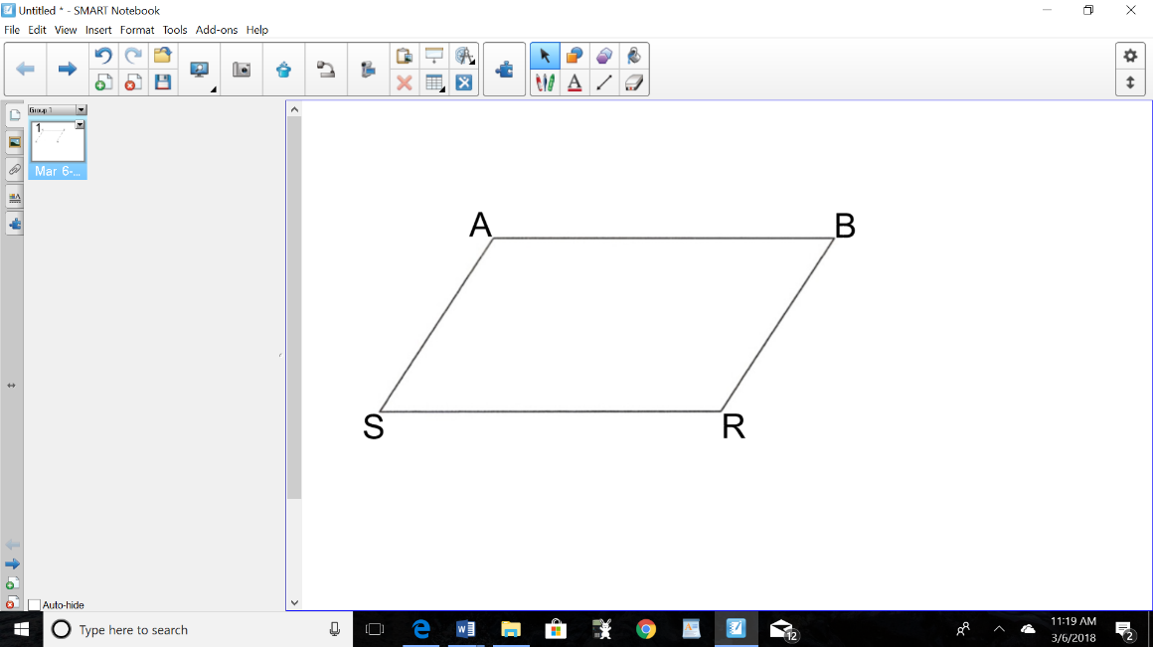

27. Given: , 

Prove: NRQW is a parallelogram

28. Given: E is the midpoint of , 

Prove: SABR is a parallelogram



29. Given: 

Prove: SABR is a parallelogram

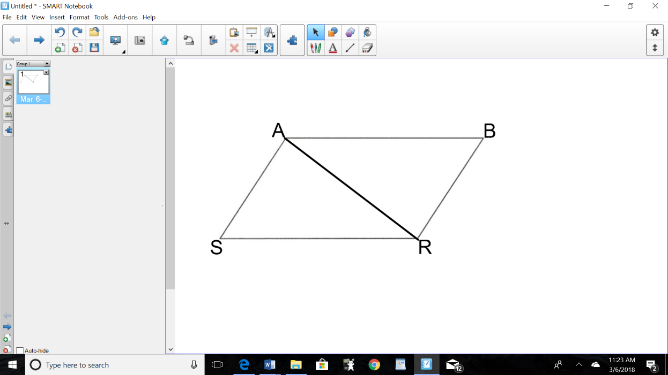

30. Given: Quadrilateral *ABCD*, diagonal , , , , 

Prove: *ABCD* is a parallelogram.

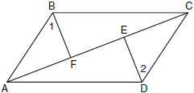

31. Given: WXRK is a parallelogram,

Prove: WXRK is a rectangle

32. Given: BDEG is a parallelogram, bisects CBA

Prove: DEGB is a rhombus

33. Given: MILO is a parallelogram, , 

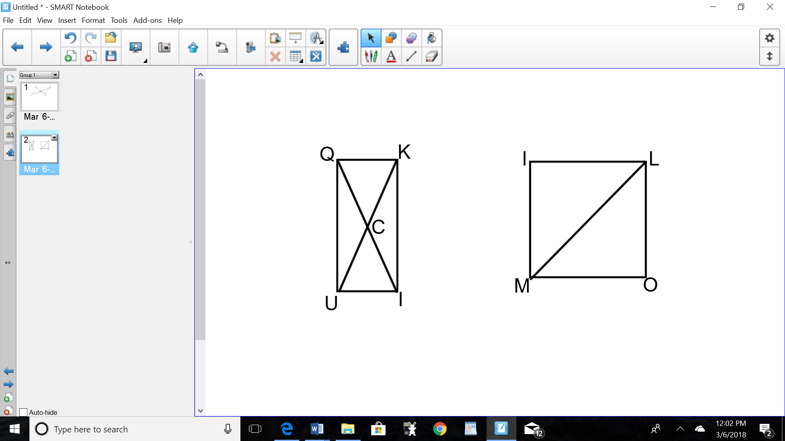Prove: MILO is a square

34. Given: QUIK is a parallelogram, 

Prove: QUIK is a rectangle

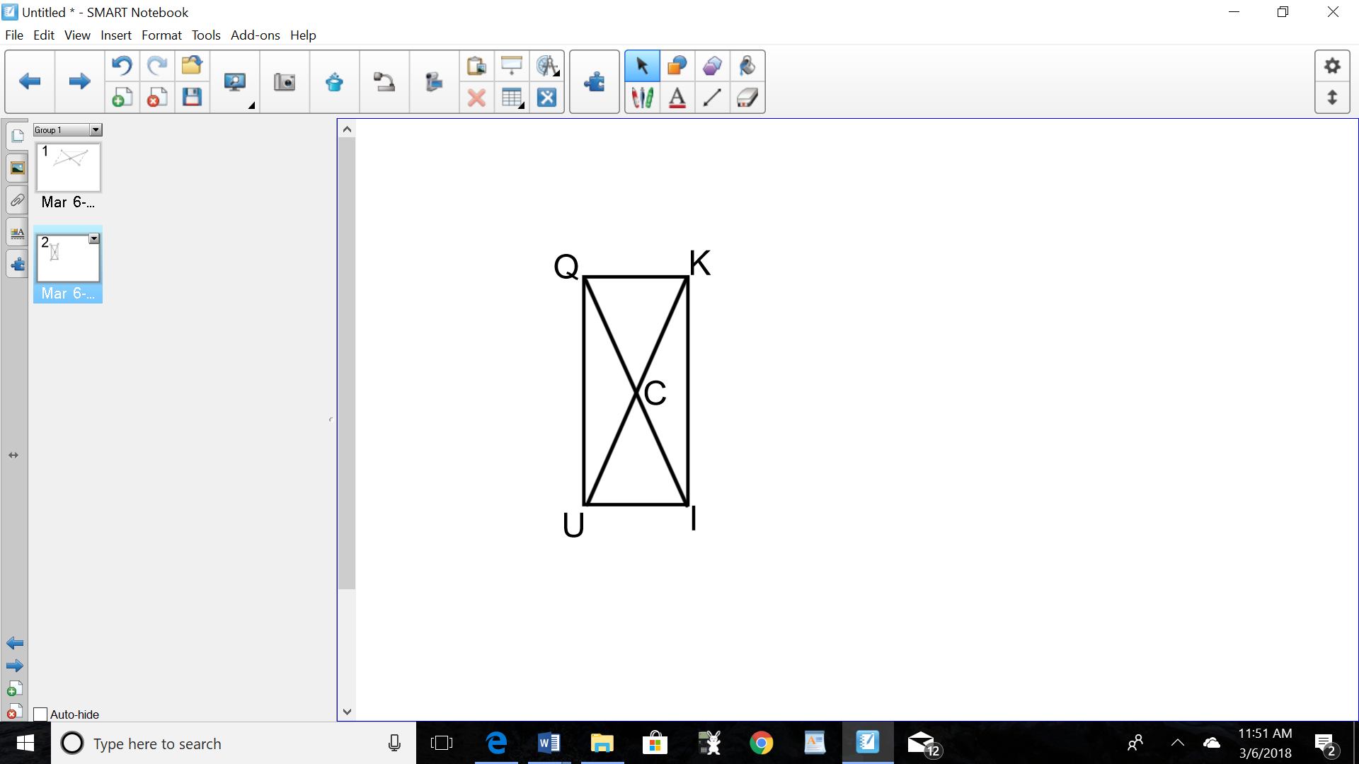

35. In the diagram of parallelogram *ABCD* below, , , .

Prove *ABCD* is a rhombus.

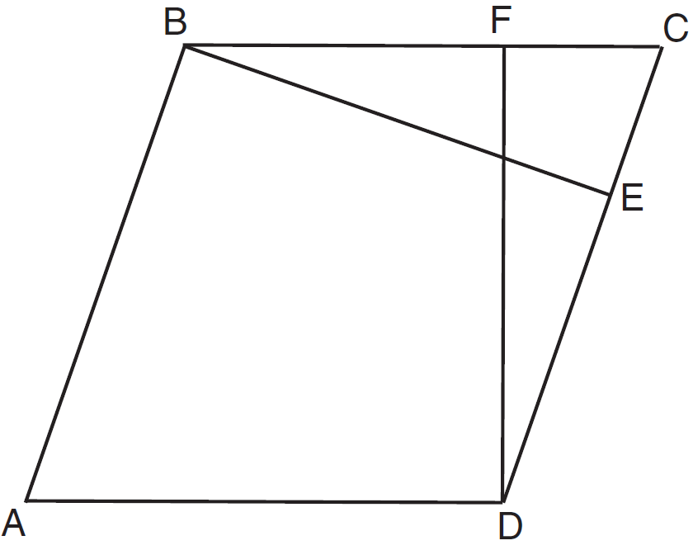

**Coordinate Geometry Proofs**

**Distance (Length) =  = **

**Slope = = **

**Midpoint** = 

***How do you prove…?***

…an **isosceles triangle**? (2 Distances)

Two Congruent Sides

. … a **right triangle**? (3 Distances)

Show the sides fit into Pythagorean Theorem

… a **parallelogram**? (4 Distances)

Two Pairs of Opposite Sides Congruent

… a **rhombus**? (4 Distances)

All Sides Congruent

… a **rectangle**? (6 Distances)

1) Two Pairs of Opposite Sides Congruent

2) Diagonals Congruent

… a **square**? (6 Distances)

1) All Sides Congruent

2) Diagonals Congruent

…a **trapezoid**? (4 Slopes)

1) 1 pair of opposite sides parallel

2) 1 pair of opposite sides not parallel

…an **isosceles trapezoid**? (4 Slopes, 2 Distances)

1) 1 pair of opposite sides parallel

2) 1 pair of opposite sides not parallel

3) Congruent Legs

1. Graph the quadrilateral MATH: M(-2, -3) A(-1, -1) T(4, 2) H(3, 0). Prove that MATH **IS** a parallelogram but is **NOT** a rectangle.

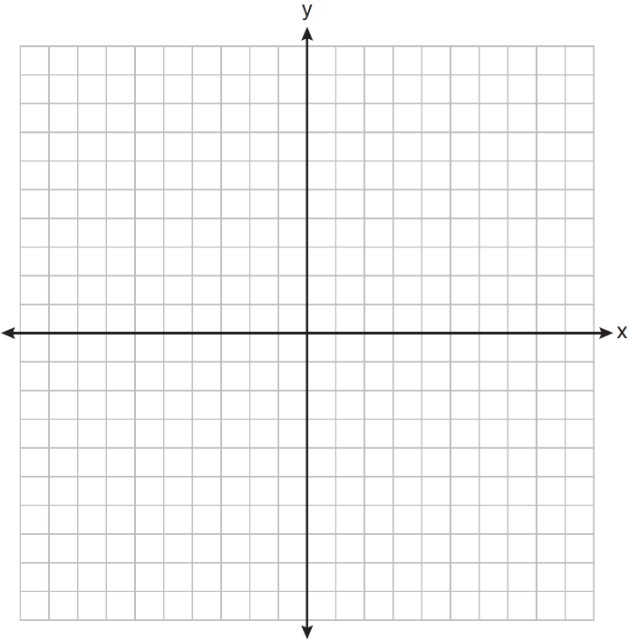

2. Quadrilateral *PQRS* has vertices , , , and . Prove that *PQRS* is a rhombus. Prove that *PQRS* is *not* a square. [The use of the set of axes below is optional.]

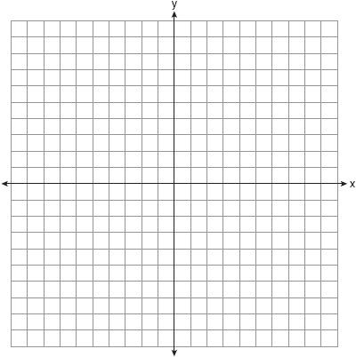

3. In the coordinate plane, the vertices of  are , , and . Prove that  is a right triangle. State the coordinates of point *P* such that quadrilateral *RSTP* is a rectangle. Prove that your quadrilateral *RSTP* is a rectangle. [The use of the set of axes below is optional.]

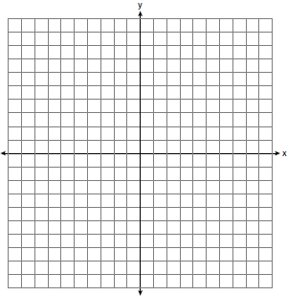

4. In the coordinate plane, the vertices of triangle *PAT* are , , and . Prove that  is an isosceles triangle. [The use of the set of axes below is optional.] State the coordinates of *R* so that quadrilateral *PART* is a parallelogram. Prove that quadrilateral *PART* is a parallelogram.



5. Given: with vertices , , and .  has midpoint *D*,  has midpoint *E*, and  has midpoint *F.*

Prove: *ADEF* is a parallelogram

*ADEF* is *not* a rhombus

[The use of the grid is optional.]



6. The vertices of rectangle NRQW are N(-2,5), R(2,5), Q(2,-3), and W(-2,-3). If A is the midpoint , B is the midpoint of , C is the midpoint of , and D is the midpoint of , prove that ABCD is a rhombus.



7. In the coordinate plane, the vertices of triangle ABC are A(0,10) B(5,0) and C(8,4). Prove that Triangle ABC is a right triangle. State the coordinates of point *P* such that quadrilateral *ABCP* is a rectangle. Prove that your quadrilateral *ABCP* is a rectangle.



8. Quadrilateral ABCD has vertices A(3,1) B(-3,5) C(5,4) and D(2,6). Prove quadrilateral ABCD is a trapezoid but *not* an isosceles trapezoid.



9. Quadrilateral JACQ has vertices J(2,-4), A(8,0), C(10,-3), and Q(4,-7). Prove that quadrilateral JACQ is a rectangle but not a square.

