Name _______________ Date _____________

Mr. Schlansky Geometry

***Transformations Regents Review***

1. The coordinates of trapezoid *ABCD* are , , , and . Trapezoid  is the image after a reflection over the line . State the coordinates of trapezoid .

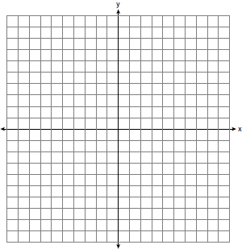

2. The coordinates of the vertices of quadrilateral METZ are M(-4,1), E(0,5), T(2,3), and Z(4,-4). Graph and state the coordinates of quadrilateral M’E’T’Z’, the image of quadrilateral METZ after a reflection in the line .



3. The coordinates of trapezoid *ABCD* are , , , and . Trapezoid  is the image after a reflection in the line  followed by a reflection in the x axis. State the coordinates of trapezoid .

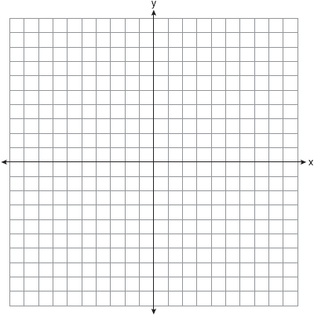

4. Triangle MKY has vertices M(6,-4), K(-4,-2), and Y(-2,6)

Graph the image of triangle MKY after a dilation of followed by a rotation of 90 and label it M’K’Y’.



5. The vertices of  have coordinates , , and ). Under which transformation is the image  *not* congruent to ?

|  |  |
| --- | --- |
| 1) | a translation of two units to the right and two units down |
| 2) | a counterclockwise rotation of 180 degrees around the origin |
| 3) | a reflection over the *x*-axis |
| 4) | a dilation with a scale factor of 2 and centered at the origin |

6. If  is the image of , under which transformation will the triangles *not* be congruent?

|  |  |
| --- | --- |
| 1) | reflection over the *x*-axis |
| 2) | translation to the left 5 and down 4 |
| 3) | dilation centered at the origin with scale factor 2 |
| 4) | rotation of 270° counterclockwise about the origin |

7. A triangle is dilated by a scale factor of 3 with the center of dilation at the origin. Which statement is true?

|  |  |
| --- | --- |
| 1) | The area of the image is nine times the· area of the original triangle. |
| 2) | The perimeter of the image is nine times the perimeter of the original triangle. |
| 3) | The slope of any side of the image is three times the slope of the corresponding side of the original triangle. |
| 4) | The measure of each angle in the image is three times the measure of the corresponding angle of the original triangle. |

8. Which transformation would result in the perimeter of a triangle being different from the perimeter of its image?

|  |  |
| --- | --- |
| 1) |  |
| 2) |  |
| 3) |  |
| 4) |  |

9. The image of rhombus *VWXY* preserves which properties under the transformation ?

|  |  |
| --- | --- |
| 1) | parallelism, only |
| 2) | orientation, only |
| 3) | both parallelism and orientation |
| 4) | neither parallelism nor orientation |

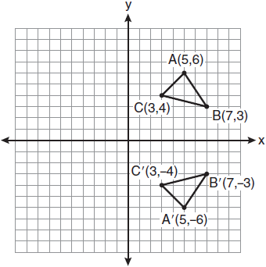

10. The rectangle *ABCD* shown in the diagram below

12. Which expression best describes the transformation shown

in the diagram below?

|  |  |  |  |
| --- | --- | --- | --- |
| 1) | same orientation; reflection |  |  |
| 2) | opposite orientation; reflection |  |  |
| 3) | same orientation; translation |
| 4) | opposite orientation; translation |

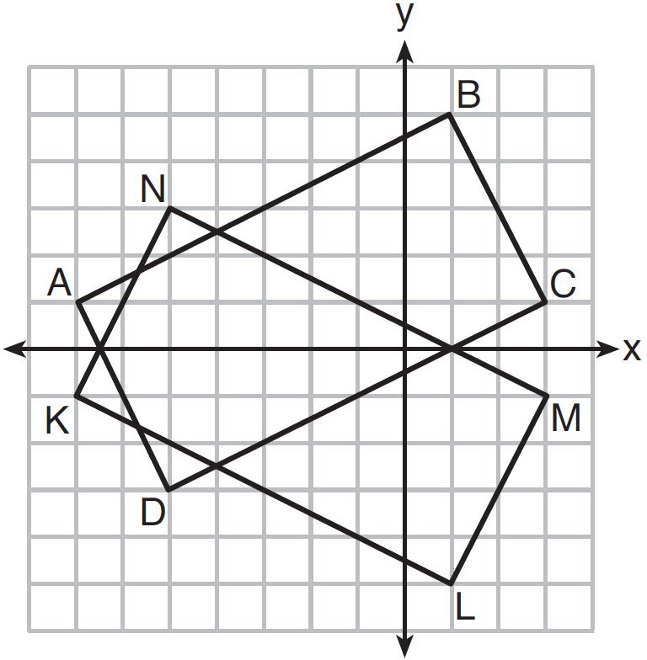 11. On the set of axes below, rectangle *ABCD* and

rectangle *KLMN* are graphed. Use the properties of

rigid motions to prove that the rectangles are congruent.

|  |  |
| --- | --- |
|  |  |
|  |  |
|  |  |
|  |  |

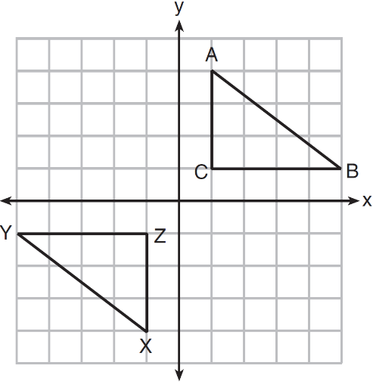 12. In the diagram below,  and  are graphed.

Use the properties of rigid motions to explain why

.

13. The diagram below shows Δ*ABC* and  Describe a sequence of rigid motions that maps Δ*ABC* onto 



D

E

F







14. Describe a sequence of rigid motions that maps Δ*DEF* onto 

Justify that 

15. As graphed on the set of axes below,  is the image of  after a sequence of transformations.

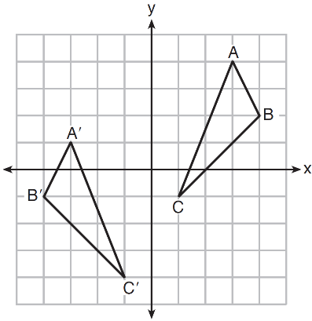Is  congruent to ? Use the properties of rigid motion to explain your answer.

16. Describe a sequence of transformations that will map  onto  as shown below.

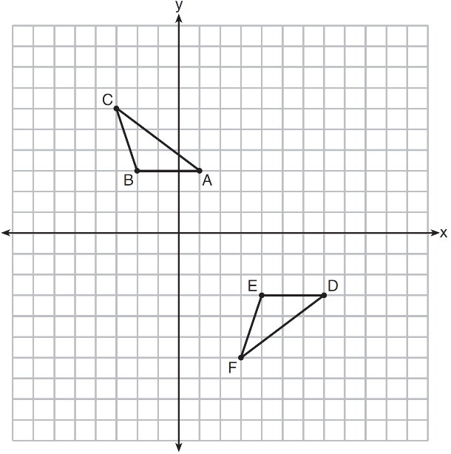

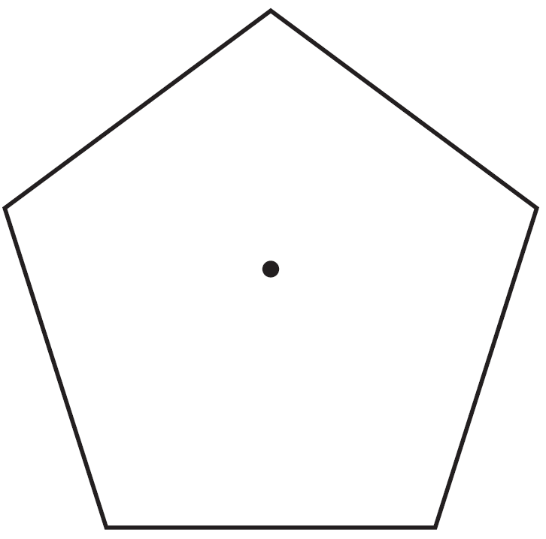 17. A regular pentagon is shown in the diagram below.

If the pentagon is rotated clockwise around its center,

the minimum number of degrees it must be rotated to

carry the pentagon onto itself is

|  |  |
| --- | --- |
| 1) | 54º |
| 2) | 72º |
| 3) | 108º |
| 4) | 360º |

18. Which of the following rotations would not map an equilateral triangle onto itself?

(1) 120º (3) 180º

(2) 240º (4) 480º

19. On the set of axes below, Geoff drew rectangle *ABCD*.

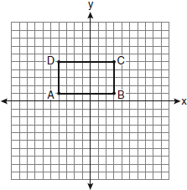

What of the following transformations would map the rectangle onto itself?

|  |  |  |  |
| --- | --- | --- | --- |
| 1) |  | 3) |  |
| 2) |  | 4) |  |

20. Circle *K* is shown in the graph below.

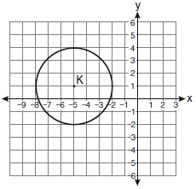

Which of the following transformations map circle K onto itself?

|  |  |  |  |
| --- | --- | --- | --- |
| 1) |  | 3) |  |
| 2) |  | 4) |  |