Name ______________ Date _____________
Mr. Schlansky Geometry

Triangles/Parallel Lines Cut By a Transversal Regents Review

1. In , , , and . Which type of triangle is ?
1) | right
2) | scalene
3) | isosceles
4) | equilateral

2. Triangle PQR has angles in the ratio of . Which type of triangle is ?
1) | acute
2) | isosceles
3) | obtuse
4) | right

3. In the diagram below, 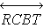 and are shown with and .

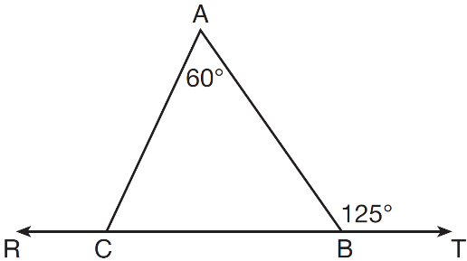

What is ?
1) | 125
2) | 115
3) | 65
4) | 55

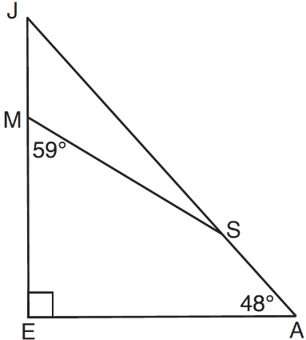
4. In the diagram of below, and . Line segment MS connects points M and S on the triangle, such that .

What is ?
1) | 163
2) | 121
3) | 42
4) | 17

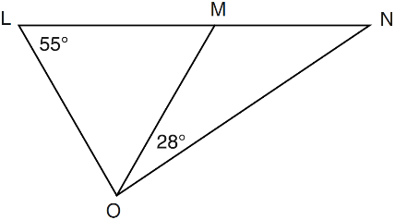
5. In the diagram below, is isosceles with .

If and , what is ?
1) | 27
2) | 28
3) | 42
4) | 70

6. In the diagram below of , H is a point on , , , and . Determine whether is an isosceles triangle and justify your answer.
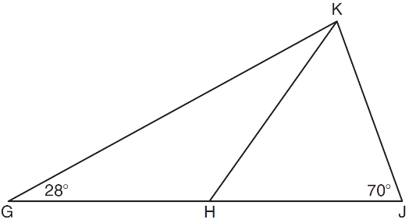

7. In the diagram below of , B is a point on such that is an equilateral triangle, and is an isosceles triangle with . Find .
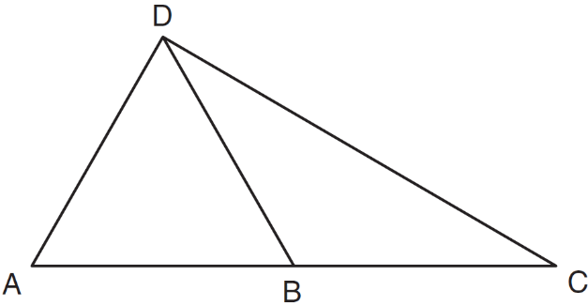

8. Fill in the boxes with "inside" or "outside" or “on”
 | Point of Concurrency | Acute | Right | Obtuse
Intersection of Altitudes

Intersection of Medians

Intersection of Perpendicular Bisectors
Intersection of Angle Bisectors

9. For a triangle, which two points of concurrence could be located outside the triangle?
1) | incenter and centroid
2) | centroid and orthocenter
3) | incenter and circumcenter
4) | circumcenter and orthocenter

10. In which triangle do the three altitudes intersect outside the triangle?
1) | a right triangle | 3) | an obtuse triangle
2) | an acute triangle | 4) | an equilateral triangle

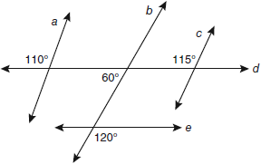
- Based on the diagram below, which statement is true?

1) |  | 3)
2) |  | 4)

- In the diagram below, lines , m, n, and p intersect line r.

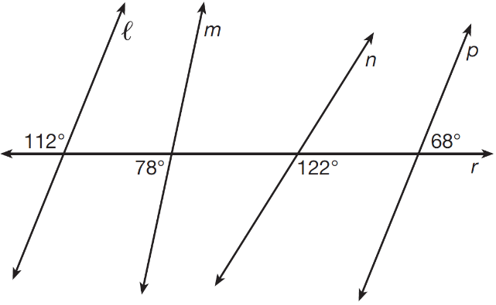

Which statement is true?
1)
2)
3)
4)

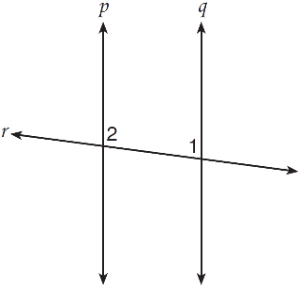
13. Lines p and q are intersected by line r, as shown below.

If and , for which value of x would ?
1) | 17
2) | 24
3) | 83
4) | 97

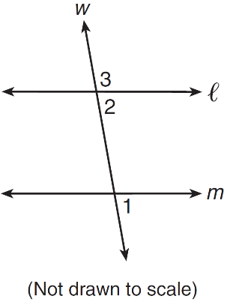
14. In the diagram below, line is parallel to line m, and
line w is a transversal.

If and , what is ?
1) | 19
2) | 23
3) | 74
4) | 86

- In the diagram below, and at R.
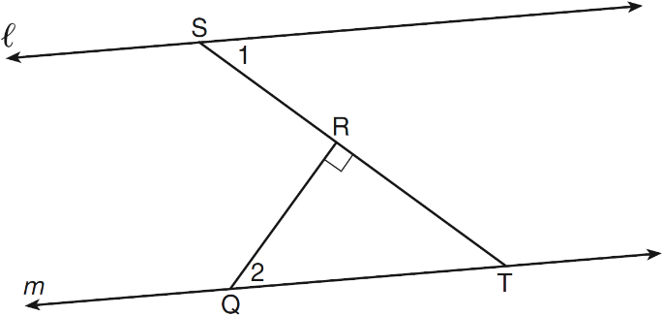

If , find . Explain how you arrived at your answer.

- In the diagram below, lines n and m are cut by transversals p and q.
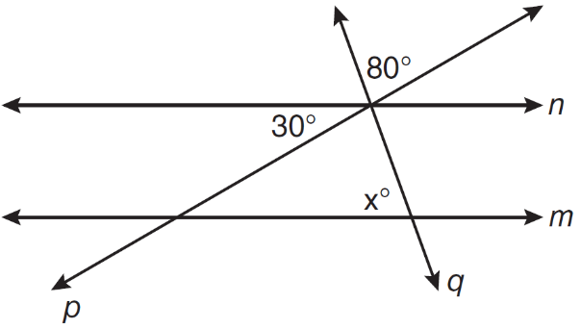

What value of x would make lines n and m parallel? Explain why that value would make the lines parallel.

