Name ___________________ Date ___________________

Mr. Schlansky Algebra II

***Factors and Zeros***

**State the zeros for the following polynomials**

1.  2. 

3.  4. 

5.  6. 

7.  8. 

**Write a possible polynomial equation in factored for if the zeros are:**

9.  10. 

11.  12. 

13.  14. 

15.  16. 

**Write a possible equation for each of the following polynomials**

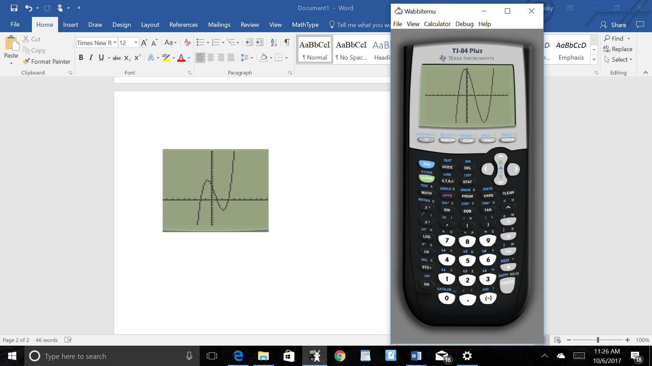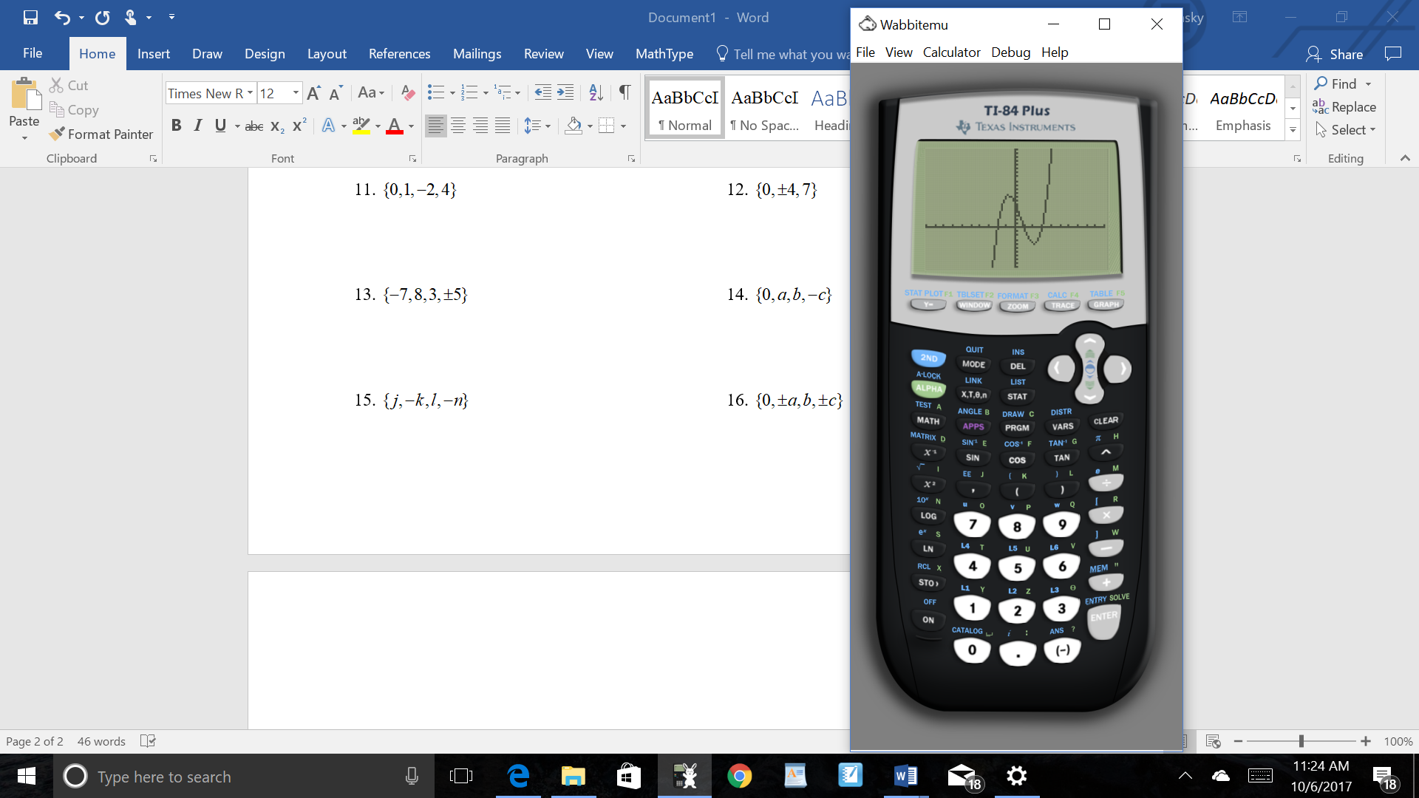17. 18.

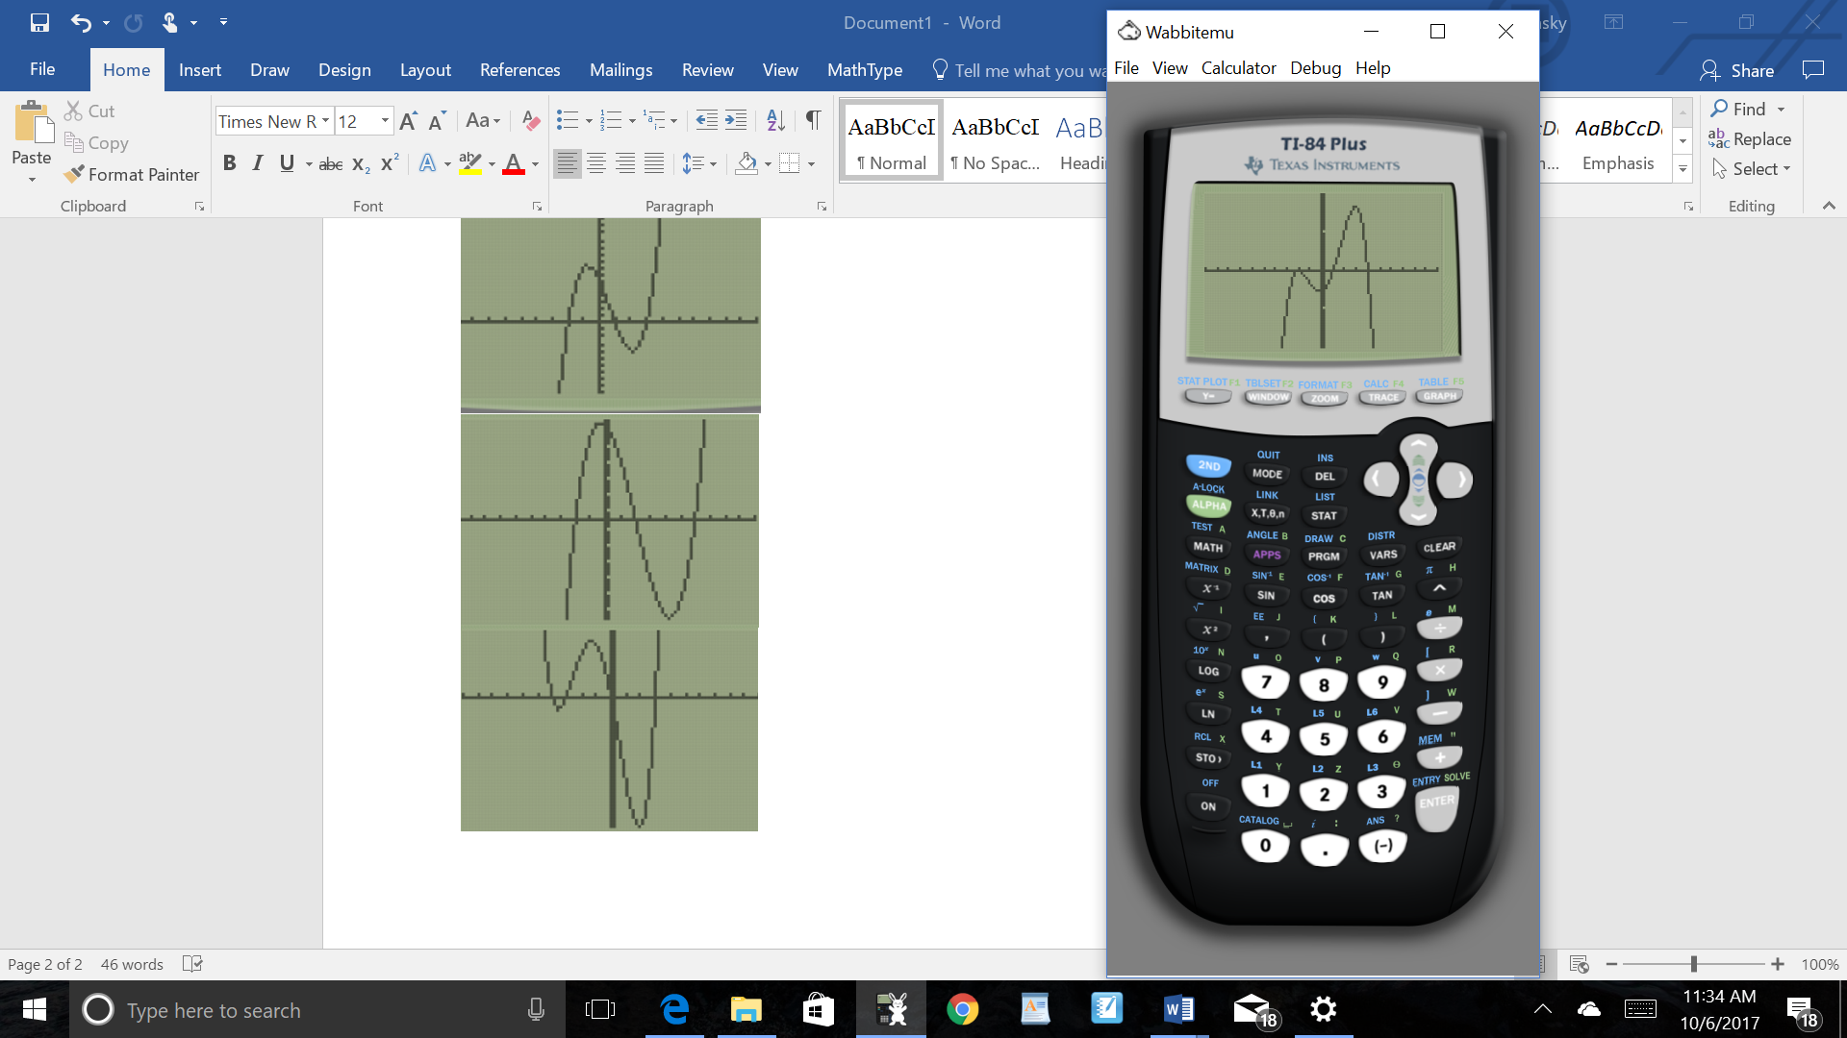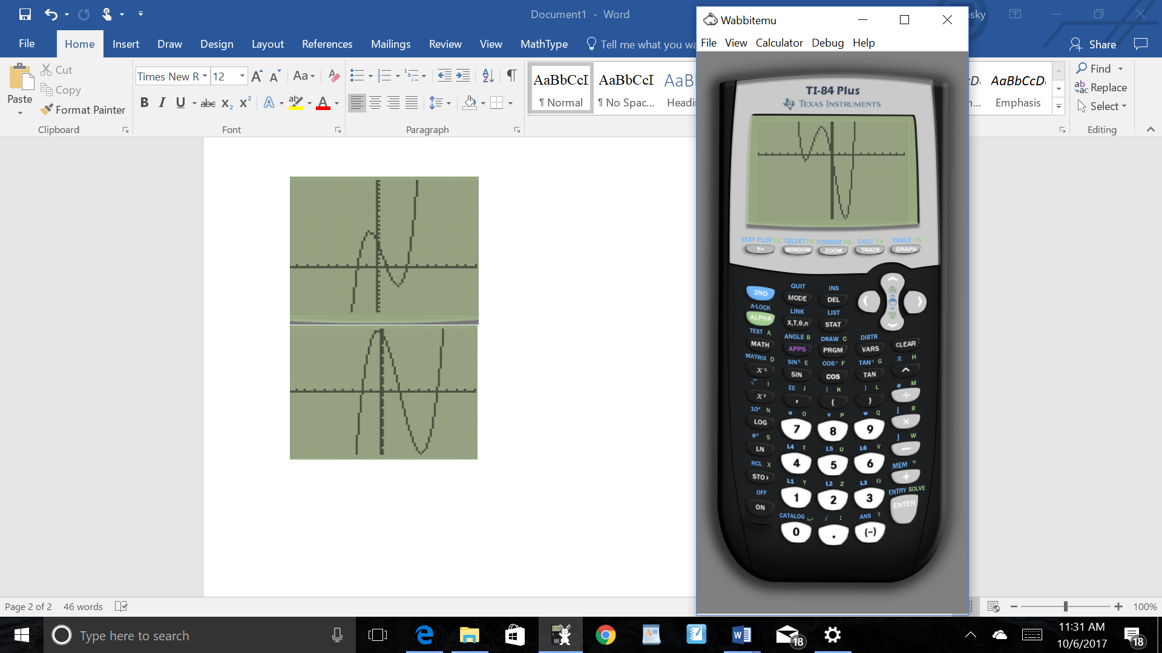19. 20.

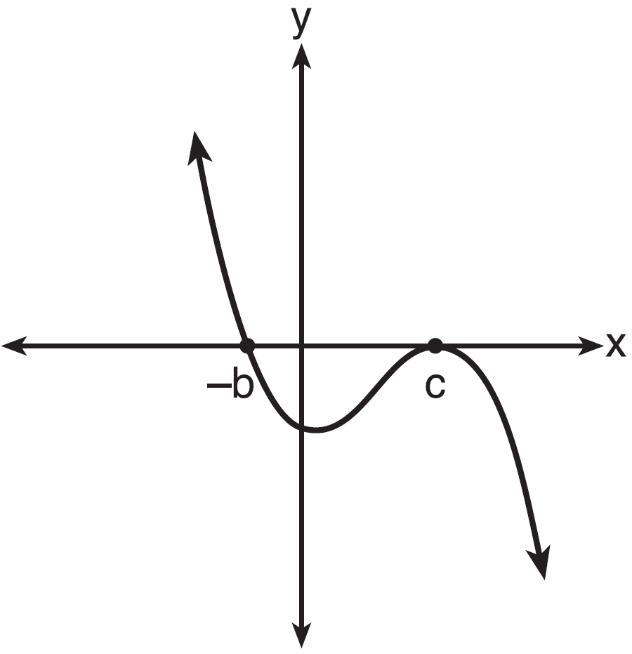

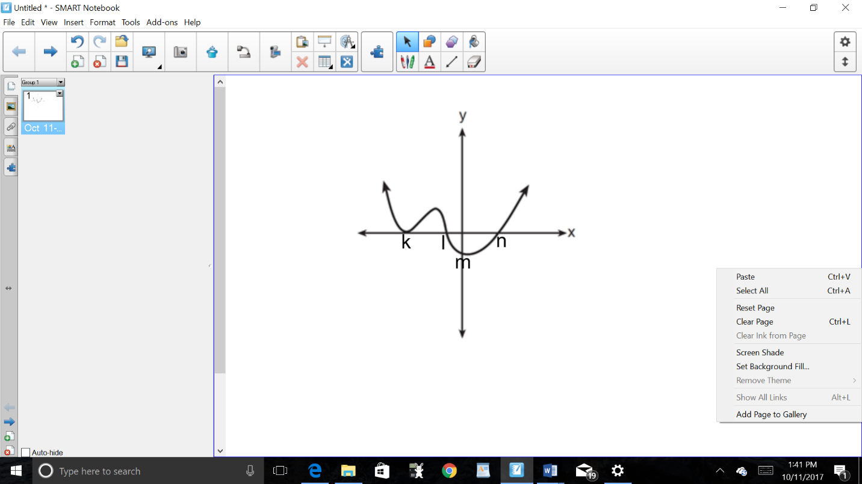21. 22.