Name ____________ Date _____________

Mr. Schlansky Geometry

***Finding Angles With Trig***

**Find the angle measure to the nearest degree**

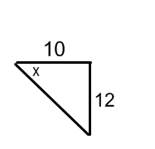

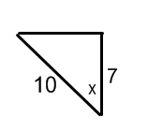1. 2.

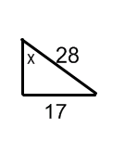

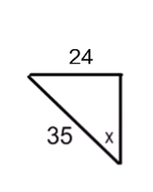3. 4.

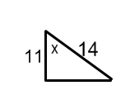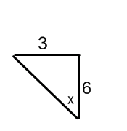

5. 6.

Name ____________ Date _____________

Mr. Schlansky Geometry

***Finding Sides With Trig***

**Find the missing side to the nearest tenth**

1. 2.







3. 4.



5. 6.

