Name _____________ Date ____________

Mr. Schlansky Algebra II

***Definition of a Parabola***

**For each of the following problems, state the coordinate of the focus and vertex, the equation of the directrix, the value of p, the equation of the parabola, and sketch the parabola.**

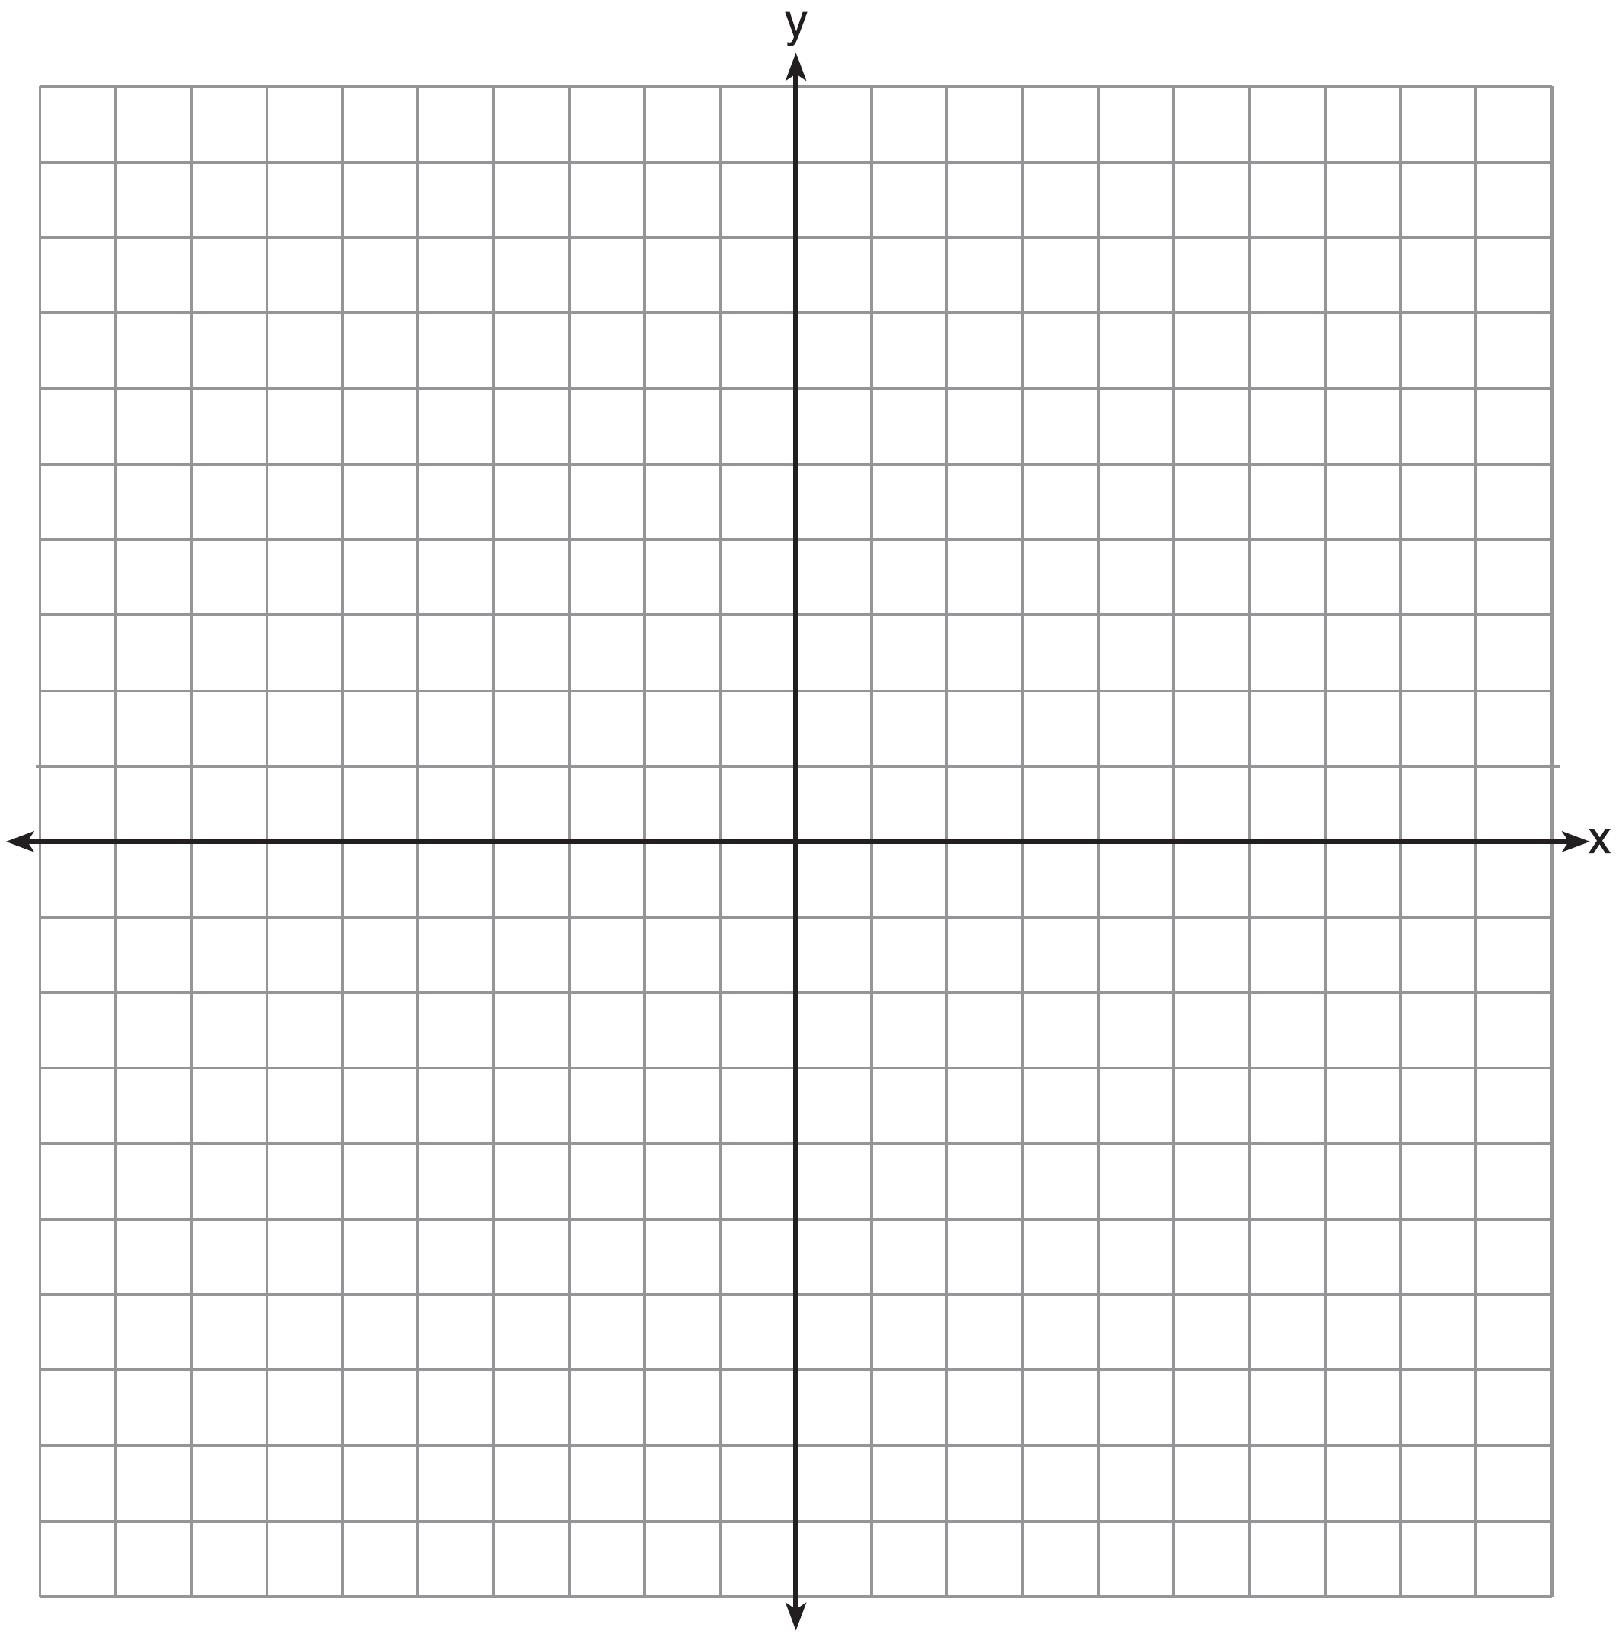

1. Focus: (0,2), Directrix: 



1. Focus: (-3,2), Directrix: 



1. Focus: (6,-4), Vertex: (6,-1)



1. Directrix: , Vertex: (2,-4)



1. Focus: (1,-3), Vertex: (1,3)
2. Focus: (-1,-2), Vertex: (-1,4)



1. Directrix: , Focus: (-4,6)



1. Directrix: , Vertex: (-2,-5)