Name _____________ Date ____________

Mr. Schlansky Algebra II

***Definition of a Parabola Regents Practice***

1. Which equation represents a parabola with a focus of  and a directrix of ?

|  |  |
| --- | --- |
| 1) |  |
| 2) |  |
| 3) |  |
| 4) |  |

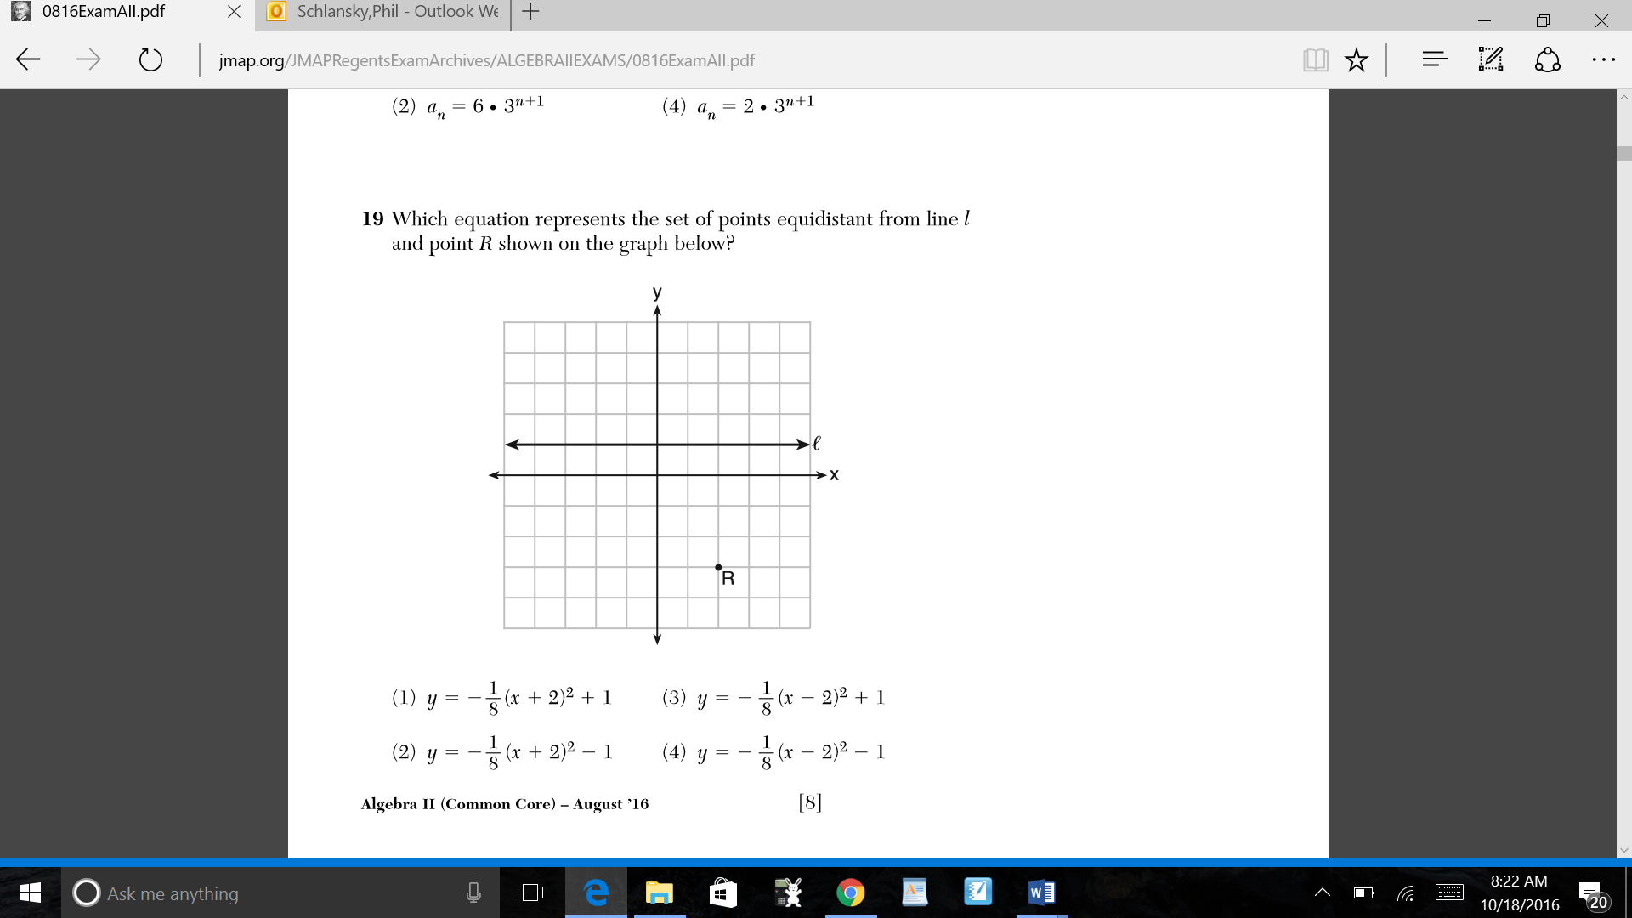2.

3. The directrix of the parabola  has the equation . Find the coordinates of the focus of the parabola.

4. Write an equation for the set of points equidistant from  and .

5. Which equation represents a parabola with the focus at  and the directrix of ?

|  |  |  |  |
| --- | --- | --- | --- |
| 1) |  | 3) |  |
| 2) |  | 4) |  |

6. A parabola has its focus at  and its directrix is . The equation of this parabola could be

|  |  |  |  |
| --- | --- | --- | --- |
| 1) |  | 3) |  |
| 2) |  | 4) |  |

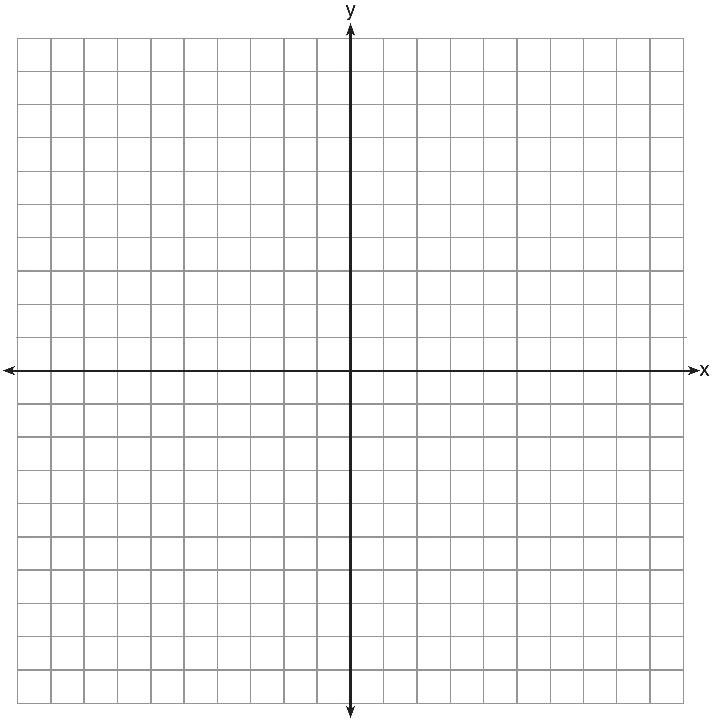

7. Write a possible equation of the parabola with the

following conditions and sketch it on the accompany

set of axes.

The distance between the focus and the directrix is 6

The parabola opens downward

The directrix is 

8. Write the equation of a parabola with a directrix of  and a vertex of (2,0) in standard form