Name ___________________ Date ___________________

Mr. Schlansky Algebra II

***Sketching Polynomial Functions***

1.  2. 

Degree: Degree:

y-intercept: y-intercept:

x-intercepts (zeros): x-intercepts (zeros):

[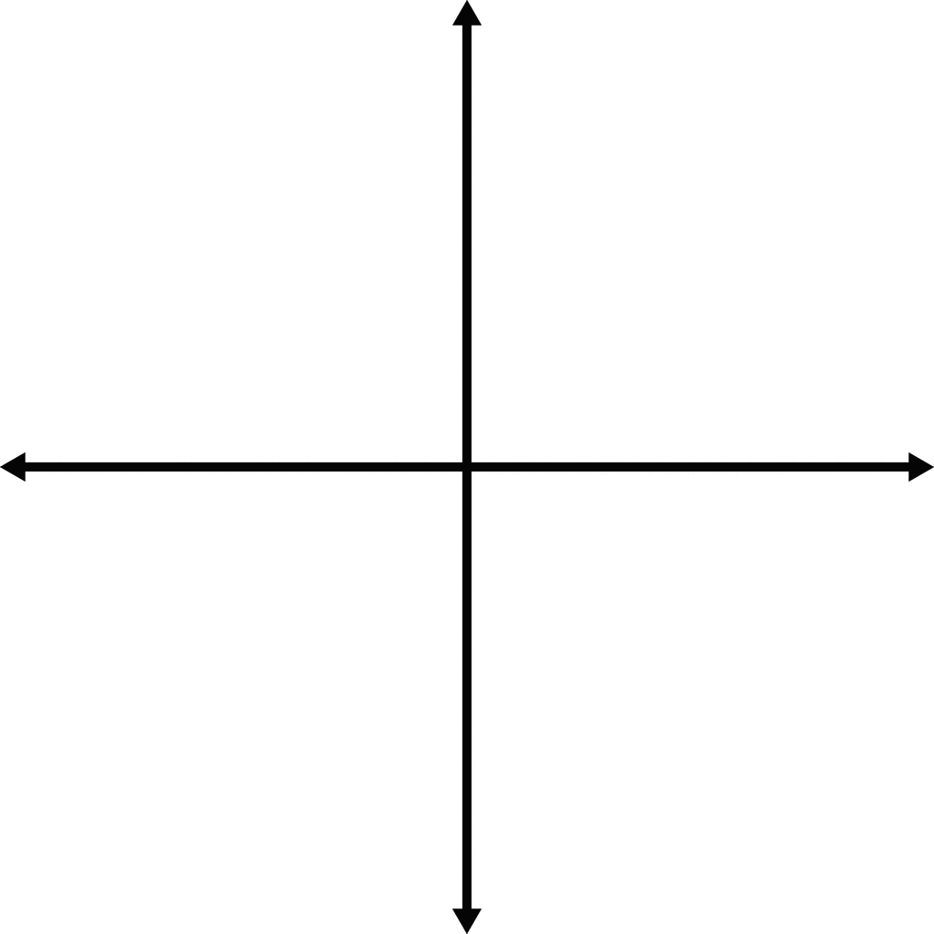](https://www.google.com/url?sa=i&rct=j&q=&esrc=s&source=images&cd=&cad=rja&uact=8&ved=0ahUKEwilvMylxqfWAhVi2IMKHZscBCAQjRwIBw&url=http://etc.usf.edu/clipart/48600/48667/48667_graph_blank.htm&psig=AFQjCNEbmZjU48AcdhVuYese9BcZ8nIbpQ&ust=1505577200443414)

End Behavior: End Behavior:

 

Intervals where function is increasing: Intervals where function is increasing:

Intervals where function is decreasing: Intervals where function is decreasing:

Intervals where function is positive: Intervals where function is positive:

Intervals where function is negative: Intervals where function is negative:

Local extrema: Local extrema:

3.  4. 

Degree: Degree:

y-intercept: y-intercept:

x-intercepts (zeros): x-intercepts (zeros):

[](https://www.google.com/url?sa=i&rct=j&q=&esrc=s&source=images&cd=&cad=rja&uact=8&ved=0ahUKEwilvMylxqfWAhVi2IMKHZscBCAQjRwIBw&url=http://etc.usf.edu/clipart/48600/48667/48667_graph_blank.htm&psig=AFQjCNEbmZjU48AcdhVuYese9BcZ8nIbpQ&ust=1505577200443414)

End Behavior: End Behavior:

 

Intervals where function is increasing: Intervals where function is increasing:

Intervals where function is decreasing: Intervals where function is decreasing:

Intervals where function is positive: Intervals where function is positive:

Intervals where function is negative: Intervals where function is negative:

Local extrema: Local extrema:

5.  6. 

Degree: Degree:

y-intercept: y-intercept:

x-intercepts (zeros): x-intercepts (zeros):

[](https://www.google.com/url?sa=i&rct=j&q=&esrc=s&source=images&cd=&cad=rja&uact=8&ved=0ahUKEwilvMylxqfWAhVi2IMKHZscBCAQjRwIBw&url=http://etc.usf.edu/clipart/48600/48667/48667_graph_blank.htm&psig=AFQjCNEbmZjU48AcdhVuYese9BcZ8nIbpQ&ust=1505577200443414)

End Behavior: End Behavior:

 

Intervals where function is increasing: Intervals where function is increasing:

Intervals where function is decreasing: Intervals where function is decreasing:

Intervals where function is positive: Intervals where function is positive:

Intervals where function is negative: Intervals where function is negative:

Local extrema: Local extrema:

7.  8. 

Degree: Degree:

y-intercept: y-intercept:

x-intercepts (zeros): x-intercepts (zeros):

[](https://www.google.com/url?sa=i&rct=j&q=&esrc=s&source=images&cd=&cad=rja&uact=8&ved=0ahUKEwilvMylxqfWAhVi2IMKHZscBCAQjRwIBw&url=http://etc.usf.edu/clipart/48600/48667/48667_graph_blank.htm&psig=AFQjCNEbmZjU48AcdhVuYese9BcZ8nIbpQ&ust=1505577200443414)

[](https://www.google.com/url?sa=i&rct=j&q=&esrc=s&source=images&cd=&cad=rja&uact=8&ved=0ahUKEwilvMylxqfWAhVi2IMKHZscBCAQjRwIBw&url=http://etc.usf.edu/clipart/48600/48667/48667_graph_blank.htm&psig=AFQjCNEbmZjU48AcdhVuYese9BcZ8nIbpQ&ust=1505577200443414)

End Behavior: End Behavior:

 

Intervals where function is increasing: Intervals where function is increasing:

Intervals where function is decreasing: Intervals where function is decreasing:

Local extrema: Local extrema:

9.  10. 

Degree: Degree:

y-intercept: y-intercept:

x-intercepts (zeros): x-intercepts (zeros):

[](https://www.google.com/url?sa=i&rct=j&q=&esrc=s&source=images&cd=&cad=rja&uact=8&ved=0ahUKEwilvMylxqfWAhVi2IMKHZscBCAQjRwIBw&url=http://etc.usf.edu/clipart/48600/48667/48667_graph_blank.htm&psig=AFQjCNEbmZjU48AcdhVuYese9BcZ8nIbpQ&ust=1505577200443414)

[](https://www.google.com/url?sa=i&rct=j&q=&esrc=s&source=images&cd=&cad=rja&uact=8&ved=0ahUKEwilvMylxqfWAhVi2IMKHZscBCAQjRwIBw&url=http://etc.usf.edu/clipart/48600/48667/48667_graph_blank.htm&psig=AFQjCNEbmZjU48AcdhVuYese9BcZ8nIbpQ&ust=1505577200443414)

End Behavior: End Behavior:

 

Intervals where function is increasing: Intervals where function is increasing:

Intervals where function is decreasing: Intervals where function is decreasing:

Local extrema: Local extrema:

11.  12. 

Degree: Degree:

y-intercept: y-intercept:

x-intercepts (zeros): x-intercepts (zeros):

[](https://www.google.com/url?sa=i&rct=j&q=&esrc=s&source=images&cd=&cad=rja&uact=8&ved=0ahUKEwilvMylxqfWAhVi2IMKHZscBCAQjRwIBw&url=http://etc.usf.edu/clipart/48600/48667/48667_graph_blank.htm&psig=AFQjCNEbmZjU48AcdhVuYese9BcZ8nIbpQ&ust=1505577200443414)

[](https://www.google.com/url?sa=i&rct=j&q=&esrc=s&source=images&cd=&cad=rja&uact=8&ved=0ahUKEwilvMylxqfWAhVi2IMKHZscBCAQjRwIBw&url=http://etc.usf.edu/clipart/48600/48667/48667_graph_blank.htm&psig=AFQjCNEbmZjU48AcdhVuYese9BcZ8nIbpQ&ust=1505577200443414)

End Behavior: End Behavior:

 

Intervals where function is increasing: Intervals where function is increasing:

Intervals where function is decreasing: Intervals where function is decreasing:

Local extrema: Local extrema: