Name _____________ Date _____________

Mr. Schlansky Geometry

***Overlapping Similar Triangles***

1. In triangle *SEB*, *A* is on , and *E* is on  so that .

If ,, and , find .

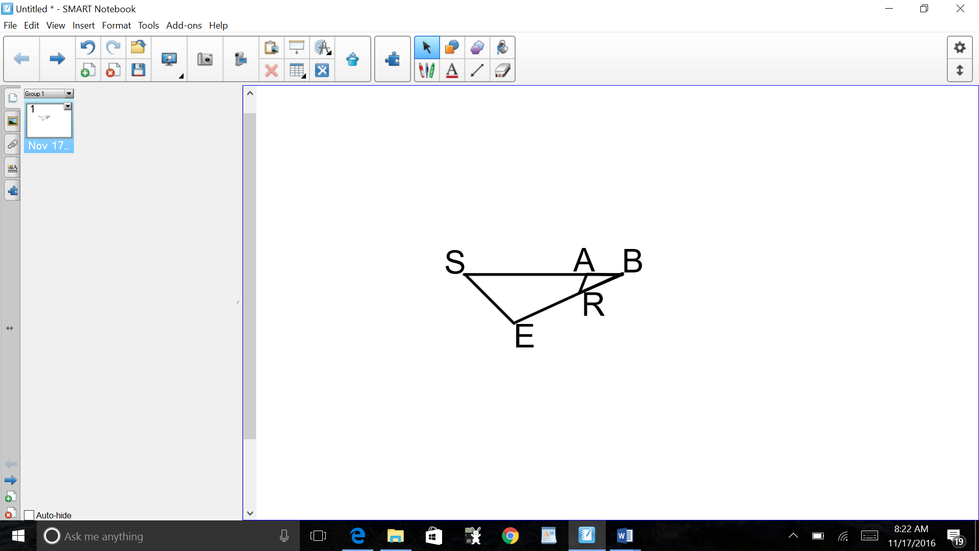

1. In triangle *AON*, *K* is on so that .

If  and , find .

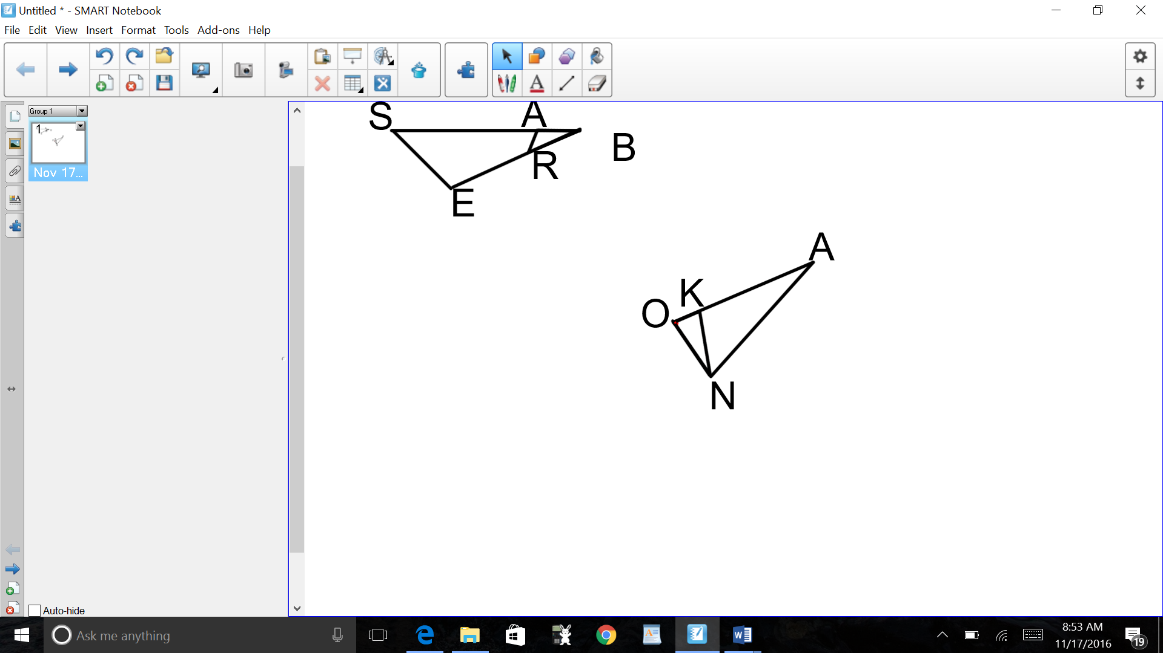

1. In triangle *TOR*, *Y* is on , and *D* is on  so that .

If ,, and , find .

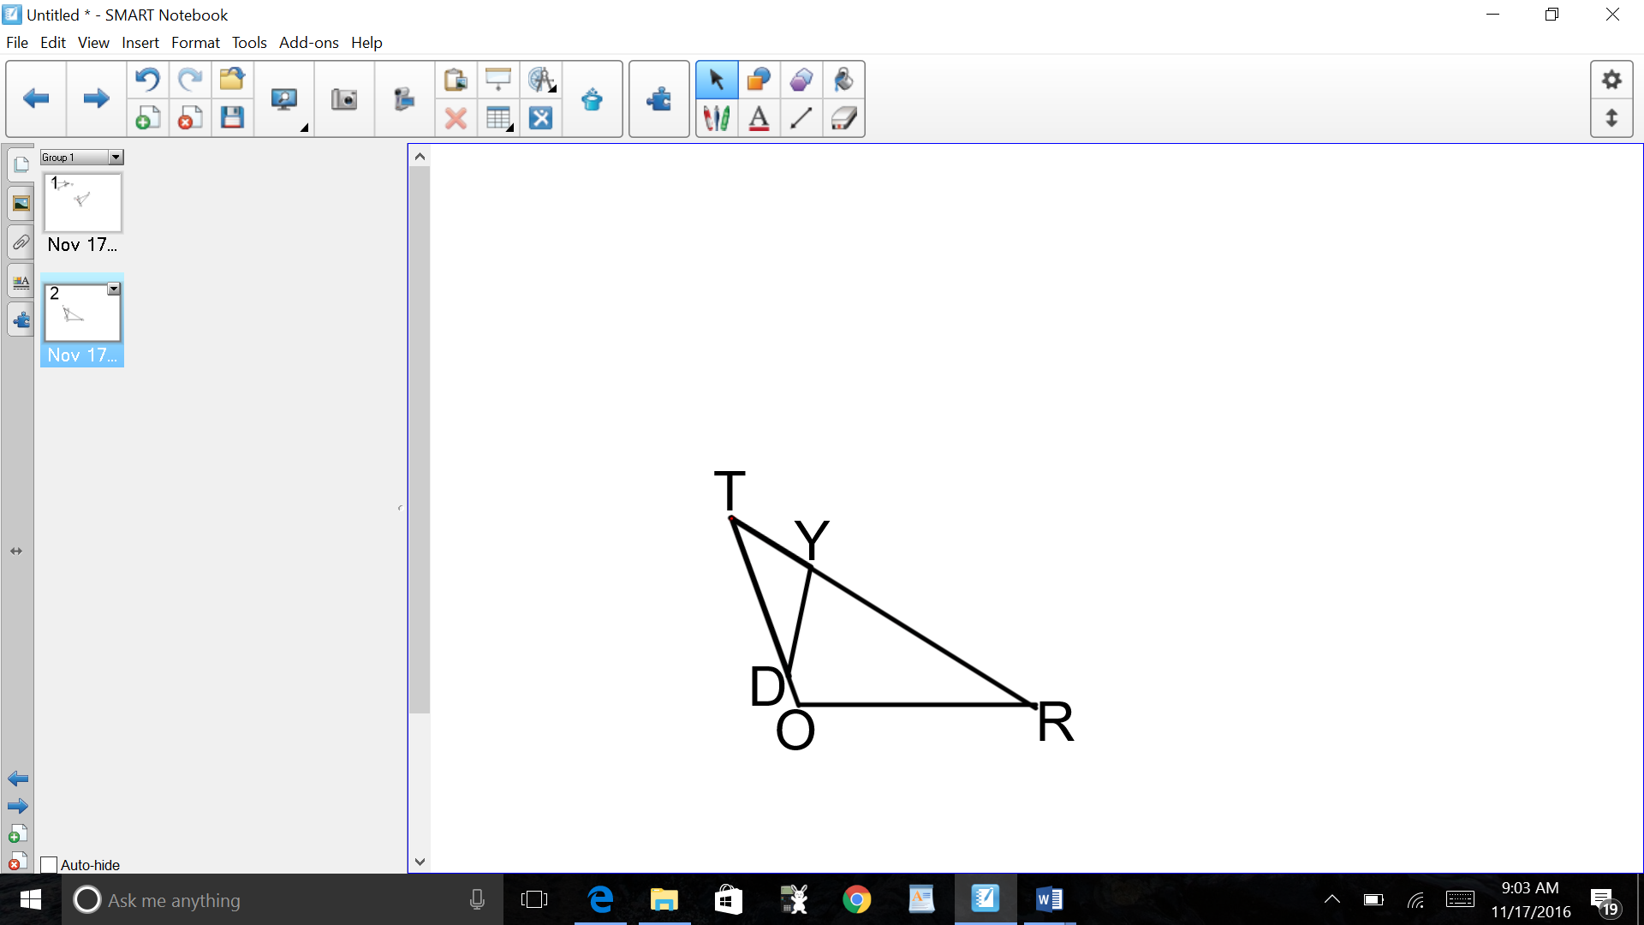

1. In triangle *SAL*, *N* is on , and *E* is on  so that .

If ,, and , find .

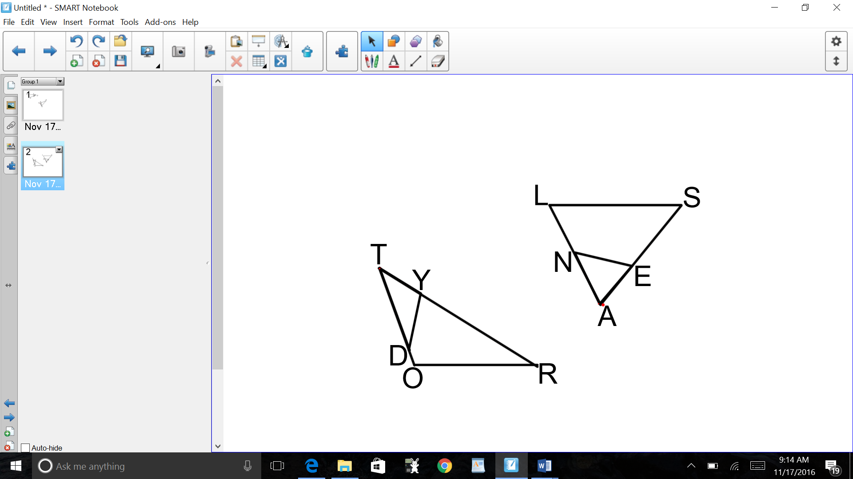

1. In triangle *CHR*, *O* is on , and *D* is on  so that .

If , , and , what is the length of ?

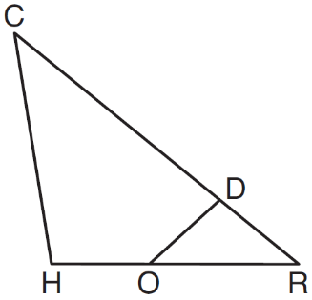

1. In  shown below, points *T* and *O* are on  and , respectively. Segment *OT* is drawn so that .

If , , and , what is the length of ?

