Name ______________ Date _____________

Mr. Schlansky Geometry

***Triangle Proofs with Addition and Subtraction Properties***

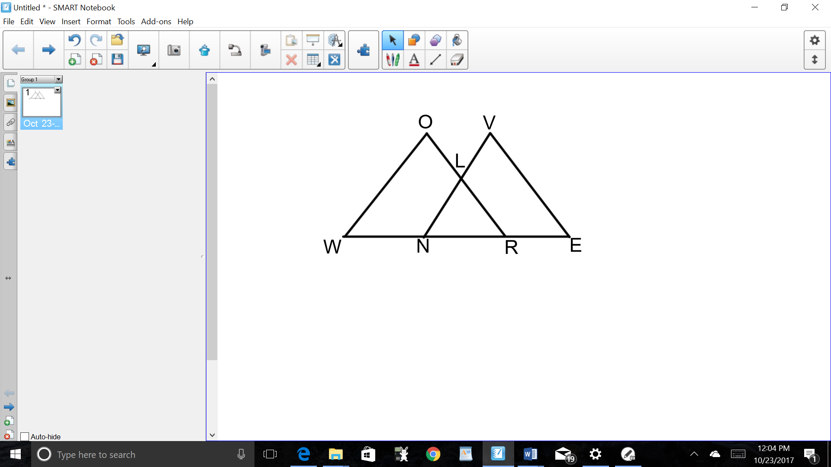

1. Given: , , 

Prove: 

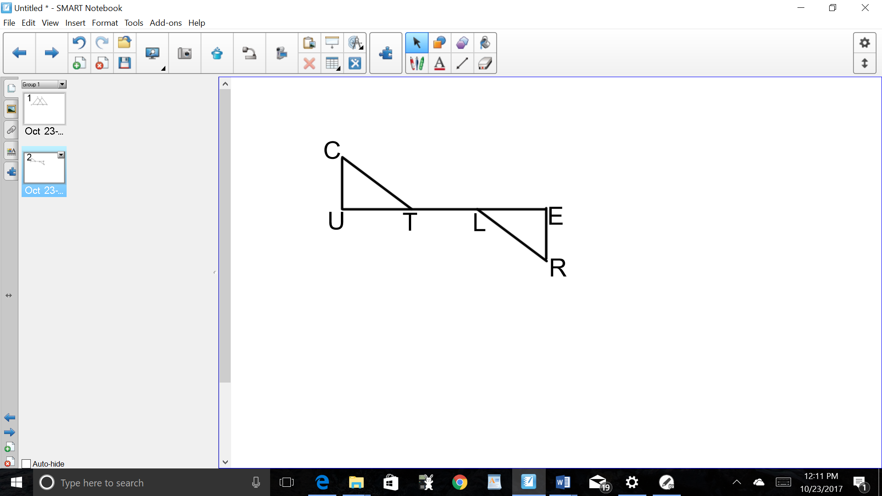

1. Given: , , , 

Prove: 

1. Given: ,, 

Prove: 

1. Given: ,

Prove: 



1. Given: 





Prove: 



1. Given: , , , 

Prove: 

1. Given: 





Prove: 