Name ______________ Date _____________

Mr. Schlansky Geometry

***Proving Triangles Are Isosceles***



1. Given: 

 bisects 

Prove:  is isosceles

1. 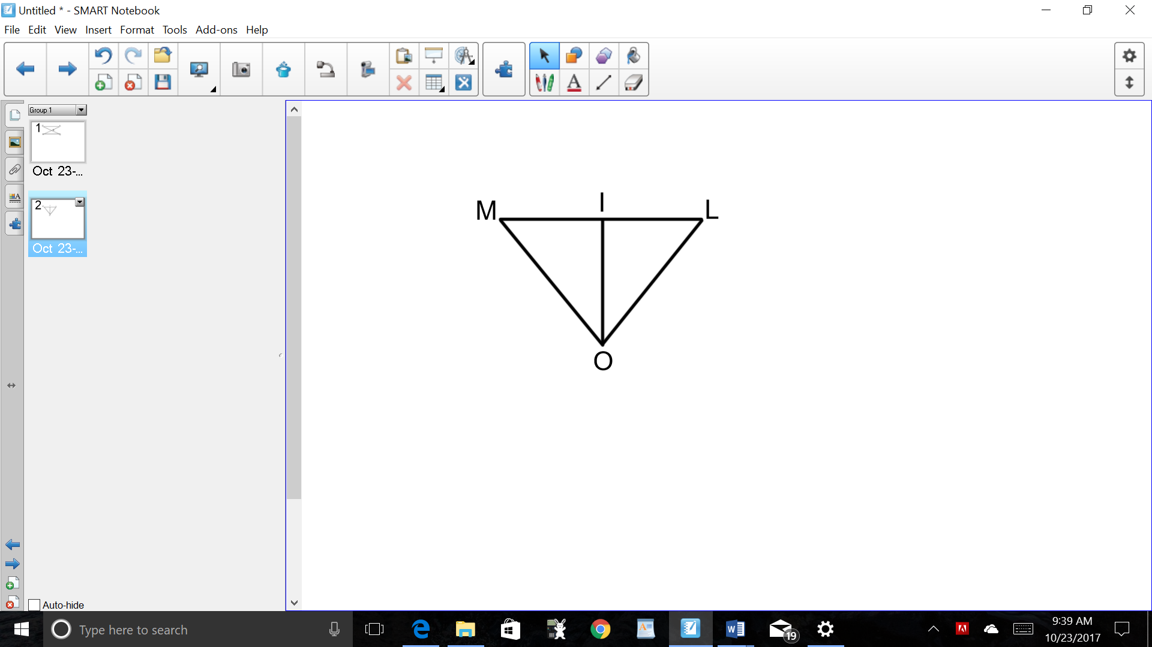Given:  is the perpendicular bisector of 

Prove:  is isosceles

1. 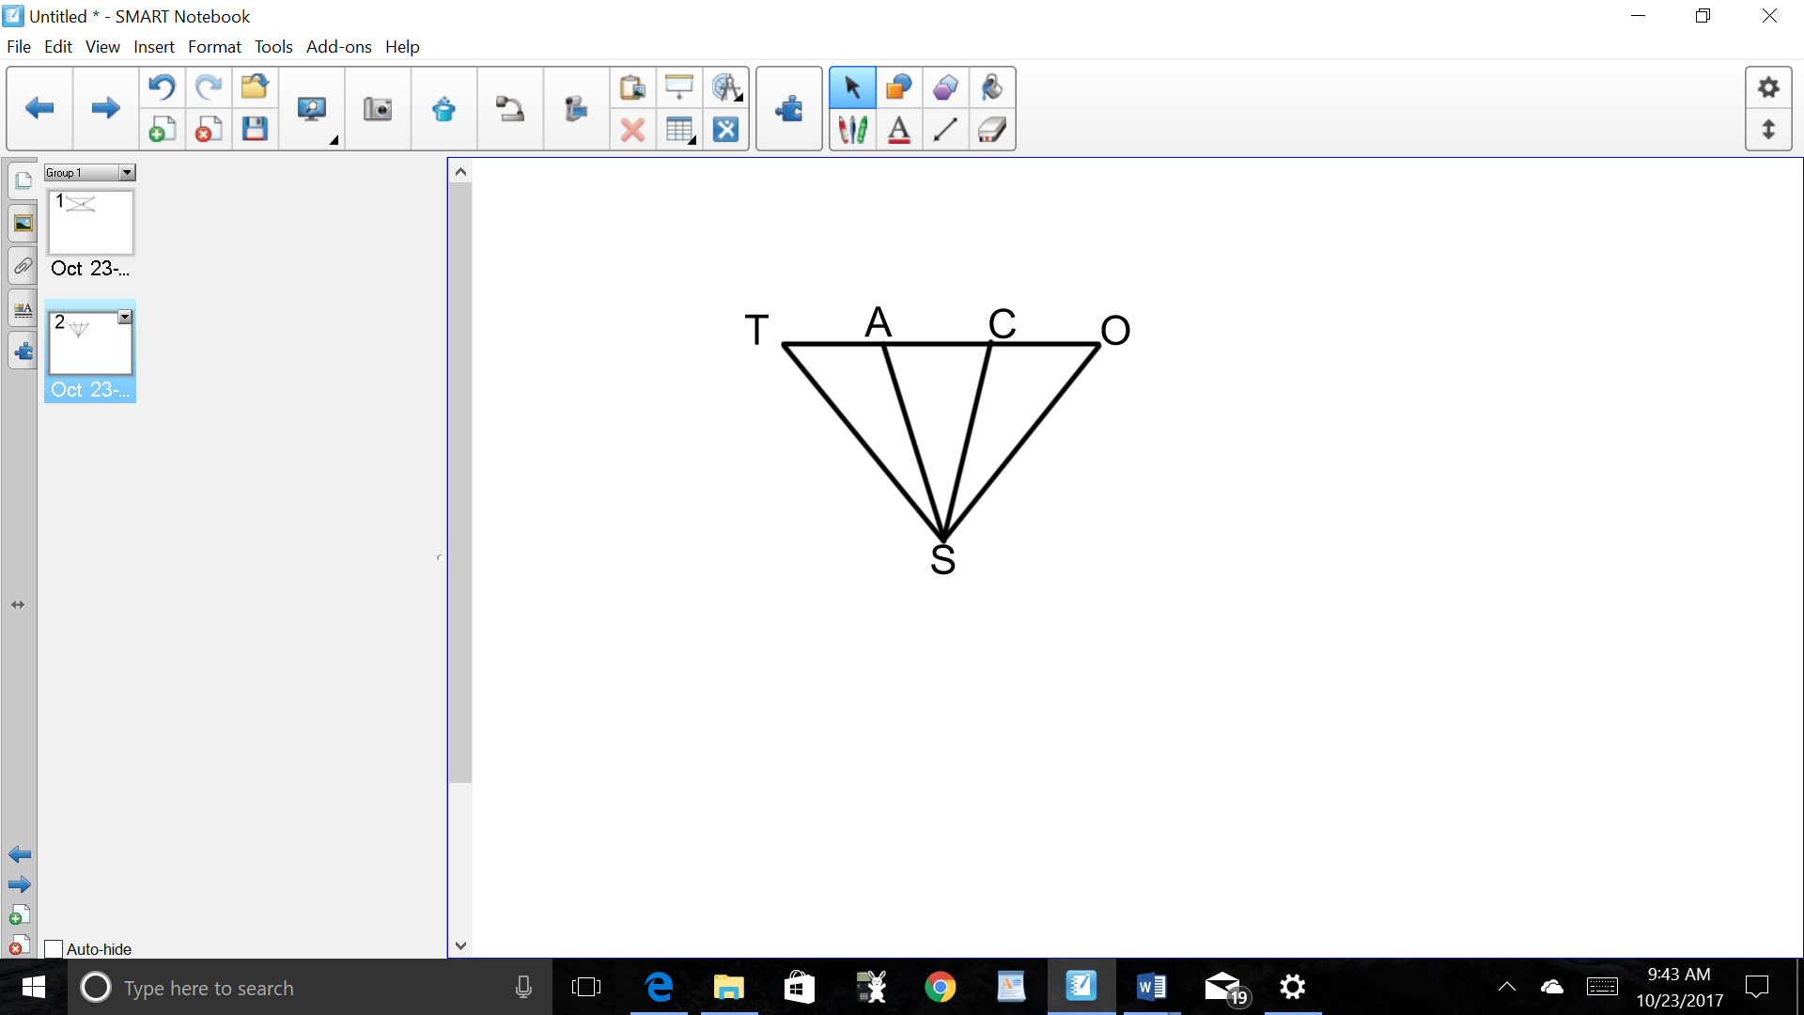Given: , , 

Prove:  is isosceles