Name ____________ Date _____________

Mr. Schlansky Geometry

***Proving Segments are Parallel***

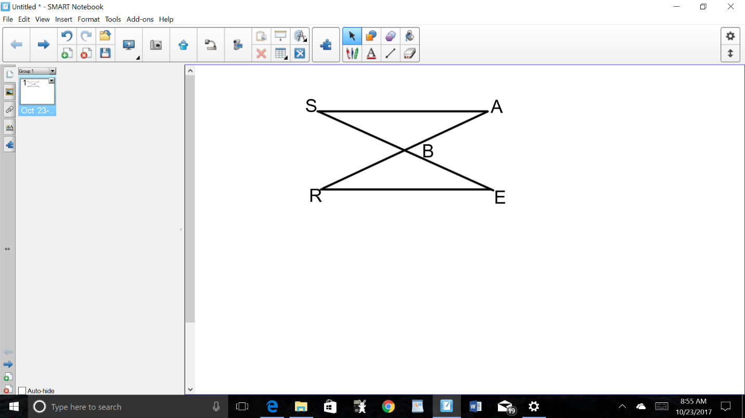

1. Given:  and  bisect each other. Prove that .



2. Given: , , , and .

Prove 

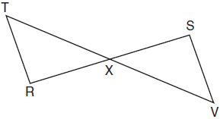 3. Given:  and  bisect each other at point *X*

 and  are drawn

Prove: 