Name _____________ Date _____________

Mr. Schlansky Geometry

***Proving Multiplication***

1. 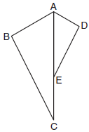Given: bisects , 

Prove: 



1. Given: , 

Prove: 

1. Given: ,, 

Prove: 

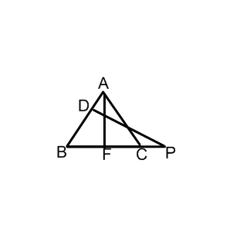

1. In  shown below, points *T* and *O* are on  and , respectively. Segment *OT* is drawn so that .

Prove: 

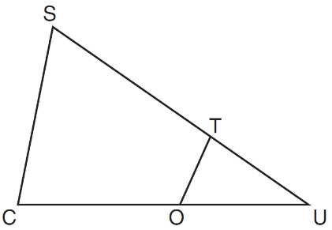

1. Given: 

Prove: 

