Name _____________ Date _____________
Mr. Schlansky Geometry

Pythagorean Theorem

Find the missing side of each right triangle rounding to the nearest tenth if necessary
- 2.

3. 4.

5. 6.

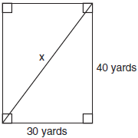
7. Tanya runs diagonally across a rectangular field that has a length of 40 yards and a width of 30 yards, as shown in the diagram below.

What is the length of the diagonal, in yards, that Tanya runs?
1) | 50 | 3) | 70
2) | 60 | 4) | 80

8. What is the value of x, in inches, in the right triangle below?
1) |  | 3)
2) | 8 | 4) | 4
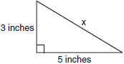

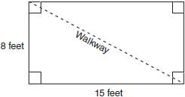
9. Nancy’s rectangular garden is represented in the diagram below.

If a diagonal walkway crosses her garden, what is its length, in feet?
1) | 17 | 3)
2) | 22 | 4)

10. The end of a dog's leash is attached to the top of a 5-foot-tall fence post, as shown in the diagram below. The dog is 7 feet away from the base of the fence post.
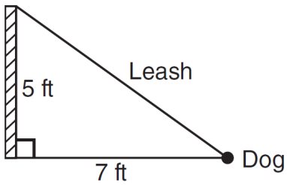
How long is the leash, to the nearest tenth of a foot?
1) | 4.9
2) | 8.6
3) | 9.0
4) | 12.0

