Name _____________ Date _____________

Mr. Schlansky Geometry

***Coordinate Geometry/Quadrilateral Properties Regents Review***

1. Determine whether the two lines represented by the equations  and  are parallel, perpendicular, or neither. Justify your response.

2. What is the equation of a line passing through  and parallel to the line represented by the equation ?

|  |  |
| --- | --- |
| 1) |  |
| 2) |  |
| 3) |  |
| 4) |  |

3. What is the equation of a line passing through (4,-2) and perpendicular to the line represented by the equation ?

1. The line  is dilated by a scale factor of -3 and centered at the origin. Write an equation of the line that represents the image of the line after the dilation.

5. Line  is transformed by a dilation with a scale factor of 2 and centered at . The line's image is

|  |  |
| --- | --- |
| 1) |  |
| 2) |  |
| 3) |  |
| 4) |  |

1. The line  is dilated by a scale factor of  and centered at the origin. Write an equation that represents the image of the line after the dilation.
2. The line  is dilated by a scale factor of  and centered at the origin. Write an equation that represents the image of the line after the dilation.

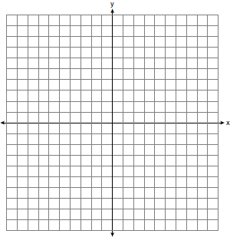 8. What are the coordinates of the point on the directed line segment from  to  that partitions the segment into a ratio of 3 to 2?

|  |  |
| --- | --- |
| 1) |  |
| 2) |  |
| 3) |  |
| 4) |  |

9. What are the coordinates of the center of a circle whose equation is ?

|  |  |
| --- | --- |
| 1) |  |
| 2) |  |
| 3) |  |
| 4) |  |

10. The equation  is equivalent to

|  |  |
| --- | --- |
| 1) |  |
| 2) |  |
| 3) |  |
| 4) |  |

11. The equation of a circle is . What are the coordinates of the center and the length of the radius of the circle?

|  |  |
| --- | --- |
| 1) | center  and radius 4 |
| 2) | center  and radius 4 |
| 3) | center  and radius 16 |
| 4) | center  and radius 16 |

12. What are the coordinates of the center and length of the radius of the circle whose equation is ?

|  |  |
| --- | --- |
| 1) | and 36 |
| 2) | and 6 |
| 3) | and 36 |
| 4) | and 6 |

13. If  is the equation of a circle, the length of the radius is

|  |  |
| --- | --- |
| 1) | 25 |
| 2) | 16 |
| 3) | 5 |
| 4) | 4 |

 14. Directed line segment *PT* has endpoints whose

coordinates are  and . Determine the

coordinates of point *J* that divides the segment in

the ratio 2 to 1.

15. The coordinates of the endpoints of  are  and . Point *P* is on . Determine and state the coordinates of point *P*, such that  is .



16. The endpoints of  are  and . Determine and state the coordinates of point *E*, if .



1. Which of the following is not true of all rectangles?
   1. Consecutive sides are perpendicular
   2. Opposite sides are parallel
   3. Diagonals are perpendicular to each other
   4. Diagonals bisect each other
2. Which of the following is true about rhombuses?
3. Consecutive sides are perpendicular
4. Opposite sides are congruent
5. Consecutive angles are congruent
6. Diagonals are congruent

19. Isosceles trapezoid *ABCD* has diagonals  and . If  and , what is the value of *x*?

|  |  |  |  |
| --- | --- | --- | --- |
| 1) | 28 | 3) | 3 |
| 2) |  | 4) |  |

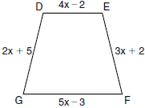 20. In the diagram below of isosceles trapezoid *DEFG*, , , , , and . Find the value of *x*.

21. The diagram below shows isosceles trapezoid *ABCD* with  and . If  and , find .

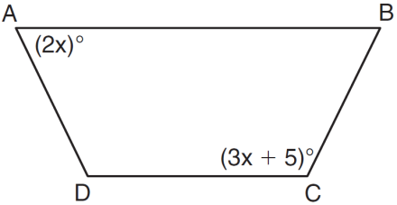

22. Triangle *HKL* has vertices , , and . The midpoint of  is *M* and the midpoint of  is *N*. Determine and state the coordinates of points *M* and *N*. Justify the statement:  is parallel to . [The use of the set of axes below is optional.]

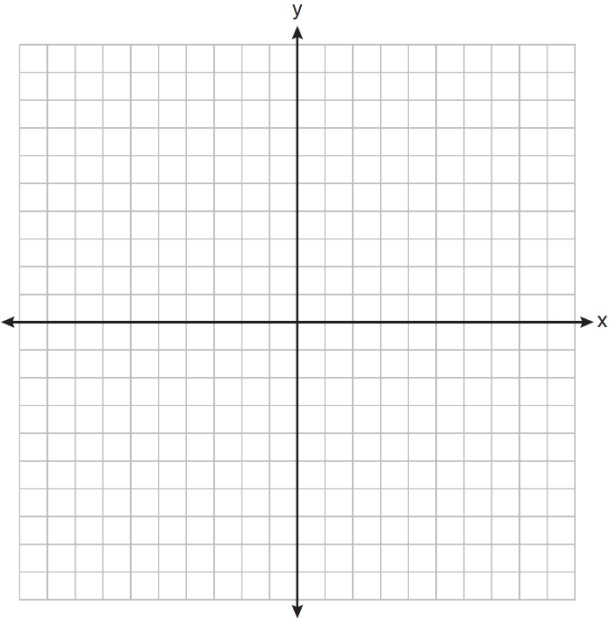

23. Graph the quadrilateral MATH: M(-2, -3) A(-1, -1) T(4, 2) H(3, 0). Prove that MATH **IS** a parallelogram but is **NOT** a rectangle.



24. Given:  with vertices , , and .  has midpoint *D*,  has midpoint *E*, and  has midpoint *F.*

Prove: *ADEF* is a parallelogram

 *ADEF* is *not* a rhombus

[The use of the grid is optional.]

25. The vertices of rectangle NRQW are N(-2,5), R(2,5), Q(2,-3), and W(-2,-3). If A is the midpoint , B is the midpoint of , C is the midpoint of , and D is the midpoint of , prove that ABCD is a parallelogram but *not* a rhombus.



26. In the coordinate plane, the vertices of  are , , and . Prove that  is a right triangle. State the coordinates of point *P* such that quadrilateral *RSTP* is a rectangle. Prove that your quadrilateral *RSTP* is a rectangle. [The use of the set of axes below is optional.]



27. In the coordinate plane, the vertices of Triangle ABC are A(0,10) B(5,0) and C(8,4). Prove that Triangle ABC is a right triangle. State the coordinates of point *P* such that quadrilateral *ABCP* is a rectangle. Prove that your quadrilateral *ABCP* is a rectangle.

