Name ___________________ Date ___________________

Mr. Schlansky Algebra II

***Remainder Theorem***

Find the remainder when  is divided by 

1.  2. 

 

3.  4. 

 

5.  6. 

 

7. What is the remainder when the following polynomial is divided by:

a)  b)  c)  d) 

8. What is the remainder when the following polynomial is divided by:

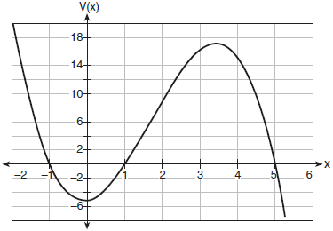a)  b)  c)  d)  e) 

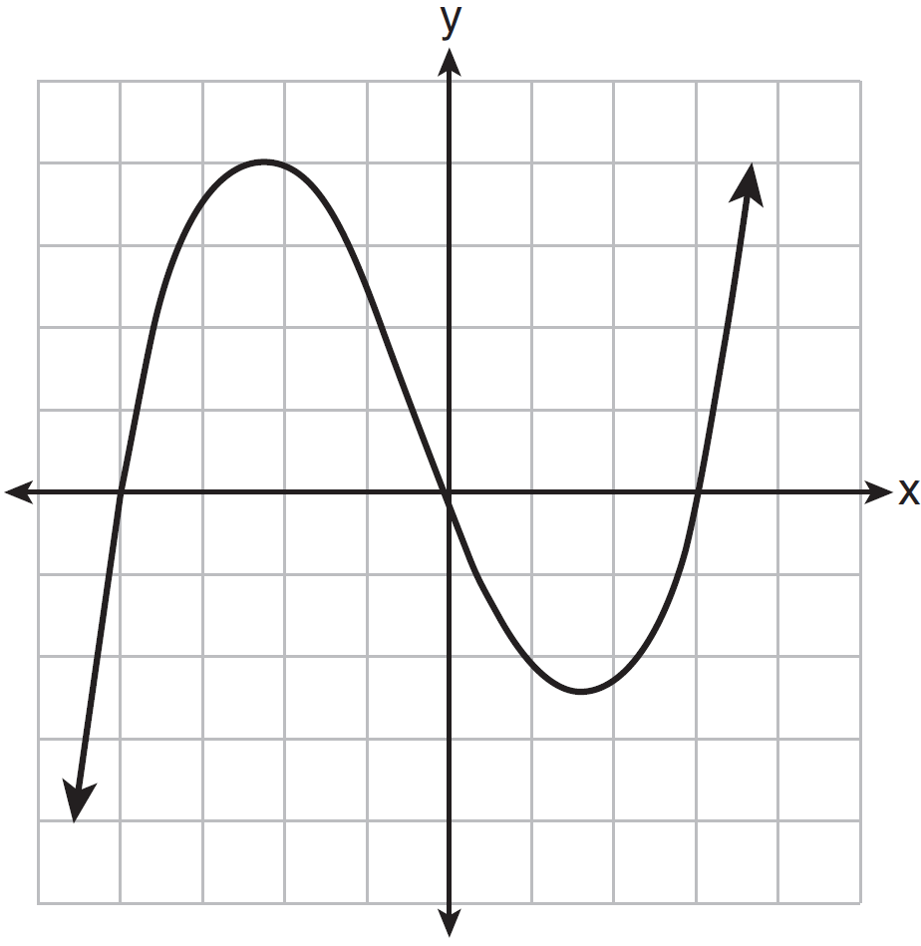

9. The graph of  is shown below.

What is the remainder when  is divided by ?

|  |  |
| --- | --- |
| 1) |  |
| 2) |  |
| 3) | 0 |
| 4) | 4 |

**Find the remainder when the following polynomials are divided**

10.  11. 

12.  13. 