Name ______________ Date _____________

Mr. Schlansky Algebra II

***Remainder Theorem Extra Review***

What do you need to know in order to determine the factors of a polynomial?

Write a possible polynomial equation in factored for if the zeros are:

1.  2. 

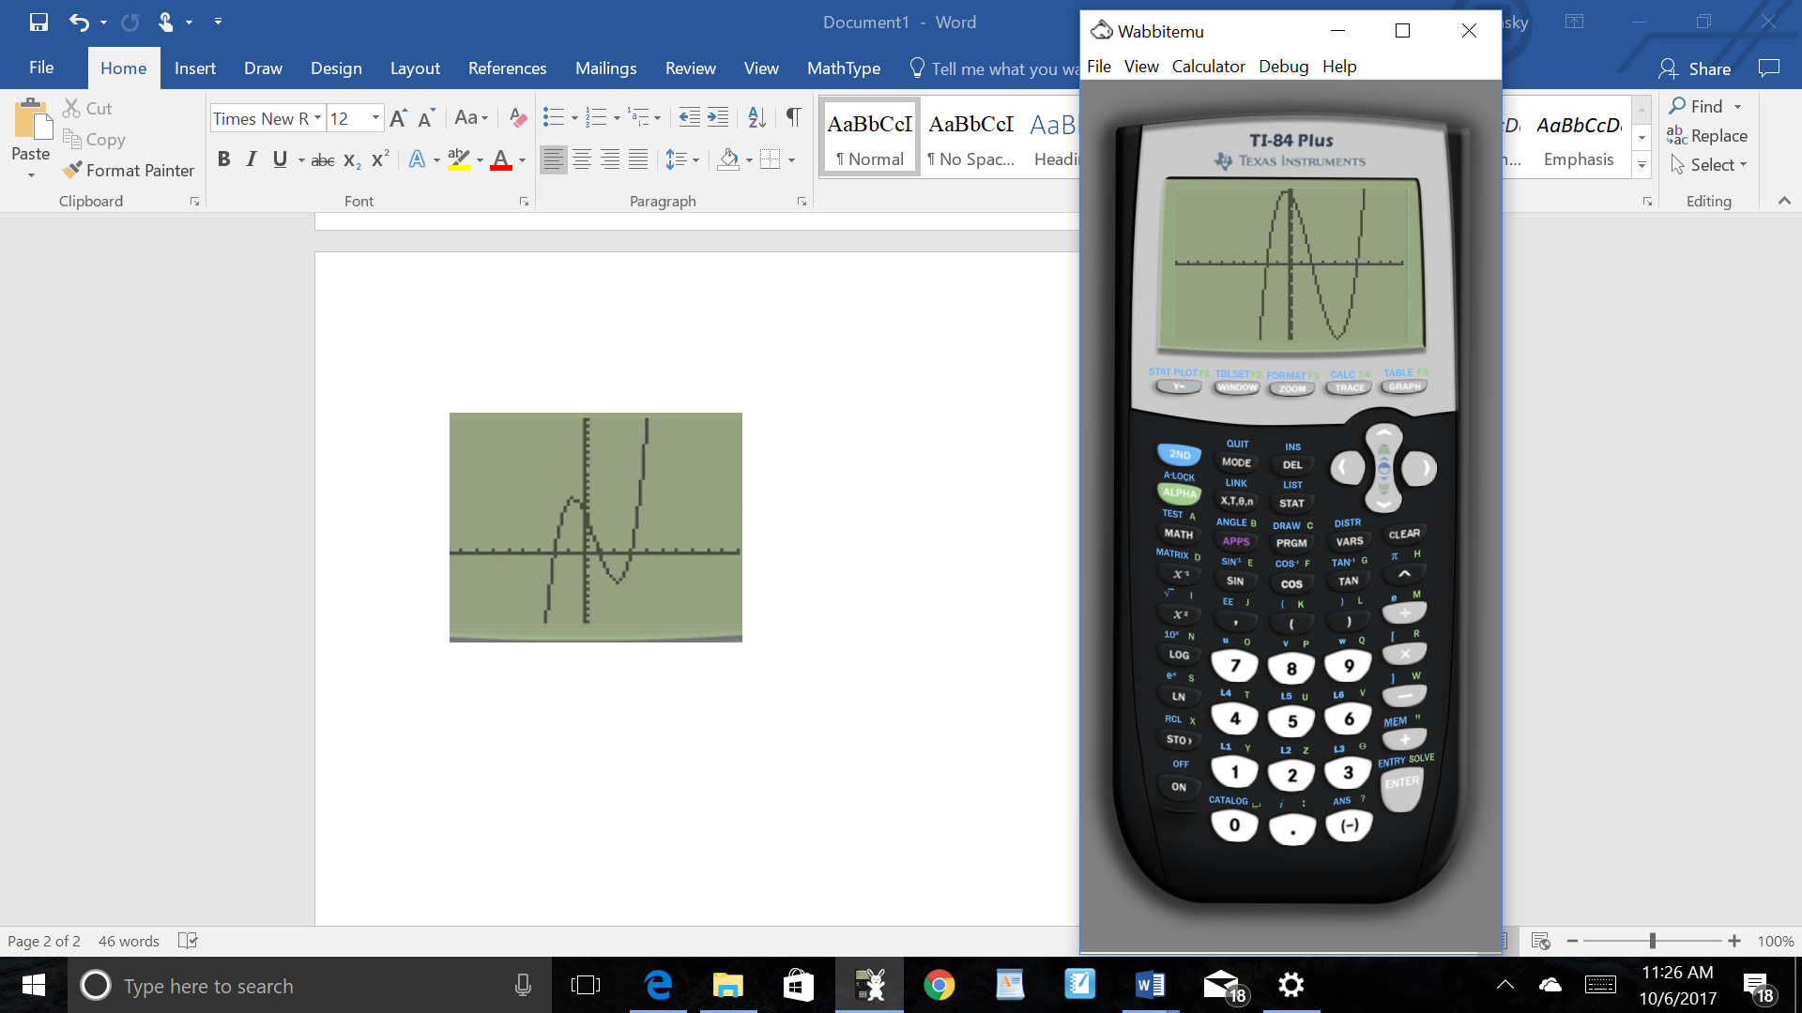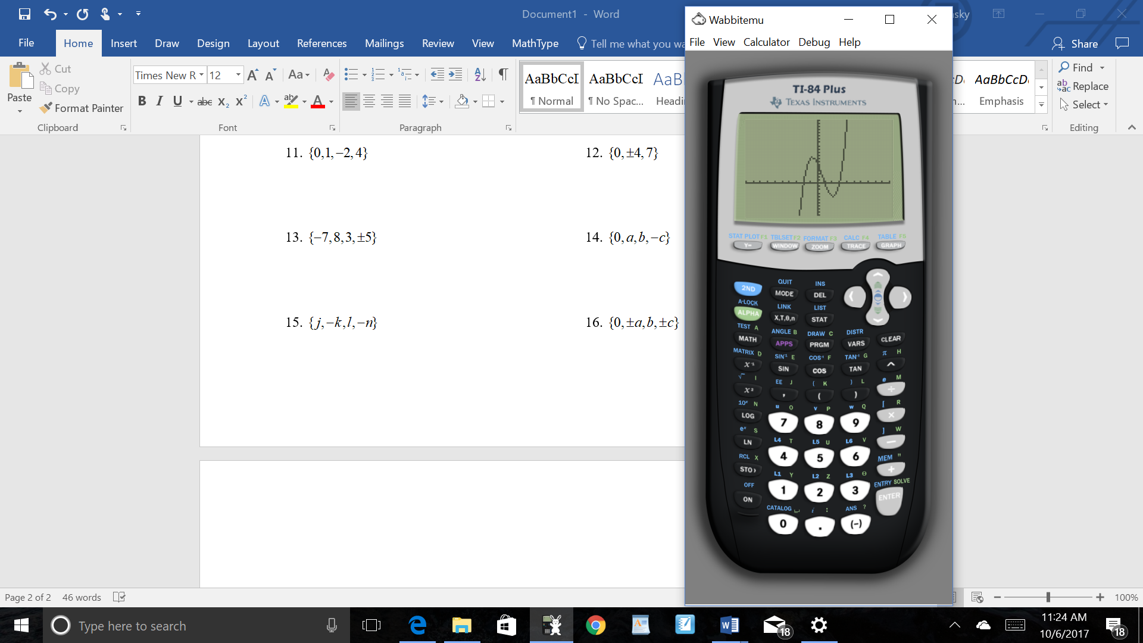3. 4.

What do you need to know in order to determine the zeros of a polynomial?

State the zeros for the following polynomials

1.  2. 

How do you find the remainder when a polynomial is divided?

1.  2. 

 

3. What is the remainder when the following polynomial is divided by:

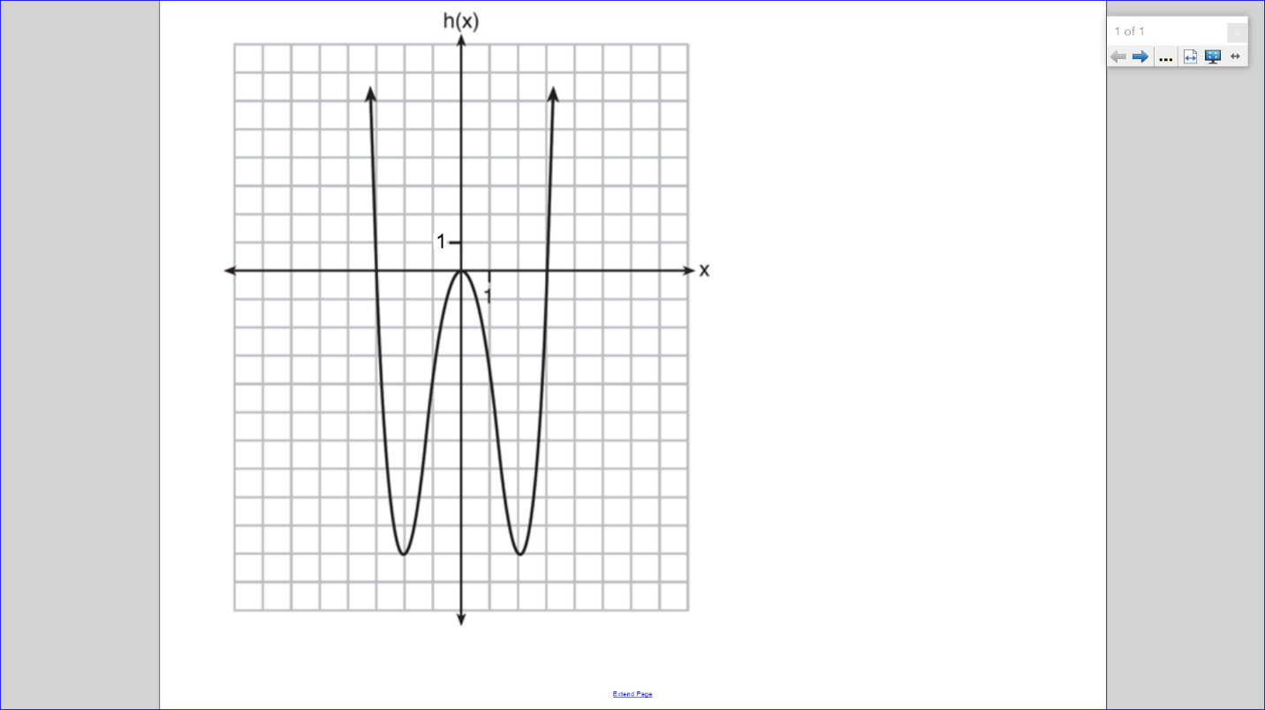

a)  b)  c)  d) 

How do you divide polynomials?

1.  2. 