Name ______________ Date _____________

Mr. Schlansky Geometry

***Right Triangles Regents Review***

**In each example, find the value of x and round to the nearest tenth if necessary**



1. 2.



3. 4.



5. 6.



7. In , the measure of ,  , and . Which ratio represents the tangent of ?

|  |  |  |  |
| --- | --- | --- | --- |
| 1) |  | 3) |  |
| 2) |  | 4) |  |

8. A right triangle contains a 38° angle whose adjacent side measures 10 centimeters. What is the length of the hypotenuse, to the *nearest hundredth of a centimeter*?

|  |  |
| --- | --- |
| 1) | 7.88 |
| 2) | 12.69 |
| 3) | 12.80 |
| 4) | 16.24 |

9. In right triangle *ABC*, , , , and . Find, to the *nearest degree*, the measure of .

10. An equilateral triangle has sides of length 20. To the *nearest tenth*, what is the height of the equilateral triangle?

|  |  |
| --- | --- |
| 1) | 10.0 |
| 2) | 11.5 |
| 3) | 17.3 |
| 4) | 23.1 |

11. A 28-foot ladder is leaning against a house. The bottom of the ladder is 6 feet from the base of the house. Find the measure of the angle formed by the ladder and the ground, to the *nearest degree*.

12. A 20-foot support post leans against a wall, making a 70° angle with the ground. To the *nearest tenth of a foot*, how far up the wall will the support post reach?

|  |  |
| --- | --- |
| 1) | 6.8 |
| 2) | 6.9 |
| 3) | 18.7 |
| 4) | 18.8 |

13. In right triangle *EFD*, , , and . What is the measure of angle *E*, to the *nearest degree*?

|  |  |
| --- | --- |
| 1) | 61 |
| 2) | 57 |
| 3) | 33 |
| 4) | 29 |

14. In right triangle *ABC* shown below,  inches,  inches, and . Find the number of degrees in the measure of angle *BAC*, to the *nearest degree*.

Find the length of  to the *nearest inch*.

15. In , where  is a right angle, . What is ?

1)  3) 

2)  4) 

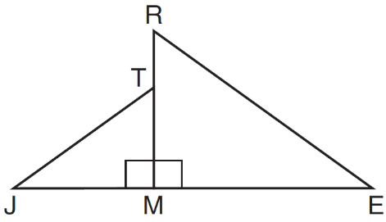

16. In the diagram below, .

Which statement is always true?

|  |  |
| --- | --- |
| 1) |  |
| 2) |  |
| 3) |  |
| 4) |  |

17. As modeled below, a movie is projected onto a large outdoor screen. The bottom of the 60-foot-tall screen is 12 feet off the ground. The projector sits on the ground at a horizontal distance of 75 feet from the screen.

Determine and state, to the *nearest tenth of a degree*, the measure of , the projection angle.

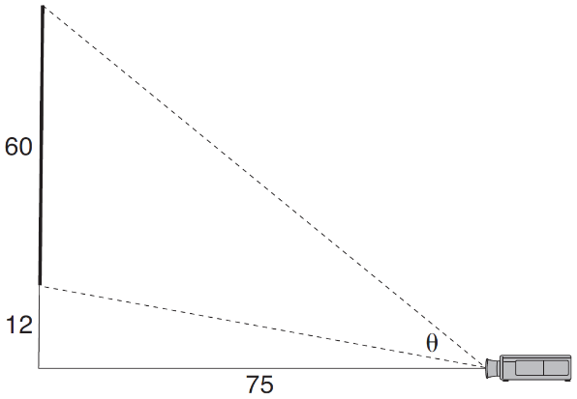

18. The aspect ratio (the ratio of screen width to height) of a rectangular flat-screen television is . The length of the diagonal of the screen is the television's screen size. Determine and state, to the *nearest inch*, the screen size (diagonal) of this flat-screen television with a screen height of 20.6 inches.

19. As shown in the diagram below, a ship is heading directly toward a lighthouse whose beacon is 125 feet above sea level. At the first sighting, point *A*, the angle of elevation from the ship to the light was 7°. A short time later, at point *D*, the angle of elevation was 16°.

To the *nearest foot*, determine and state how far the ship traveled from point *A* to point *D*.

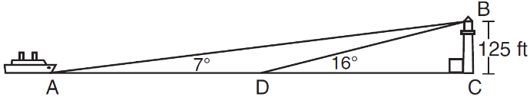

20. In , the complement of  is . Which statement is always true?

|  |  |
| --- | --- |
| 1) |  |
| 2) |  |
| 3) |  |
| 4) |  |

21. In scalene triangle *ABC* shown in the diagram below, .

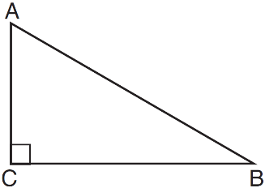

Which equation is always true?

|  |  |
| --- | --- |
| 1) |  |
| 2) |  |
| 3) |  |
| 4) |  |

22. Explain why  for *x* such that .

23. Find the value of *R* that will make the equation  true when . Explain your answer.

24. Which expression is always equivalent to  when ?

|  |  |
| --- | --- |
| 1) |  |
| 2) |  |
| 3) |  |
| 4) |  |

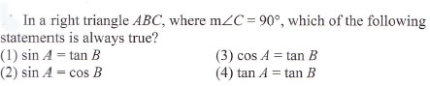

25.

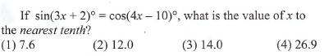

26.

27. In right triangle *ABC* with the right angle at *C*, ** and . Determine and state the value of *x*. Explain your answer.