Name ______________ Date _____________

Mr. Schlansky Geometry

***Scale Factor***

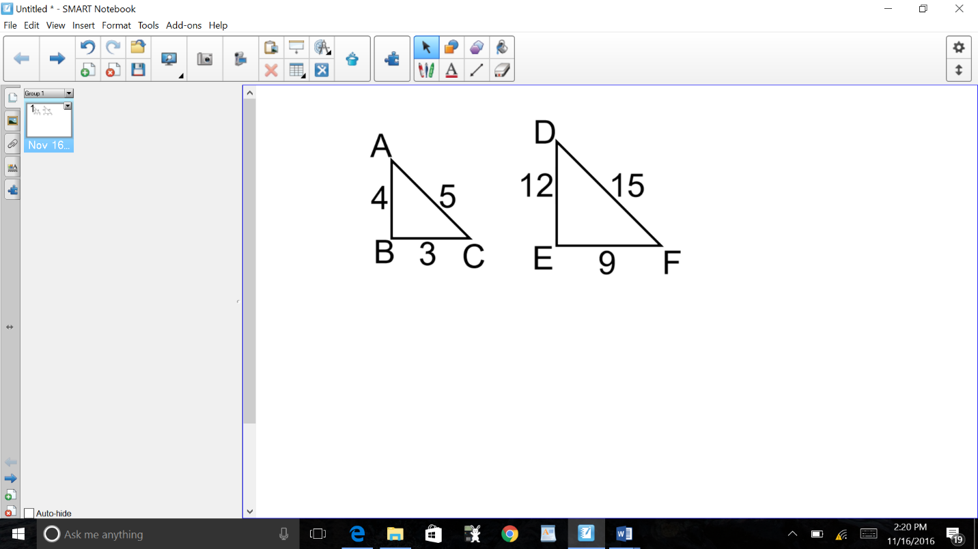

1. In the diagram below, is the image of after a dilation.

What is the scale factor of the dilation:

Numerically:

Segments:



2. In the diagram below, is the image of  after a dilation.

What is the scale factor of the dilation:

Numerically:

Segments:

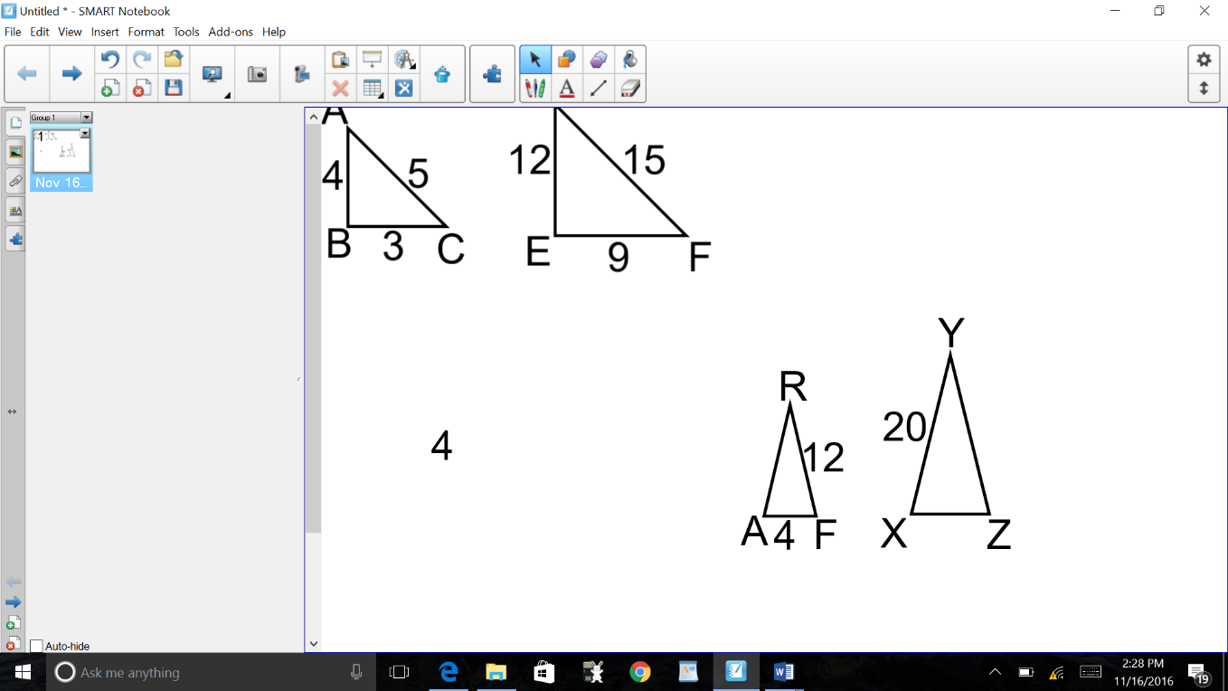

3. In the diagram below, isoscelesis the image of  after a

dilation. What is the scale factor of the dilation:

Numerically:

Segments:

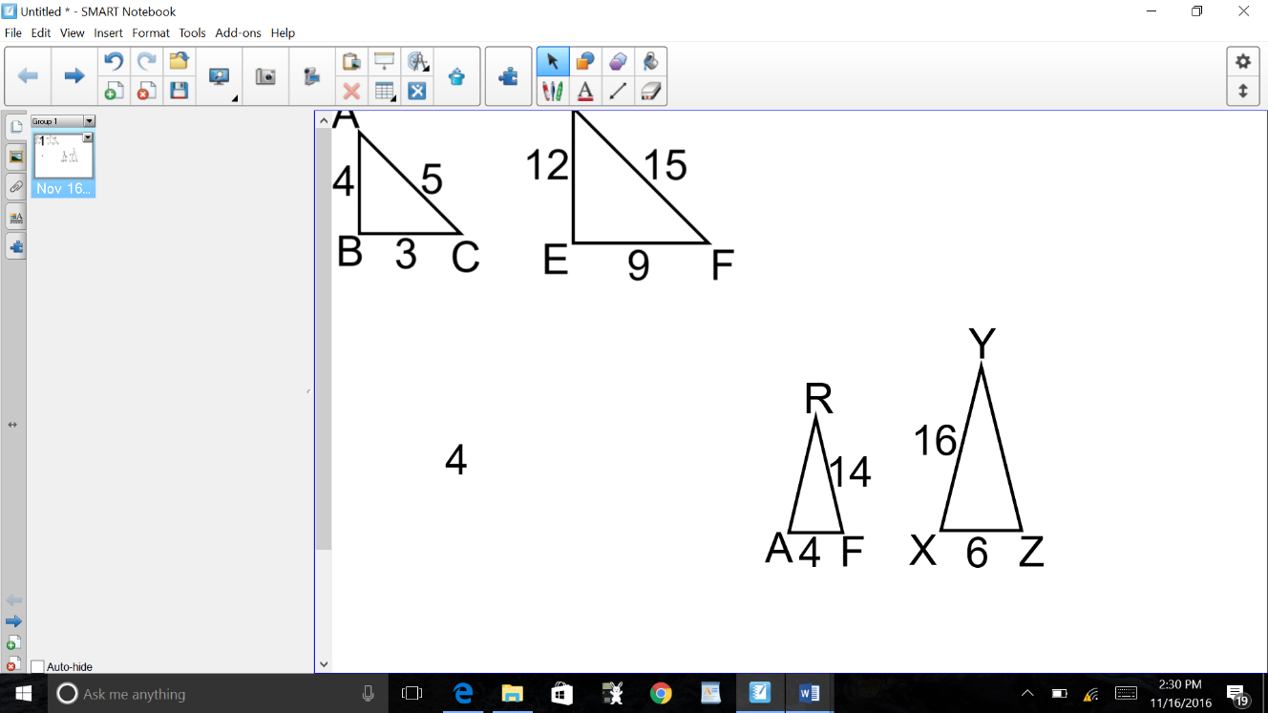4. In the diagram below, is the image of  after a dilation.

What is the scale factor of the dilation:

Numerically:

Segments:

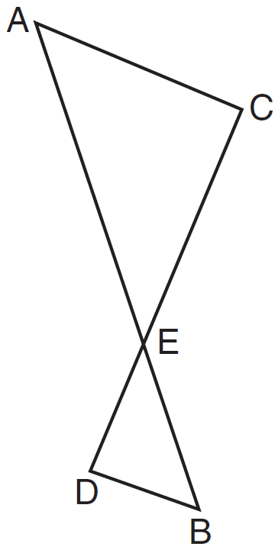

5. In the diagram below,  is the image of after a sequence

of transformations. If , , and , What is the scale factor

of the dilation:

Numerically:

Segments:

6. In the diagram below,  has coordinates , , and . The coordinates of its image after a sequence of transformations is . What is the scale factor of the dilation numerically and using segments?

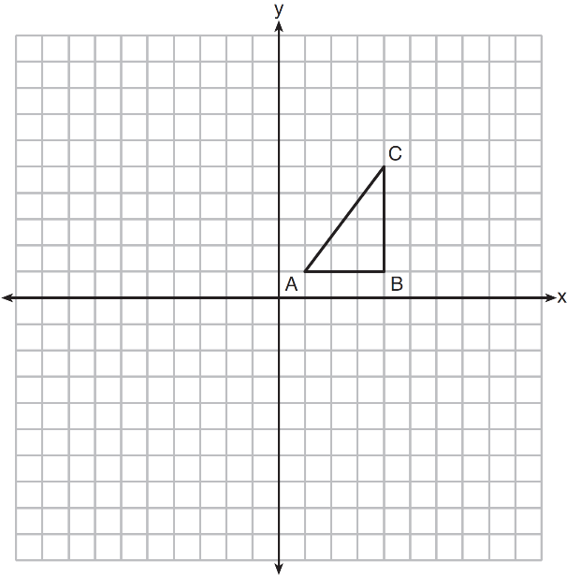

7. In the diagram shown below,  is the image of after a dilation of *k* centered at point A.

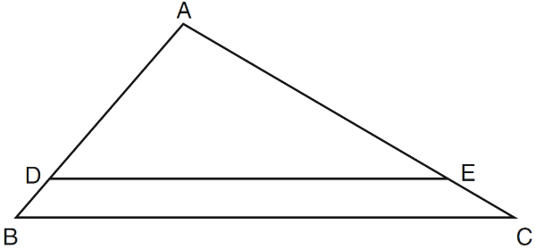

If , , and , what is the value of *k*?

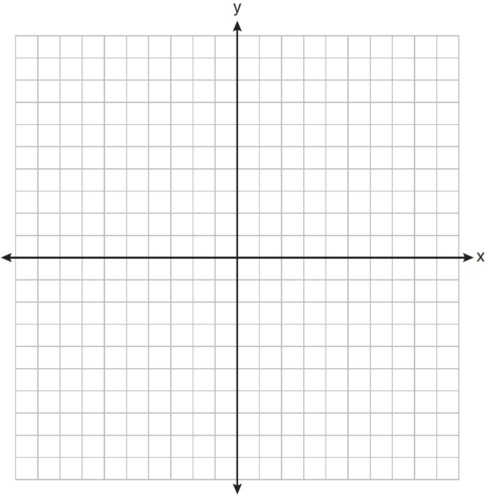8.  has coordinates . The

coordinates of , the image of  after a sequence

of transformations is . What is

the scale factor?

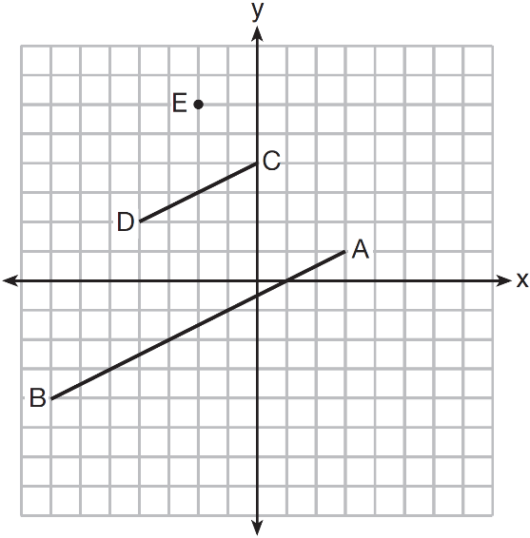 9. In the diagram below,  is the image of  after a dilation of scale factor *k* with center *E*.

Which ratio is equal to the scale factor *k* of the dilation?

|  |  |
| --- | --- |
| 1) |  |
| 2) |  |
| 3) |  |
| 4) |  |

10. In the diagram below,  is the image of  after a dilation centered at the origin. The coordinates of the vertices are , , , , and .

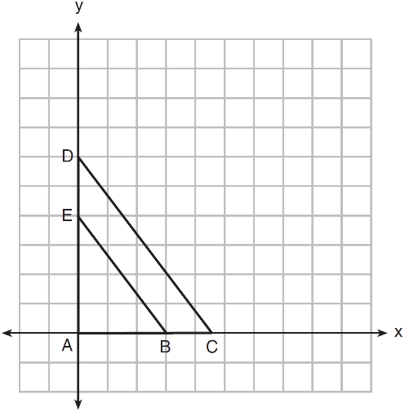

The scale factor of dilation is

|  |  |
| --- | --- |
| 1) |  |
| 2) |  |
| 3) |  |
| 4) |  |

11. In the diagram below,  is the image of  after a reflection over the line *AC* followed by a dilation centered at point *A*. What is the scale factor of the dilation?

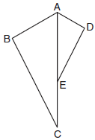

12. In the diagram below,  is the image of  after a dilation centered at point *A*. What is the scale factor of the dilation?

