Name _____________ Date _____________

Mr. Schlansky Geometry

***Similar Triangles Regents Review***

1. In the diagram below of , *D* is the midpoint of , *O* is the midpoint of , and *G* is the midpoint of .

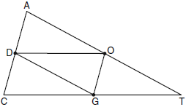

If , , and , what is the perimeter of parallelogram *CDOG*?

|  |  |  |  |
| --- | --- | --- | --- |
| 1) | 21 | 3) | 32 |
| 2) | 25 | 4) | 40 |

2. In the diagram below, the vertices of ** are the midpoints of thesides of equilateral triangle *ABC,* and the perimeter of ** is 36 cm.

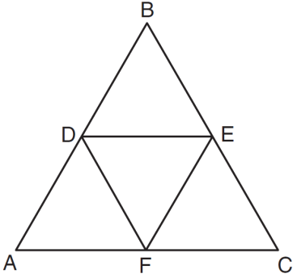

What is the length, in centimeters, of ?

|  |  |
| --- | --- |
| 1) | 6 |
| 2) | 12 |
| 3) | 18 |
| 4) | 4 |

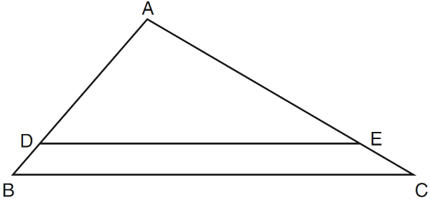 3. In the diagram of  shown below, .

If , , and , what is the

length of ?

|  |  |
| --- | --- |
| 1) | 6 |
| 2) | 2 |
| 3) | 3 |
| 4) | 15 |

4. In triangle ABC, M is a point on  and N is a point on  such that  If  = 8,  = 12, and  = 6. Find the length of 

 5. In the diagram of  shown below, .

If = 6, = 10, and = 9, find 

6. In the diagram below of , , , , and .

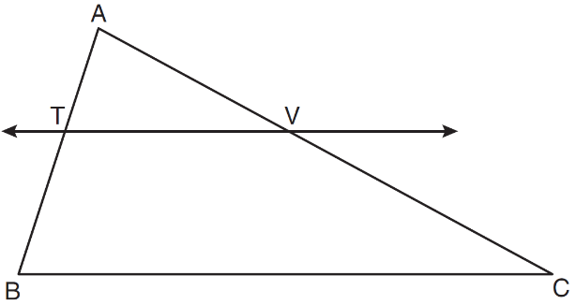

What is the length of ?

|  |  |
| --- | --- |
| 1) |  |
| 2) |  |
| 3) | 14 |
| 4) | 24 |

7. In the diagram below of right triangle *ACB*, altitude  is drawn to hypotenuse .

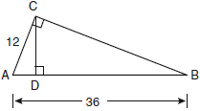

If  and , what is the length of ?

|  |  |  |  |
| --- | --- | --- | --- |
| 1) | 32 | 3) | 3 |
| 2) | 6 | 4) | 4 |

8. In the diagram below of right triangle *ACB*, altitude  intersects  at *D*. If  and ,find the length of  in simplest radical form.

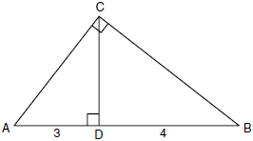

9. In the diagram below,  is a  right triangle. The altitude, *h*, to the hypotenuse has been drawn. Determine the length of *h*.

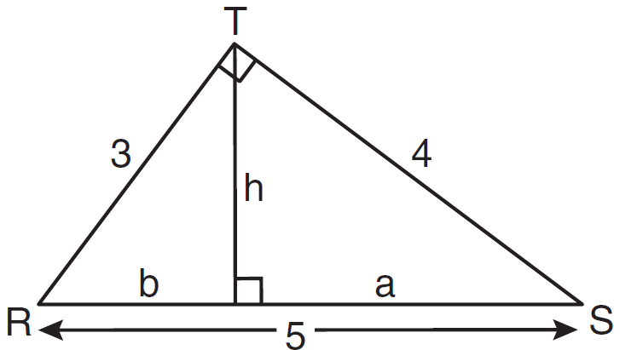

1. In triangle *CHR*, *O* is on , and *D* is on  so that .

If , , and , what is the length of ?

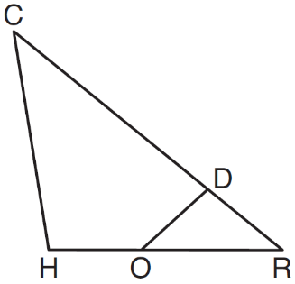

1. In  shown below, points *T* and *O* are on  and , respectively. Segment *OT* is drawn so that .

If , , and , what is the length of ?

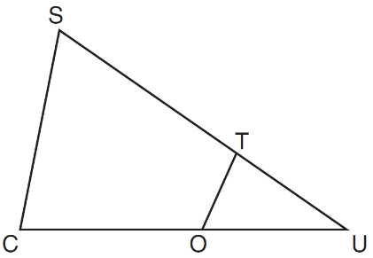

1. A flagpole casts a shadow 16.60 meters long. Tim stands at a distance of 12.45 meters from the base of the flagpole, such that the end of Tim's shadow meets the end of the flagpole's shadow. If Tim is 1.65 meters tall, determine and state the height of the flagpole to the *nearest tenth of a meter*.
2. A flagpole is 6.5 feet tall. It casts a shadow that is 30.24 feet long. Johnny is standing where the flagpole’s shadow ends and is casting his own shadow of 8.82 feet. To the *nearest tenth of a foot,* how tall is Johnny?
3. A 120 foot high building casts a 20 foot shadow. Jamal is standing 12 feet from the base of the building and the end of his shadow meets the end of the buildings shadow. How tall is Jamal?

15. To find the distance across a pond from point *B* to point *C*, a surveyor drew the diagram below. The measurements he made are indicated on his diagram.

Use the surveyor's information to determine and state the distance from point *B* to point *C*, to the *nearest yard*.

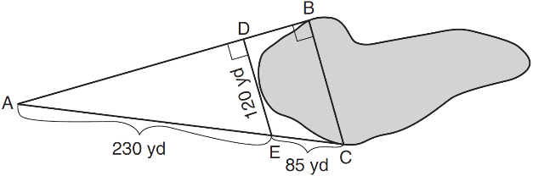

16. In the diagram below, the line of sight from the park ranger station, *P*, to the lifeguard chair, *L*, on the beach of a lake is perpendicular to the path joining the campground, *C*, and the first aid station, *F*. The campground is 0.25 mile from the lifeguard chair. The straight paths from both the campground and first aid station to the park ranger station are perpendicular.

If the path from the park ranger station to the campground is 0.55 mile, determine and state, to the *nearest hundredth of a mile*, the distance between the park ranger station and the lifeguard chair. Gerald believes the distance from the first aid station to the campground is at least 1.5 miles. Is Gerald correct? Justify your answer.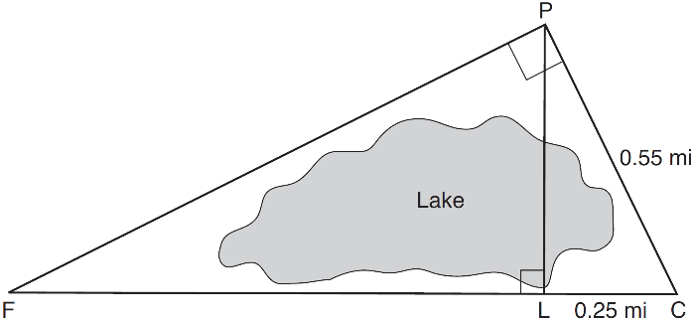

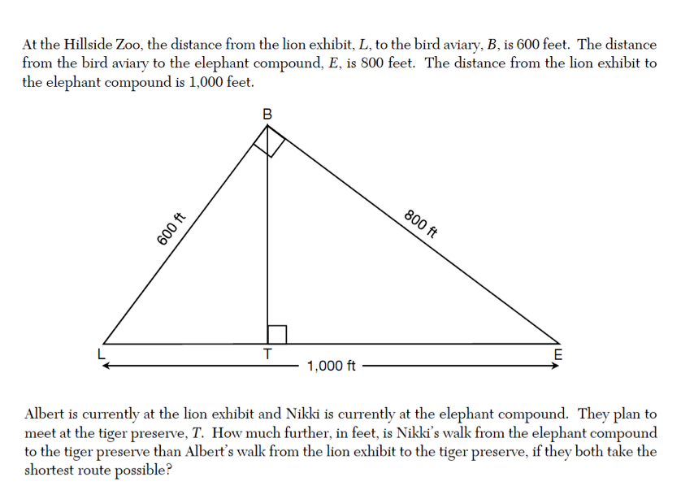

17.

18. Given  such that . Which statement is *not* true?

|  |  |  |  |
| --- | --- | --- | --- |
| 1) |  | 3) |  |
| 2) |  | 4) |  |

19.  is similar to . The ratio of the length of  to the length of  is . Which ratio is also equal to ?

(1)  (2)  (3)  (4) 

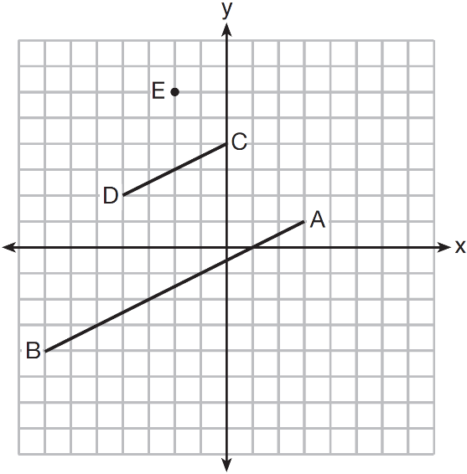 20. In the diagram below,  is the image of  after a dilation of scale factor *k* with center *E*.

Which ratio is equal to the scale factor *k* of the dilation?

|  |  |
| --- | --- |
| 1) |  |
| 2) |  |
| 3) |  |
| 4) |  |

21. In the diagram below,  is the image of  after a dilation centered at the origin. The coordinates of the vertices are , , , , and .

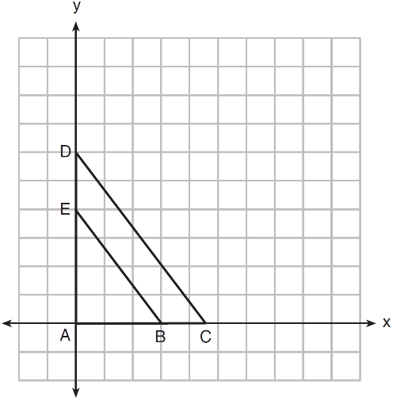

The scale factor of dilation is

|  |  |
| --- | --- |
| 1) |  |
| 2) |  |
| 3) |  |
| 4) |  |

22. In the diagram below,  has coordinates , , and . The coordinates of its image after a sequence of transformations is . What is the constant of dilation?

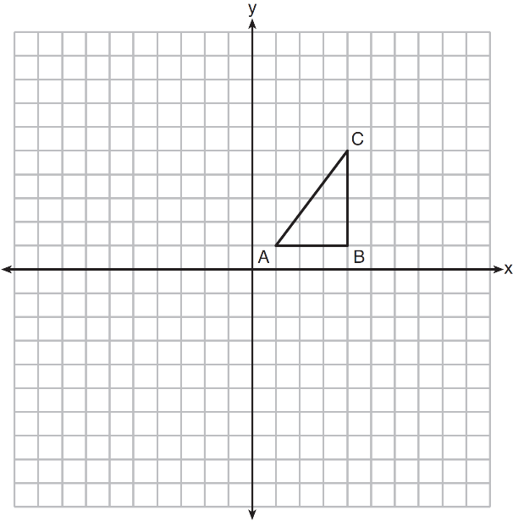

23. In the diagram shown below,  is the image of after a dilation of *k* centered at point A.

If , , and , what is the value of *k*?



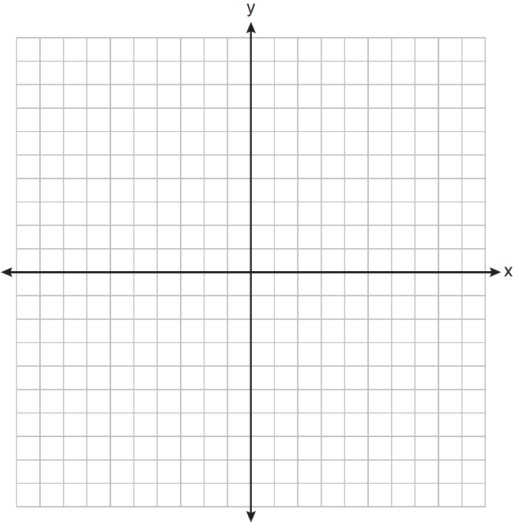

24.  has coordinates . The

coordinates of , the image of  after a sequence

of transformations is . What is

the constant of dilation?

25. As shown in the diagram below, circle *A* has a radius of 3 and circle *B* has a radius of 5.

Use transformations to explain why circles *A* and *B* are similar.

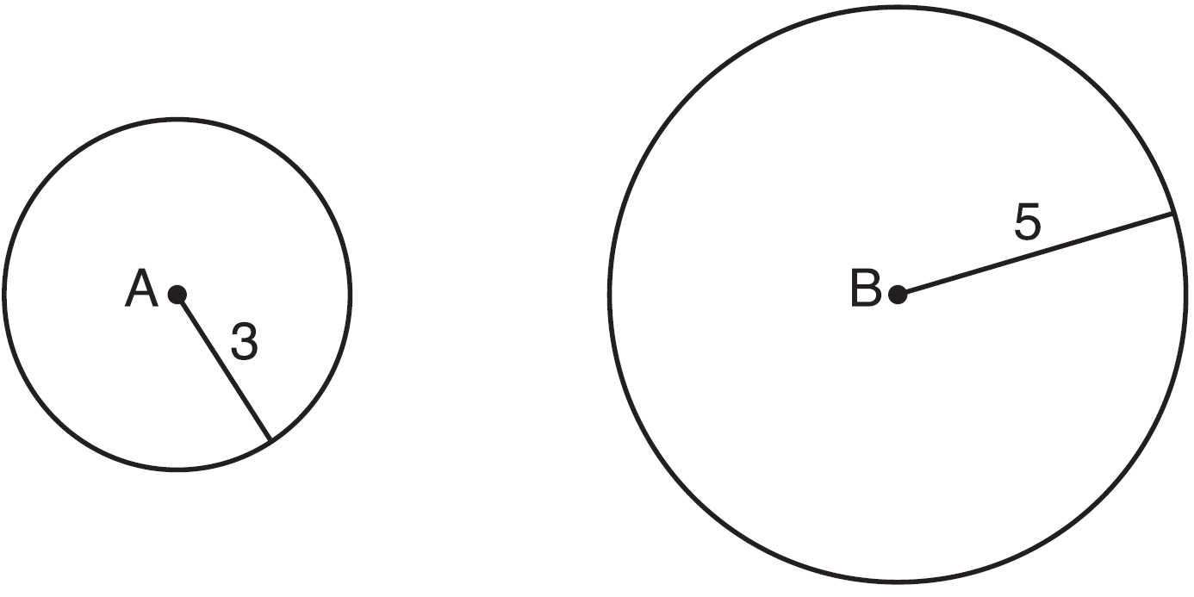

26. In the diagram below, triangles *XYZ* and *UVZ* are drawn such that  and .

Describe a sequence of similarity transformations that shows  is similar to .

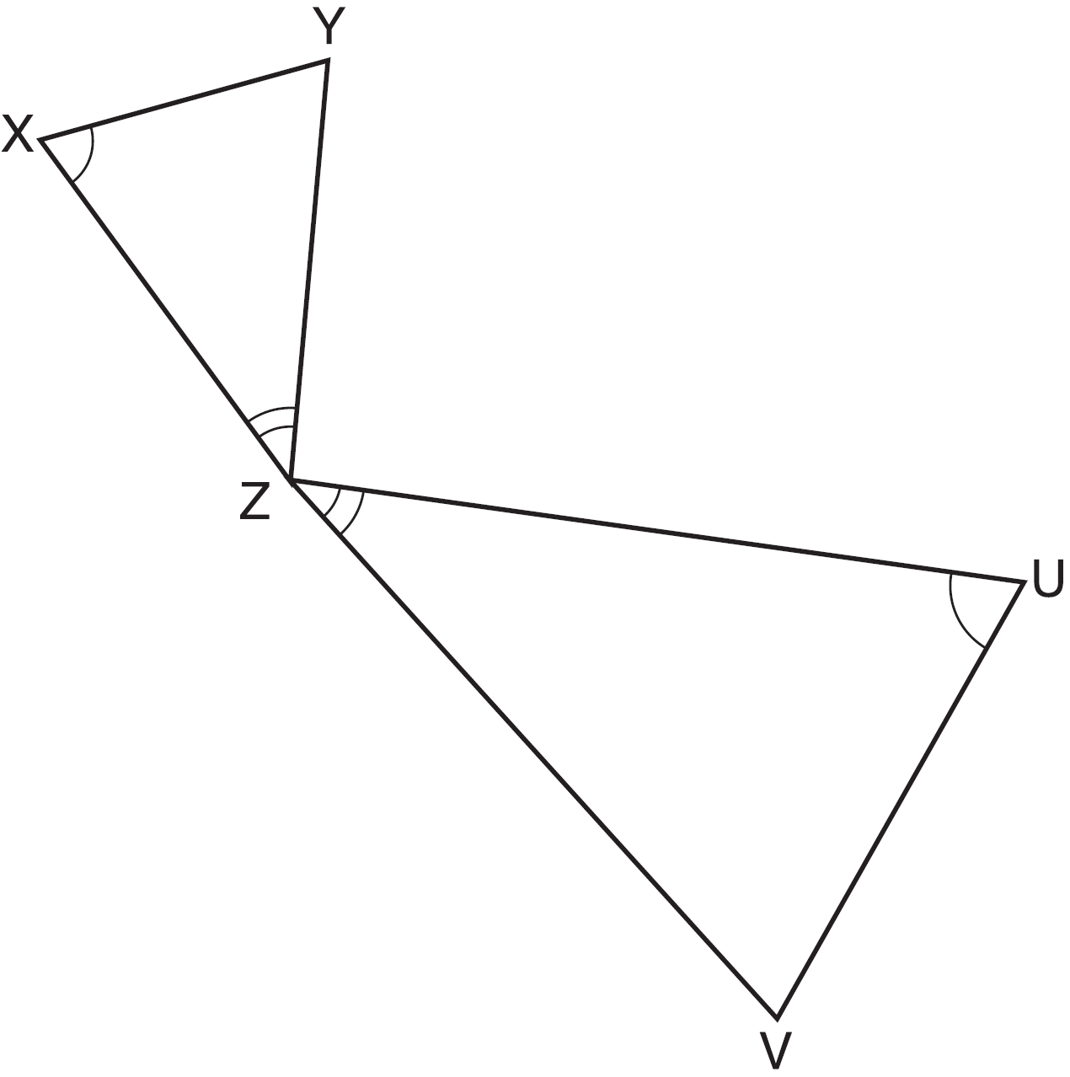

27. In the diagram below,  is the image of  after a transformation.

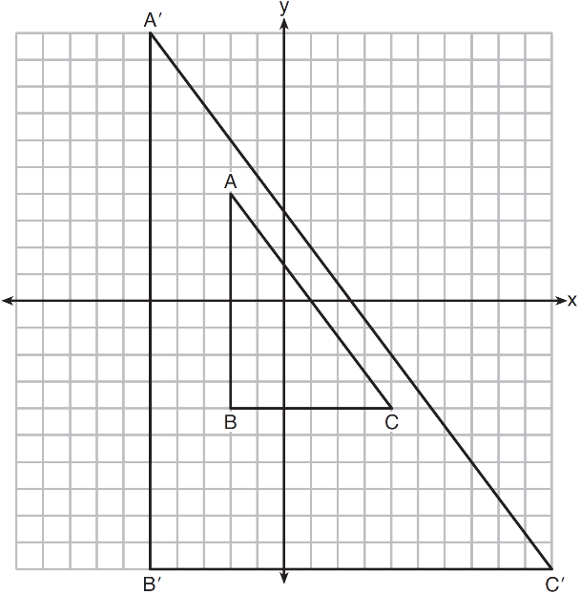

Describe the transformation that was performed. Explain why .

28. If  is dilated by a scale factor of 3, which statement is true of the image ?

|  |  |
| --- | --- |
| 1) |  |
| 2) |  |
| 3) |  |
| 4) |  |

1. The image of  after a dilation of scale factor *k* centered at point *A* is , as shown in the diagram below.

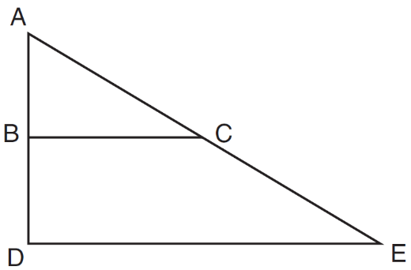

Which statement is always true?

|  |  |
| --- | --- |
| 1) |  |
| 2) |  |
| 3) |  |
| 4) |  |

1. In the diagram below,  is the image of  after a clockwise rotation of 180° and a dilation where , , , , , and .

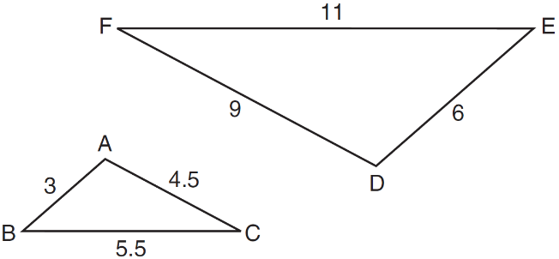

Which relationship must always be true?

|  |  |
| --- | --- |
| 1) |  |
| 2) |  |
| 3) |  |
| 4) |  |

1. In the diagram below, .

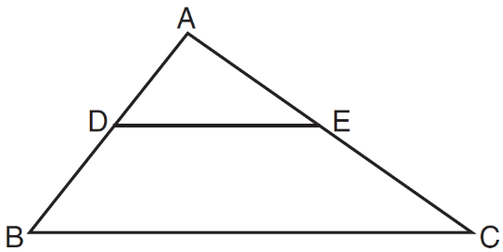

Which measurements are justified by this similarity?

|  |  |
| --- | --- |
| 1) | , , , and |
| 2) | , , , and |
| 3) | , , , and |
| 4) | , , , and |

32. Given that , which is the correct statement about their corresponding sides?

1)  3) 

2)  4) 

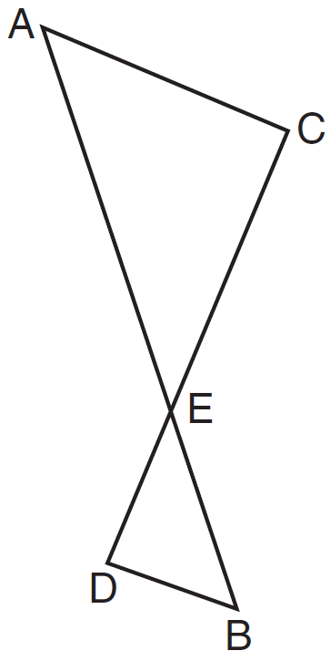

1. As shown in the diagram below,  and  intersect at *E*, and .

Given , which equation is true?

|  |  |
| --- | --- |
| 1) |  |
| 2) |  |
| 3) |  |
| 4) |  |

1. Triangles *RST* and *XYZ* are drawn below. If , , , , and , is  similar to ? Justify your answer.

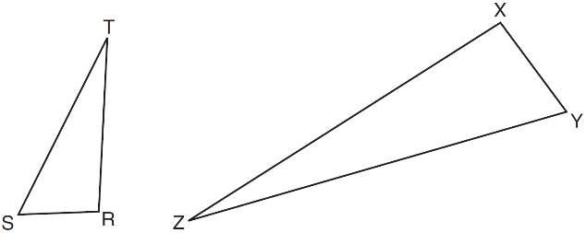

1. In the diagram below, .

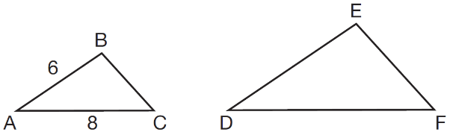

If  and , which statement will justify similarity by SAS?

|  |  |
| --- | --- |
| 1) | , , and |
| 2) | , , and |
| 3) | , , and |
| 4) | , , and |

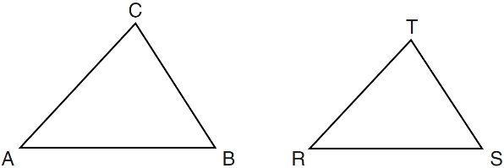 36. In the diagram below, .

Which statement is *not* true?

|  |  |
| --- | --- |
| 1) |  |
| 2) |  |
| 3) |  |
| 4) |  |

37. Scalene triangle *ABC* is similar to triangle *DEF*. Which statement is *false*?

|  |  |
| --- | --- |
| 1) |  |
| 2) |  |
| 3) |  |
| 4) |  |

38. Triangle ABC is similar to triangle DEF. The length of is 6 and the length of is 8. Which of the following must be true?



1. I and II 2) II and IV

3) I and III 4) I, II, and III