Name ______________ Date _____________

Mr. Schlansky Geometry

***Sequences of Similarity Transformations***

1. As shown in the diagram below, circle *A* has a radius of 3 and circle *B* has a radius of 5.

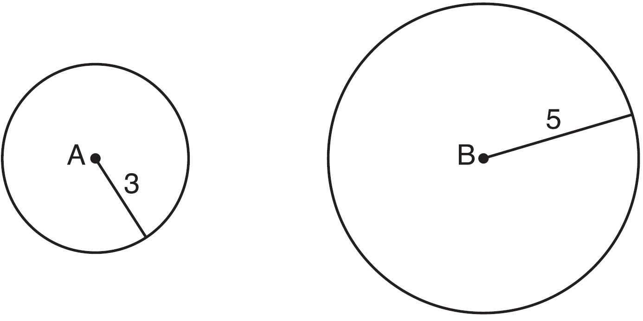

Use transformations to explain why circles *A* and *B* are similar. Are the circles congruent? Explain your answer.

1. In the diagram below, triangles *XYZ* and *UVZ* are drawn such that  and .

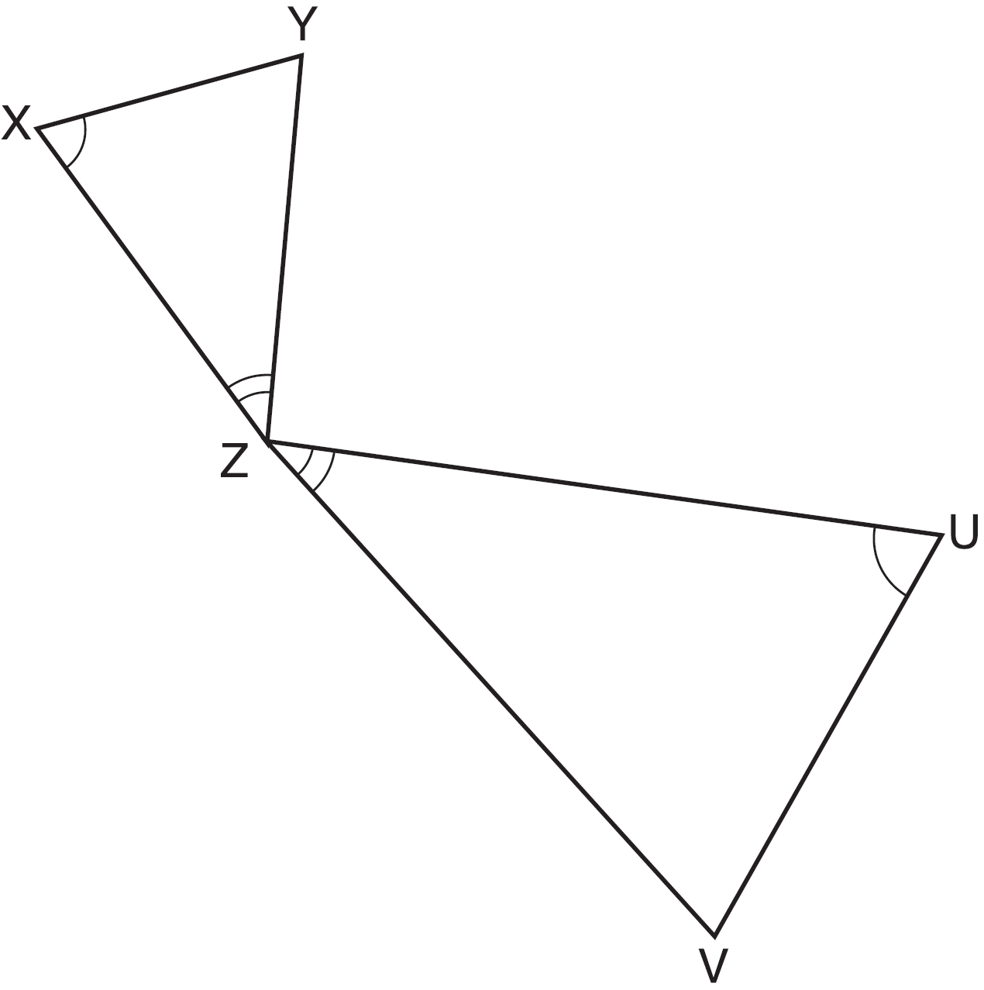

Describe a sequence of transformations that maps  onto . Are the triangles similar? Explain your answer.

1. In the diagram below,  is the image of  after a transformation.

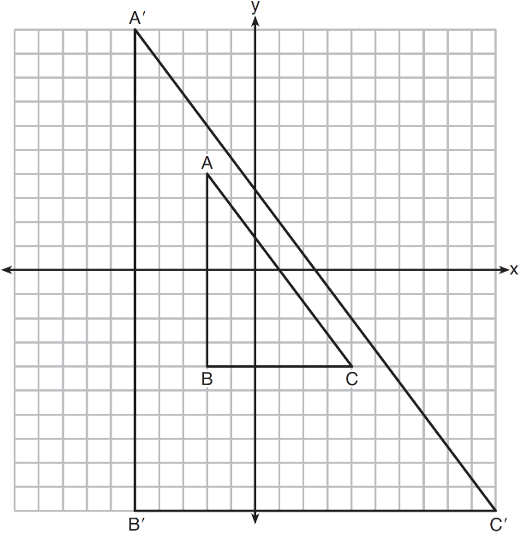

Describe the transformation that was performed. Explain why .

1. In the diagram below,  is parallel to , and  intersects  at *A*. Describe a sequence of transformations that maps  onto . Are the triangle similar? Explain your answer. Are the triangles congruent? Explain your answer.

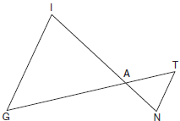

1. Describe a sequence of transformation that would map  onto . What is the relationship between  and ? Explain your answer.

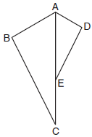

1. Triangle *ABC* and triangle *ADE* are graphed on the set of axes below.
2. Describe a transformation that maps triangle *ABC* onto triangle *ADE*. Explain why this transformation makes triangle *ADE* similar to triangle *ABC*.

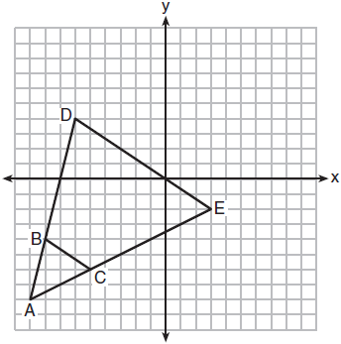

1. Given: , , and 

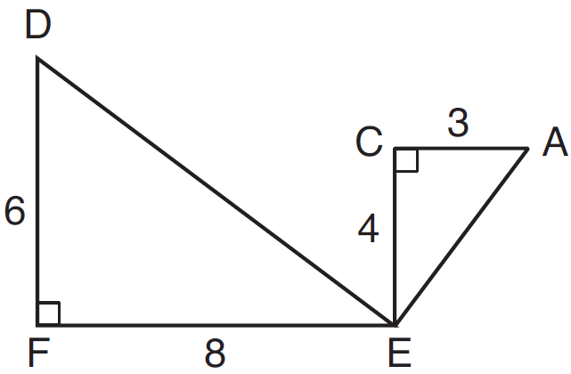What is a correct sequence of similarity transformations that shows ?

|  |  |
| --- | --- |
| 1) | a rotation of 180 degrees about point *E* followed by a horizontal translation |
| 2) | a counterclockwise rotation of 90 degrees about point *E* followed by a horizontal translation |
| 3) | a rotation of 180 degrees about point *E* followed by a dilation with a scale factor of 2 centered at point *E* |
| 4) | a counterclockwise rotation of 90 degrees about point *E* followed by a dilation with a scale factor of 2 centered at point *E* |