Name _______________ Date _____________

Mr. Schlansky Geometry

***Similar Triangles with Algebra***

1. In the diagram of  below, points *D* and *E* are on sides  and  respectively, such that .

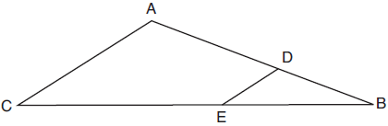

If *EB* is 3 more than *DB*, , and , what is the length of ?

|  |  |
| --- | --- |
| 1) | 6 |
| 2) | 8 |
| 3) | 9 |
| 4) | 12 |

1. In the diagram below of right triangle *ABC*, altitude  is drawn to hypotenuse .

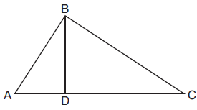

If , , and , what is the length of ?

|  |  |
| --- | --- |
| 1) | 5 |
| 2) | 2 |
| 3) | 8 |
| 4) | 11 |

3. In triangle ABC, ||. If  = 2,  = x + 1,  = x, and  = x + 6, find 



4. Altitude  is drawn to right triangle ABC. If = 8,  = x, and  = x – 12. Find the measure of .

5. Altitude  is drawn to right triangle PSR. If  = 12 and is 3 less than , find the length of .

6. In the diagram, || , , = 2, = 2, and  = x. Find .



7. Altitude  is drawn to right triangle ABC. The measure of  is 9 less than . If the altitude is 6, find the measure of .

8. In the diagram, , is 7 less than . If  = 5 and  = 3, find the measure of .

