Name _____________ Date _____________

Mr. Schlansky Geometry

***Similar Triangle Proofs Practice***

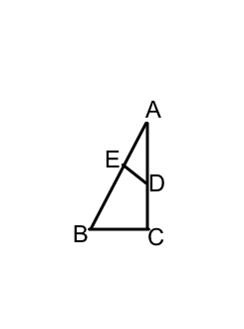

1. Given: 



Prove: 

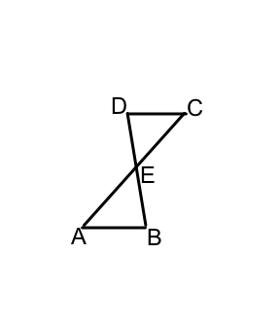

2. Given 

Prove: 

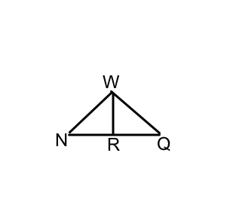3. Given:  bisects 



Prove: 