Name ______________ Date _____________
Mr. Schlansky Geometry

Solids Regents Review
1.
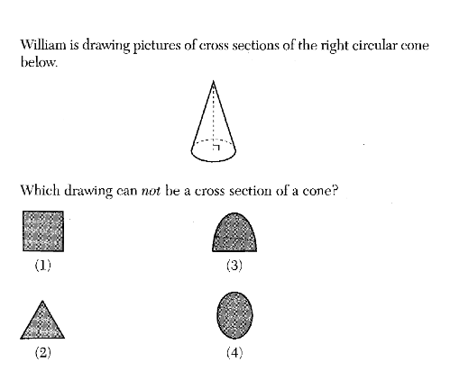
2.
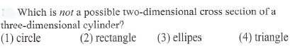

3.
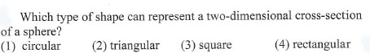

4. Which figure can have the same cross section as a sphere?
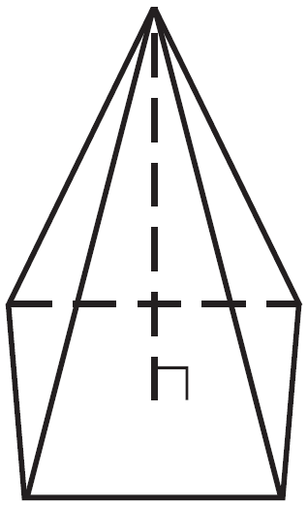
1) 3)

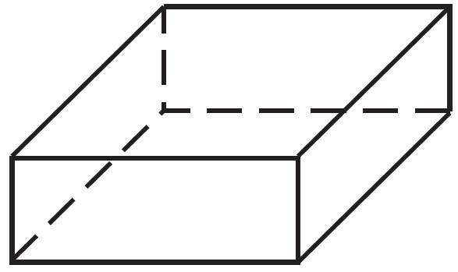

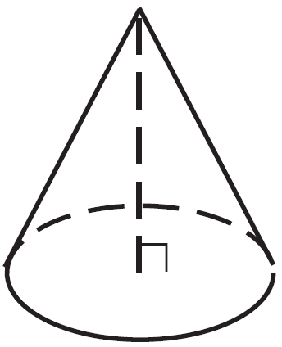
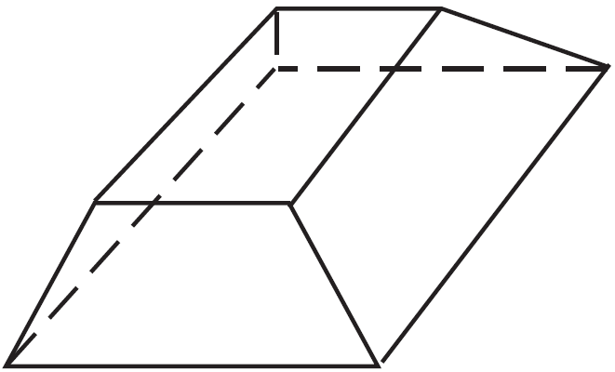
2) 4)

5. Which object is formed when right triangle RST shown below is rotated around leg ?
1) | a pyramid with a square base
2) | an isosceles triangle
3) | a right triangle
4) | a cone

6. If the rectangle below is continuously rotated about side w, which solid figure is formed?
1) | pyramid
2) | rectangular prism
3) | cone
4) | cylinder

7.
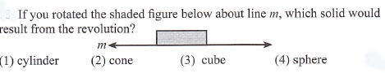
8.
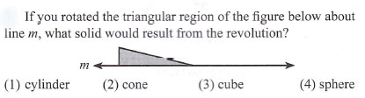
9. Mrs. Ayer is painting the outside of her son’s toy box, including the top and bottom. The toy box measures 3 feet long, 1.5 feet wide, and 2 feet high. What is the total surface area she will paint?
1) |  | 3)
2) |  | 4)

10. How many square inches of wrapping paper are needed to entirely cover a box that is 2 inches by 3 inches by 4 inches?
1) | 18
2) | 24
3) | 26
4) | 52
11. Carlos is preparing to sculpt a large rectangular block of stone.
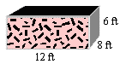
What is the surface area of this prism?

12. What is the measure of a side of the largest square that can be constructed inside a circle if the radius of the circle is 5 cm. Round your answer to the nearest tenth of a cm.

13. Linda is designing a circular piece of stained glass with a diameter of 7 inches. She is going to sketch a square inside the circular region. To the nearest tenth of an inch, the largest possible length of a side of the square is
1) | 3.5
2) | 4.9
3) | 5.0
4) | 6.9

14. What is the area of the largest square that can be drawn inside a circle whose diameter is 10 inches?

15. A square has each side measuring 10 inches. What is the circumference of the largest circle than can be drawn inside the square?

16. A circle with a radius of 5 was divided into 24 congruent sectors. The sectors were then rearranged, as shown in the diagram below.

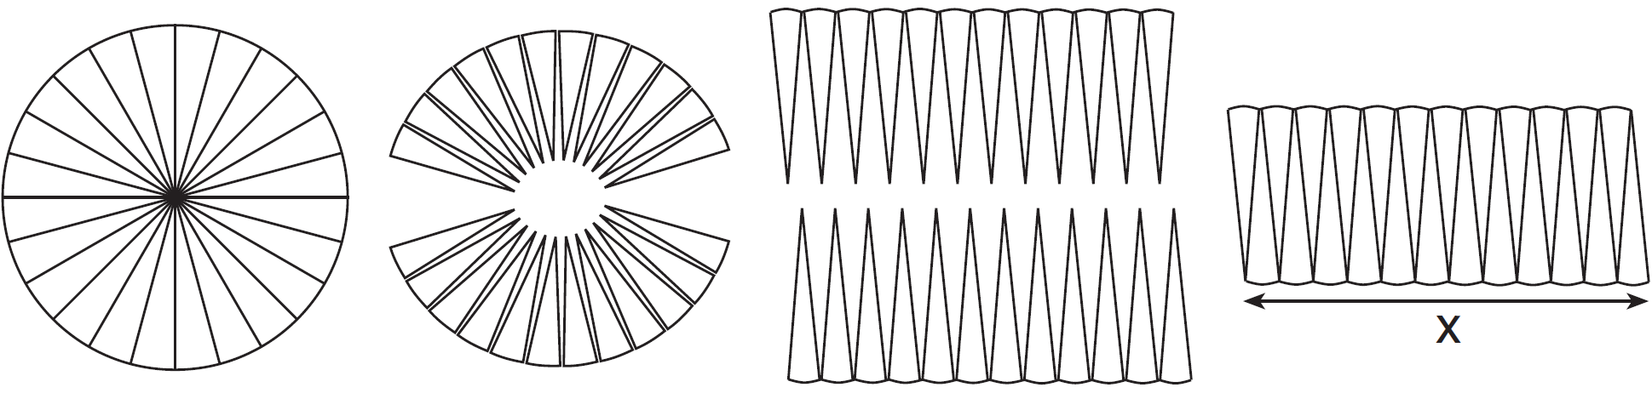

To the nearest integer, the value of x is
1) | 31
2) | 16
3) | 12
4) | 10

17. A designer needs to create perfectly circular necklaces. The necklaces each need to have a radius of 10 cm. What is the largest number of necklaces that can be made from 1000 cm of wire?
1) 15 2) 16 3) 31 4) 32

18. Lenny made a cube in technology class. Each edge measured 1.5 cm. What is the volume of the cube in cubic centimeters?
1) | 2.25 | 3) | 9.0
2) | 3.375 | 4) | 13.5

19. A cylindrical container has a diameter of 12 inches and a height of 15 inches, as illustrated in the diagram below.
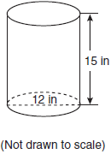
What is the volume of this container to the nearest tenth of a cubic inch?
1) | 6,785.8 | 3) | 2,160.0
2) | 4,241.2 | 4) | 1,696.5
20. A cylinder has a diameter of 10 inches and a height of 2.3 inches. What is the volume of this cylinder, to the nearest tenth of a cubic inch?
1) | 72.3
2) | 83.1
3) | 180.6
4) | 722.6

21. What is the volume of a rectangular prism whose length is 4 cm, width is 6 cm, and height is 5 cm?

22. In the diagram below, a right circular cone has a diameter of 8 inches and a height of 12 inches.
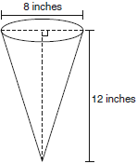
What is the volume of the cone to the nearest cubic inch?
1) | 201 | 3) | 603
2) | 481 | 4) | 804

23. A regular pyramid with a square base is shown in the diagram below.

A side, s, of the base of the pyramid is 12 meters, and the height, h, is 42 meters. What is the volume of the pyramid in cubic meters?
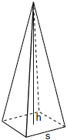

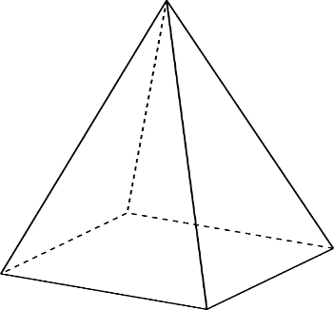
24. A regular pyramid has a square base with an edge length of 6, an altitude of 4,
and a slant height of 5. Find its volume.

25. A cone has a base with a radius of 2, an altitude of 7, and a slant height of 9.
Find its volume in terms of .
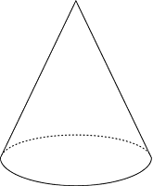

26. A brick that weighs 1824 grams has dimensions that measure 4 cm by 3 cm by 8 cm. To the nearest tenth, what is the density of the brick?

27. A cylindrical candleholder has a diameter of 4.5 cm and a height of 20 cm. If the candleholder has a mass of 2900 g, rounded to the nearest whole number, what is its density?

28. A wooden cube has an edge length of 6 centimeters and a mass of 137.8 grams. Determine the density of the cube, to the nearest thousandth. State which type of wood the cube is made of, using the density table below.

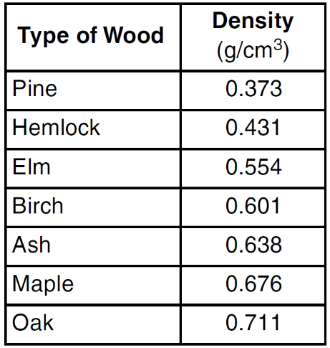

29. Jennifer is having her Sweet 16 party on a giant circular patio that has a radius of 7.2 meters. If there are 83 people at the party, to the nearest tenth, what is the population density?

30. For a music festival, a stage was built in the shape of a right triangle whose sides measure 6 yards, 8 yards, and 10 yards. At the end of the concert, all of the performers came out an performed together. There were a total of 62 performers on the stage. To the nearest tenth of a person, what was the population density on the stage?

31. Town A has an area of 12 square miles. Town B has an area of 10 square miles. If town A has a population of 8,198 people and town B has a population of 7,384 people, which town has a greater population density? Justify your answer.

32. A shipping container is in the shape of a right rectangular prism with a length of 12 feet, a width of 8.5 feet, and a height of 4 feet. The container is completely filled with contents that weigh, on average, 0.25 pound per cubic foot. What is the weight, in pounds, of the contents in the container?
1) | 1,632
2) | 408
3) | 102
4) | 92

33. A container in the shape of a sphere with a diameter of 20 cm is designed to hold gourmet ice cream. If the ice cream weighs .3 ounces per cubic centimeter, how much do the contents of the container weigh? Round your answer to the nearest whole number?

34. Molly wishes to make a lawn ornament in the form of a solid sphere. The clay being used to make the sphere weighs .075 pound per cubic inch. If the sphere’s radius is 4 inches, what is the weight of the sphere, to the nearest pound?
1) 34 2) 20 3) 15 4) 4

- A fish tank in the shape of a rectangular prism has dimensions of 14 inches, 16 inches, and 10 inches. The tank contains 1680 cubic inches of water. What percent of the fish tank is empty?

- A cylindrical test tube was full of a chemical. The radius of the cylinder was .75 inches and its height was 6 inches. If 5 cubic inches were used for an experiment, to the nearest tenth of a percent, what percent of the chemical remains in the test tube?

- Mr. Schlansky has a cylindrical water bottle that has a diameter of 3 inches and a height of 14 inches. If there is currently 18 cubic inches of water in the water bottle, to the nearest percent, what percent of the bottle is empty?

38. The diameter of a basketball is approximately 9.5 inches and the diameter of a tennis ball is approximately 2.5 inches. The volume of the basketball is about how many times greater than the volume of the tennis ball?
1) 3591 2) 65 3) 55 4) 4

- How many times greater is the volume of a 4 inch cube than the volume of a 2 inch cube?
- 4 2) 8 3) 2 4) 56

- A company is choosing between two tanks for mixing chemicals. Both tanks have the same price, so the company plans to choose the one that can hold the most chemicals. The first tank is conical with a diameter of 10 feet and a height of 15 feet. The second tank is a hemisphere with a radius of 5.5 feet. (One cubic foot = 7.48 gallons)
- Which tank should they use?
- How many gallons, to the nearest gallon, will the tank hold?

- The water tower in the picture below is modeled by the two-dimensional figure beside it. The water tower is composed of a hemisphere, a cylinder, and a cone. Let C be the center of the hemisphere and let D be the center of the base of the cone.

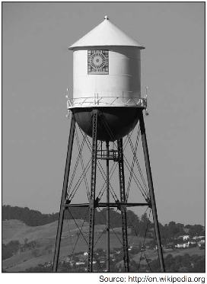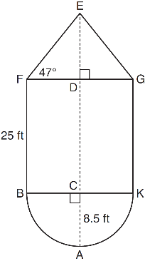

If feet, feet, and , determine and state, to the nearest cubic foot, the volume of the water tower. The water tower was constructed to hold a maximum of 400,000 pounds of water. If water weighs 62.4 pounds per cubic foot, can the water tower be filled to 85% of its volume and not exceed the weight limit? Justify your answer.

- Walter wants to make 100 candles in the shape of a cone for his new candle business. The mold shown below will be used to make the candles. Each mold will have a height of 8 inches and a diameter of 3 inches. To the nearest cubic inch, what will be the total volume of 100 candles?

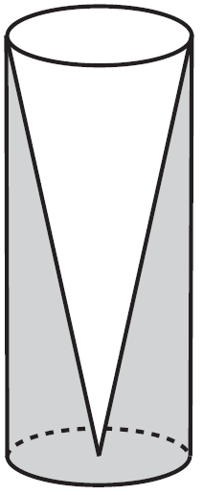

Walter goes to a hobby store to buy the wax for his candles. The wax costs $0.10 per ounce. If the weight of the wax is 0.52 ounce per cubic inch, how much will it cost Walter to buy the wax for 100 candles? If Walter spent a total of $37.83 for the molds and charges $1.95 for each candle, what is Walter's profit after selling 100 candles?

- A water glass can be modeled by a truncated right cone (a cone which is cut parallel to its base) as shown below.

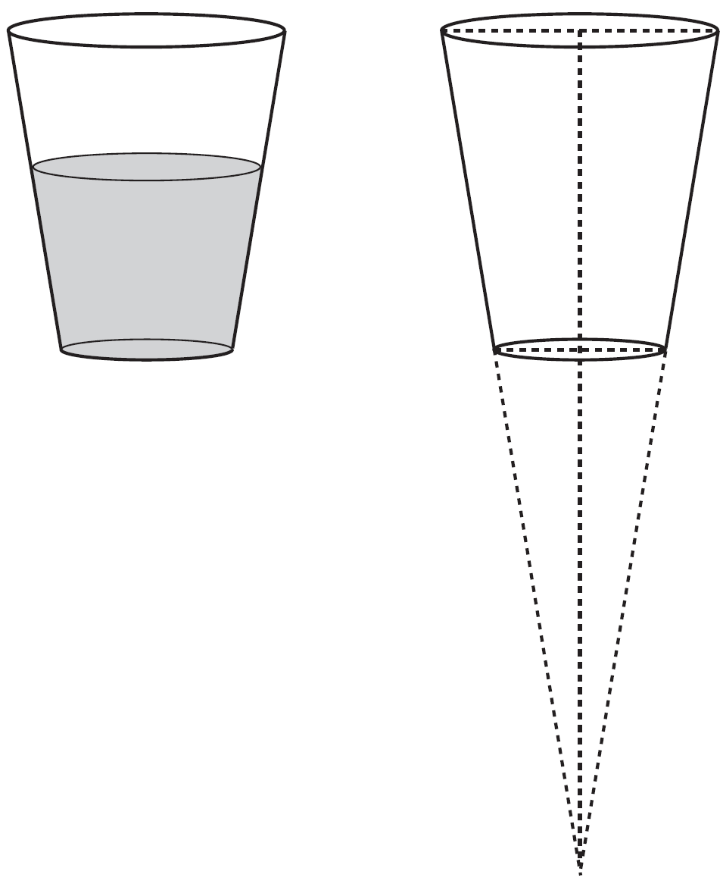
The diameter of the top of the glass is 3 inches, the diameter at the bottom of the glass is 2 inches, and the height of the glass is 5 inches. The base with a diameter of 2 inches must be parallel to the base with a diameter of 3 inches in order to find the height of the cone. Explain why. Determine and state, in inches, the height of the larger cone. Determine and state, to the nearest tenth of a cubic inch, the volume of the water glass.

- A snow cone consists of a paper cone completely filled with shaved ice and topped with a hemisphere of shaved ice, as shown in the diagram below. The inside diameter of both the cone and the hemisphere is 8.3 centimeters. The height of the cone is 10.2 centimeters.

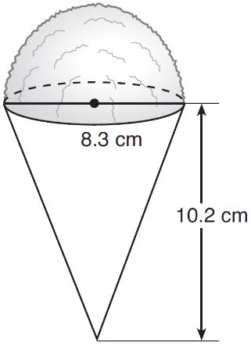
The desired density of the shaved ice is , and the cost, per kilogram, of ice is $3.83. Determine and state the cost of the ice needed to make 50 snow cones.

