Name____________________ Date____________

Mr. Schlansky Geometry

***Translations***

1. Triangle *TAP* has coordinates , , and . On the set of axes below, graph and label , the image of  after the translation 5 units to the left and 1 unit down.

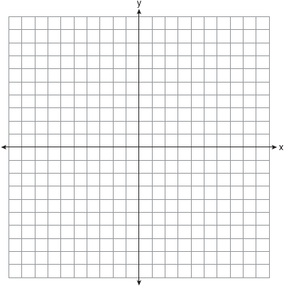

1. Graph the image of  with , , and  after a translation 3 units to the right and 2 unit up.



1. What is the image of  with vertices ,  and  after a translation 2 units to the left and 4 units up?



1. Graph the image of quadrilateral ADEF with vertices ,,, and after a translation 5 units to the left?

