Name ____________ Date _____________
Mr. Schlansky Geometry

Triangle Proofs Multiple Choice

1. In the diagram below, bisects at B, and bisects at C.

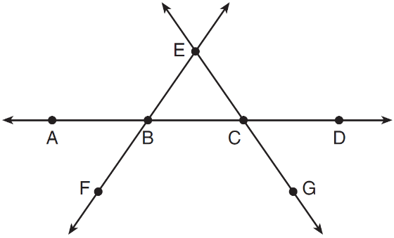

Which statement is always true?
1)
2)
3) | bisects at C.
4) | bisects at B.

2. Line segment EA is the perpendicular bisector of , and and are drawn.

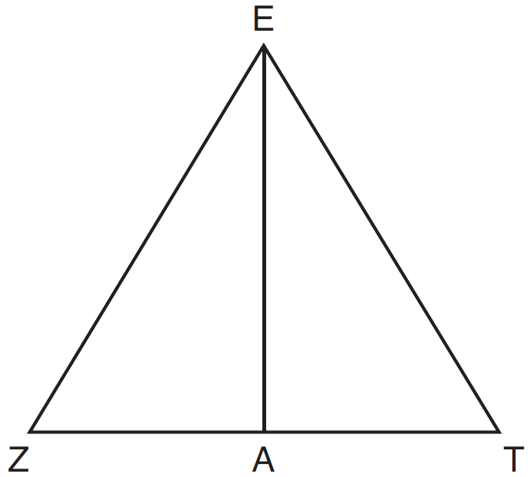

Which conclusion can not be proven?
1) | bisects angle ZET.
2) | Triangle EZT is equilateral.
3) | is a median of triangle EZT.
4) | Angle Z is congruent to angle T.

3. Segment CD is the perpendicular bisector of at E. Which pair of segments does not have to be congruent?
1)
2)
3)
4)

4. Given: and shown in the diagram below with

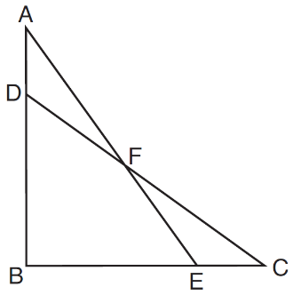

Which statement is needed to prove using only ?
1)
2)
3)
4)

5. She was given that , and has already proven . Which pair of corresponding parts and triangle congruency method would not prove ?
1) | and SAS | 3) | and AAS
2) | and SAS | 4) | and ASA

