Name _____________ Date _____________

Mr. Schlansky Geometry

***Triangles Proofs Regents Review***

1. In the diagram below ofARF andDOG, ,, and 

Which of the follow could be used to prove that ?

(1) AAS (3) HL

(2) ASA (4) SAS

2. In the diagram below, ,, and 

Which of the follow could be used to prove that ?

(1) AAS (3) HL

(2) ASA (4) SAS



3. Given:  bisects ADC



Prove: 



4. Given: 





Prove: 



5. Given: 





Prove: QU

6. Given: 

R

A

B

Prove: 

C

T

S



7. Given: ABCD is a rectangle, M is the midpoint of 

Prove: 

8. Given: ABCD is a parallelogram

Prove: 



9. Given: ABCD is a rhombus, 

Prove: 

10. Given: Altitudes and 

Prove: DFC ~ FBE

11. Given: 

Prove: 



12. Given: 

Prove: 

13. Given: , 

Prove: ABCD is a parallelogram



14. Given: , 

Prove: NRQW is a parallelogram



15. Given: YMNK is a parallelogram, 

Prove: MOKE is a parallelogram



16. Given: Parallelogram *ANDR* with  and  bisecting  and  at points *W* and *E*, respectively

Prove that . Prove that quadrilateral *AWDE* is a parallelogram.

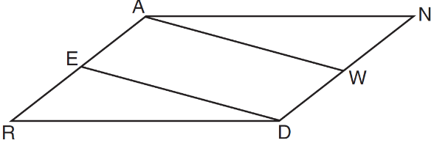

17. In the diagram of parallelogram *ABCD* below, , , .

Prove *ABCD* is a rhombus.

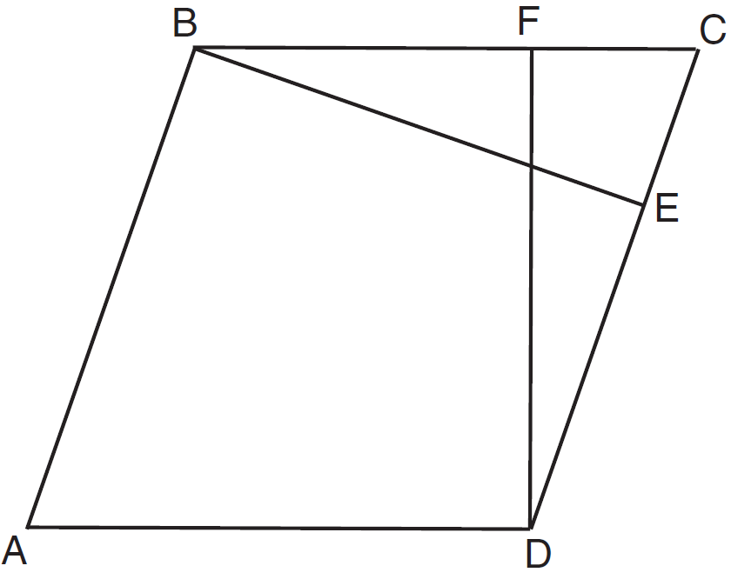

18. Given: Parallelogram *ABCD*, , and diagonal 

Prove: 

