Name ______________ Date _____________

Mr. Schlansky Geometry

***Right Triangle Applications***

1. In the diagram below of  and , angles *H* and *N* are right angles, and .

If  and , what is the measure of angle *Y*, to the *nearest degree*?

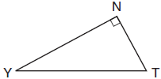

|  |  |
| --- | --- |
| 1) | 23° |
| 2) | 25° |
| 3) | 65° |
| 4) | 67° |

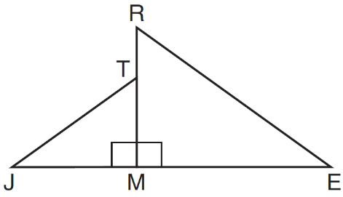 2. In the diagram below, .

Which statement is always true?

|  |  |
| --- | --- |
| 1) |  |
| 2) |  |
| 3) |  |
| 4) |  |

3. Skye says that the two triangles below are congruent. Margaret says that the two triangles are similar.

Are Skye and Margaret both correct? Explain why.

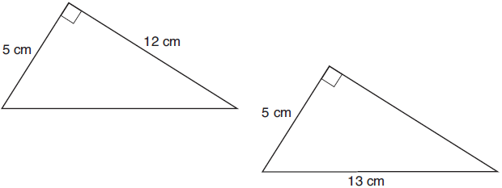

4. A homeowner is building three steps leading to a deck, as modeled by the diagram below. All three step rises, , , and , are congruent, and all three step runs, , , and , are congruent. Each step rise is perpendicular to the step run it joins. The measure of  and .

If each step run is parallel to  and has a length of 10 inches, determine and state the length of each step rise, to the *nearest tenth of an inch*. Determine and state the length of , to the *nearest inch*.

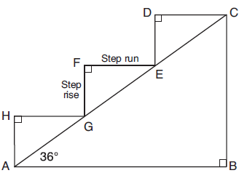

5. As shown in the diagram below, a ship is heading directly toward a lighthouse whose beacon is 125 feet above sea level. At the first sighting, point *A*, the angle of elevation from the ship to the light was 7°. A short time later, at point *D*, the angle of elevation was 16°.

To the *nearest foot*, determine and state how far the ship traveled from point *A* to point *D*.

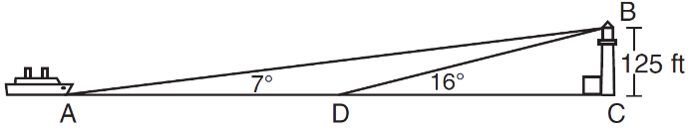

6. In the diagram below, , , and . Find to the nearest tenth, .

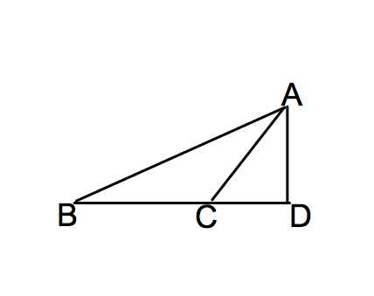

7. Find x in the diagram below rounded to the nearest tenth of a cm.

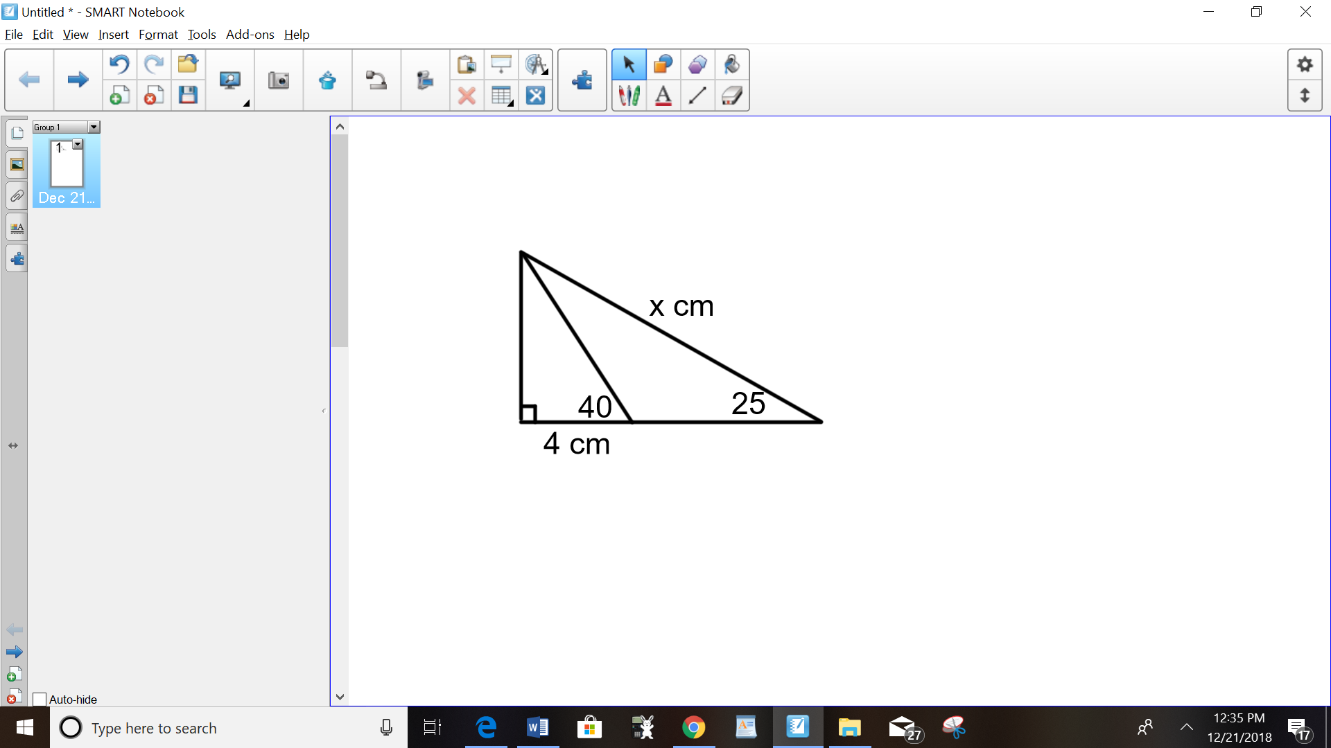

8. In the diagram below, , , and. Find to the nearest hundredth.

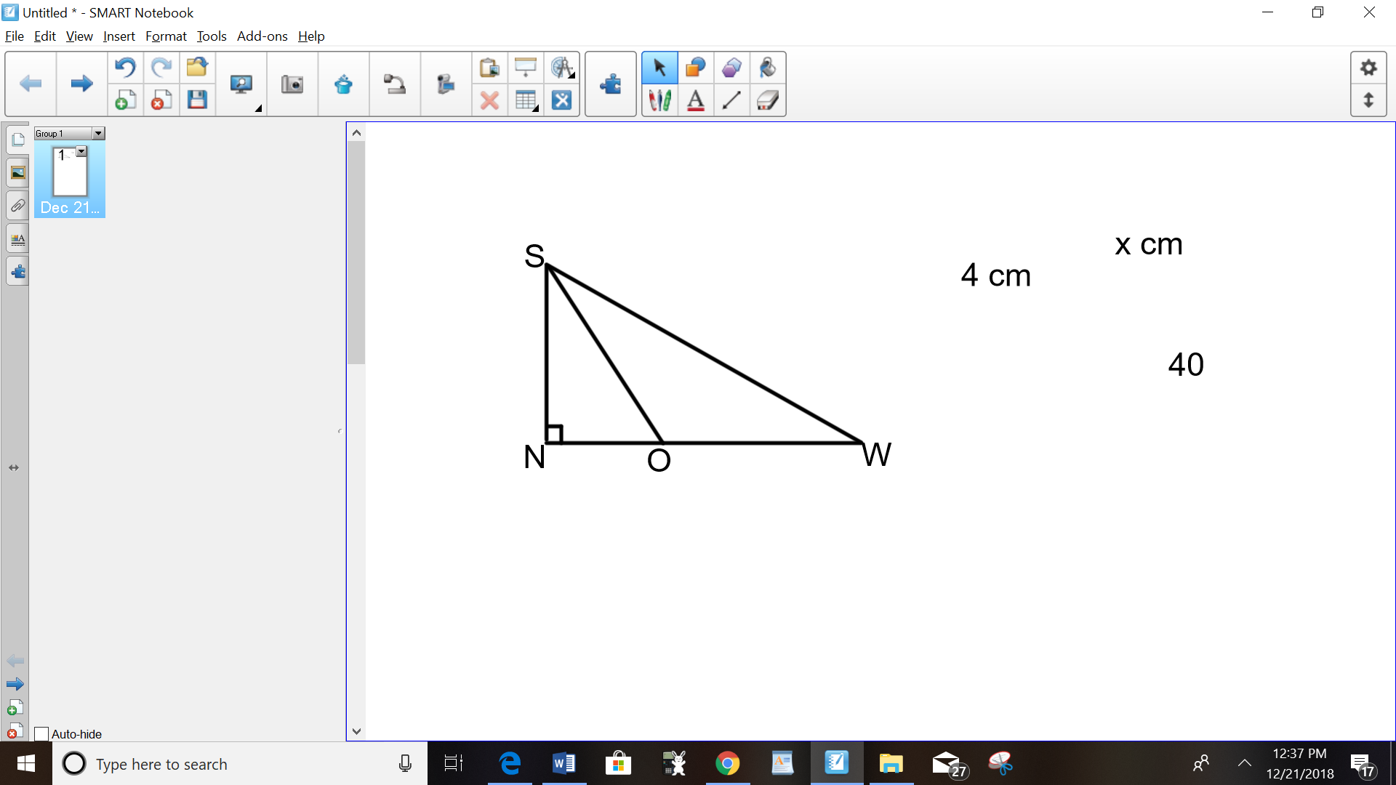

9. In the diagram below, , , and . Find  to the nearest thousandth.

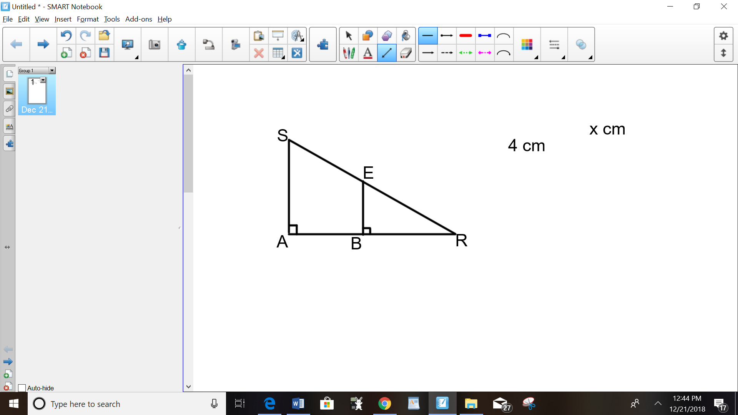

10. The map of a campground is shown below. Campsite *C*, first aid station *F*, and supply station *S* lie along a straight path. The path from the supply station to the tower, *T*, is perpendicular to the path from the supply station to the campsite. The length of path ** is 400 feet. The angle formed by path ** and path ** is 72°. The angle formed by path  and path  is 55°.

Determine and state, to the *nearest foot*, the distance from the campsite to the tower.

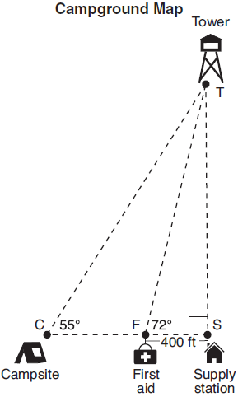

11. As modeled below, a movie is projected onto a large outdoor screen. The bottom of the 60-foot-tall screen is 12 feet off the ground. The projector sits on the ground at a horizontal distance of 75 feet from the screen.

Determine and state, to the *nearest tenth of a degree*, the measure of , the projection angle.

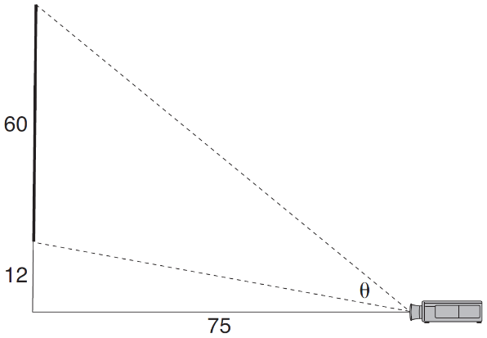

12. The aspect ratio (the ratio of screen width to height) of a rectangular flat-screen television is . The length of the diagonal of the screen is the television's screen size. Determine and state, to the *nearest inch*, the screen size (diagonal) of this flat-screen television with a screen height of 20.6 inches.

13. Keira has a square poster that she is framing and placing on her wall. The poster has a diagonal 58 cm long and fits exactly inside the frame. The width of the frame around the picture is 4 cm.

Determine and state the total area of the poster and frame to the *nearest tenth of a square centimeter*.

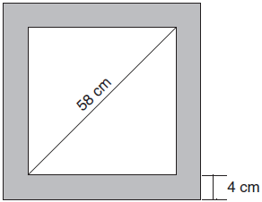

14. Freda, who is training to use a radar system, detects an airplane flying at a constant speed and heading in a straight line to pass directly over her location. She sees the airplane at an angle of elevation of 15° and notes that it is maintaining a constant altitude of 6250 feet. One minute later, she sees the airplane at an angle of elevation of 52°. How far has the airplane traveled, to the *nearest foot*? Determine and state the speed of the airplane, to the *nearest mile per hour*.