Name ______________ Date _____________

Mr. Schlansky Geometry

***Similar Triangles Using ROCS***

1. The sides of a triangle are 8, 12, and 15. The longest side of a similar triangle is 18. What is the ratio of the perimeter of the smaller triangle to the perimeter of the larger triangle?

1. 2:3
2. 4:9
3. 5:6
4. 25:36

2. The sides of a triangle are 8, 12, and 15. The smallest side of a similar triangle is 12. What is the ratio of the area of the smaller triangle to the area of the larger triangle?

1. 2:3
2. 4:9
3. 5:6
4. 25:36
5. Two triangles are similar. The sides of the smaller triangle have lengths of 6, 7, and 12. The perimeter of the larger triangle is 75. Find the length of the longest side of the larger triangle.
6. If, , , and , and the perimeter of  is 28, find the perimeter of .
7. If, , , and , and the area of  is 28, find the area of .
8. Two triangles are similar. The sides of the smaller triangle have lengths of 4, 6, and 8. The perimeter of the larger triangle is 27. Find the length of the shortest side of the triangle.
9. Two triangles are similar. The sides of the smaller one are 5 cm, 7 cm, and 9cm. If the perimeter of the larger triangle is 42cm, what is the measure of the largest side?

8. Triangle *ABC* is similar to triangle *DEF*. The lengths of the sides of  are 5, 8, and 11. What is the length of the shortest side of  if its perimeter is 60?

9. In the diagram below, .

If , ,  and the area of  is 64, what is the area of ?

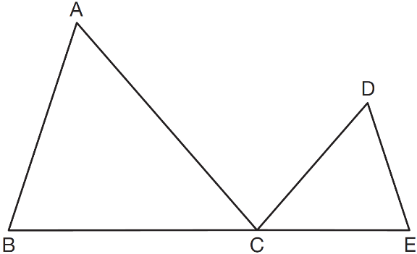

10. In the diagram below, .

If , , , and the perimeter of  is 30, what is the perimeter of ?

